**PHASE 6 — App Services**

**Tasks**

1. Create App Service Plan
2. Deploy 2 Web Apps
3. Enable Managed Identity
4. Configure App Insights
5. Create deployment slots
6. Secure app access

**Brief Explanation:** In Phase 6, we created an **App Service Plan** in Azure to host web applications. We then deployed a **Web App** under this plan, enabling **Managed Identity** for secure access to other Azure resources. We configured **Application Insights** for monitoring and performance tracking. Deployment slots were set up to allow safe staging and testing of updates. Finally, we deployed a **static HTML website** to the Web App using **Zip Deploy,** ensuring it is accessible through the Web App URL. This phase sets up a scalable and monitored environment for hosting web applications in Azure.

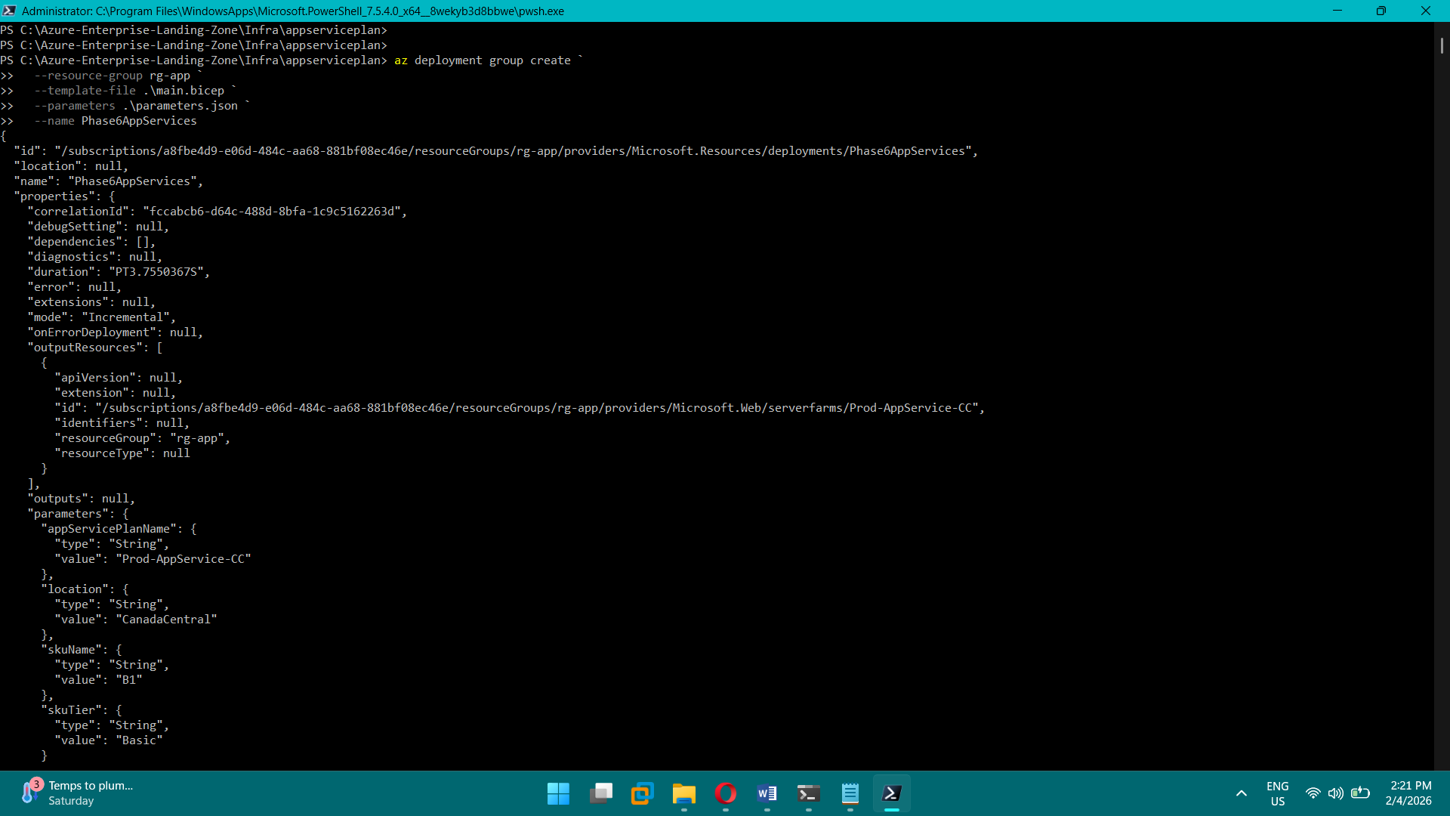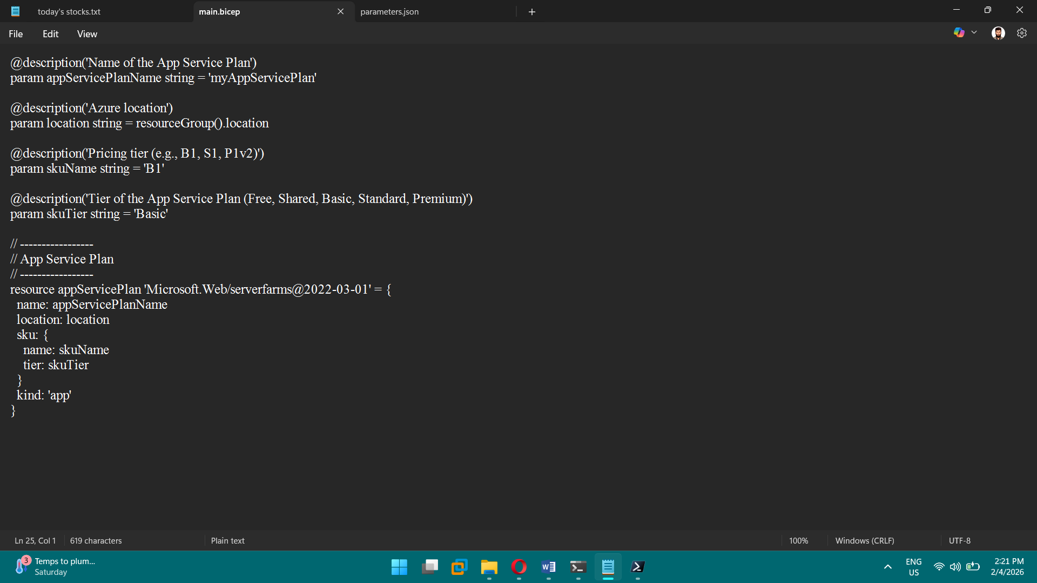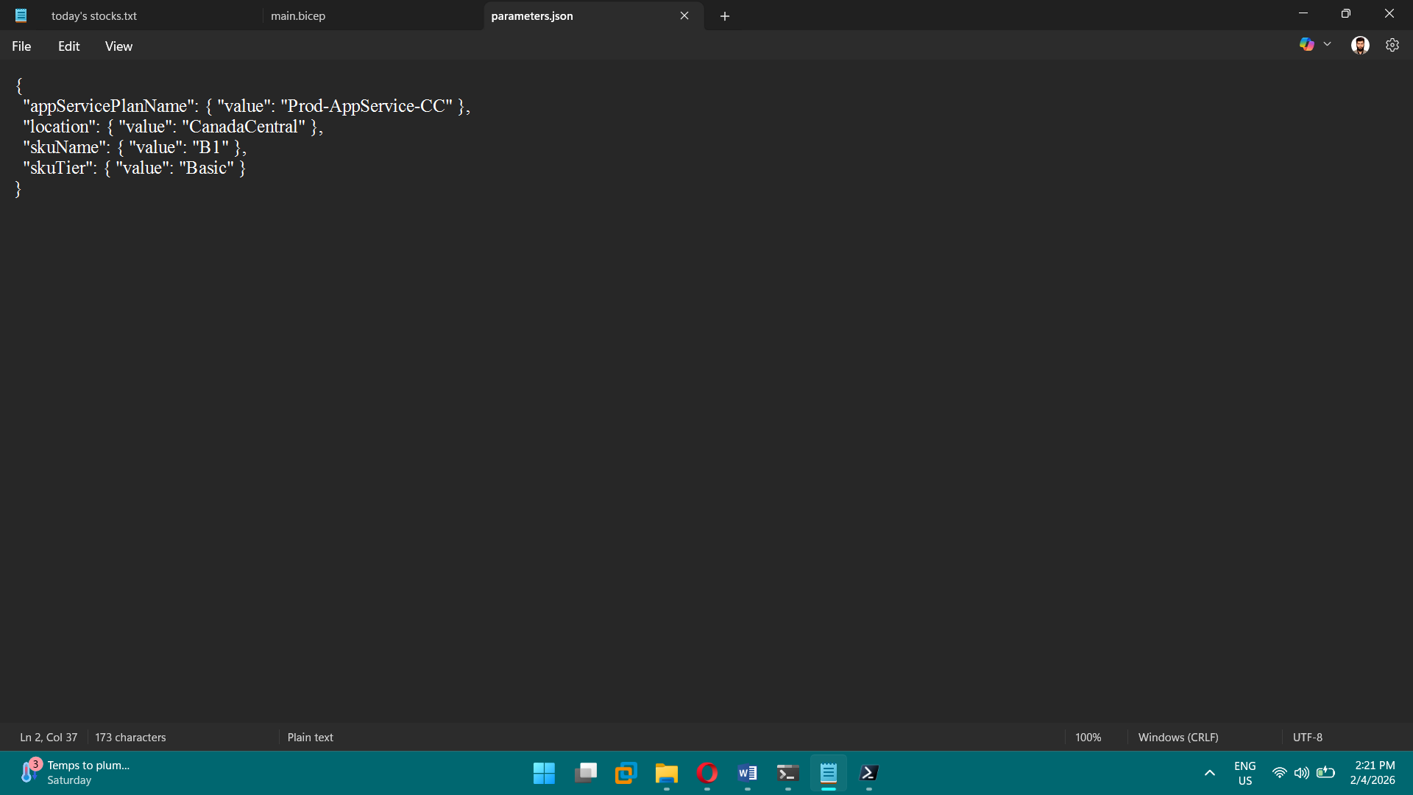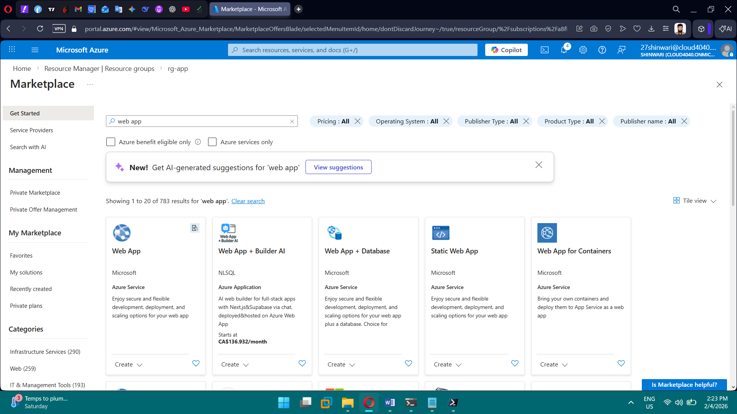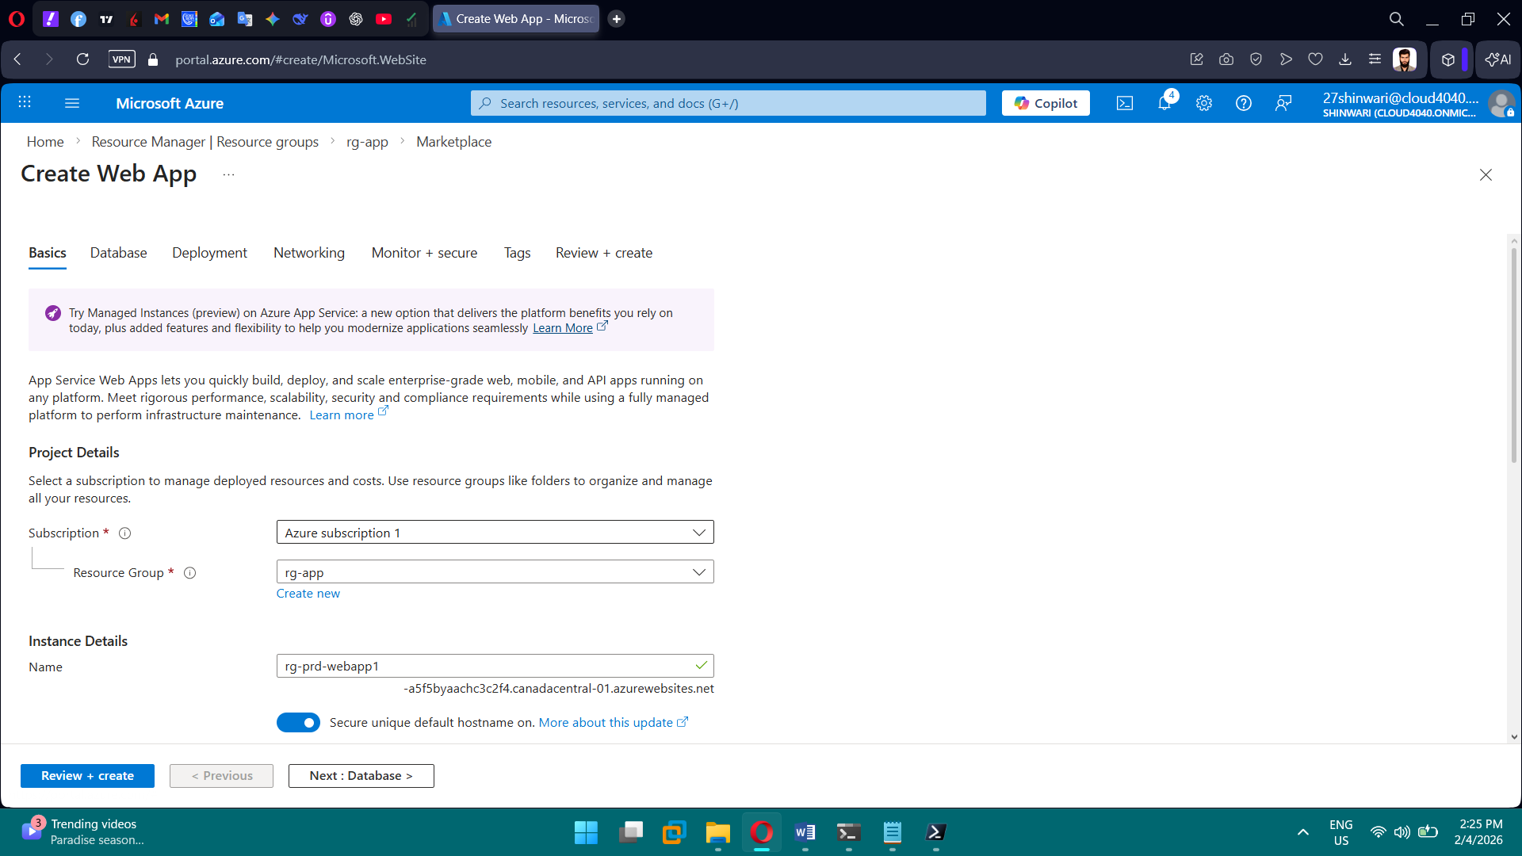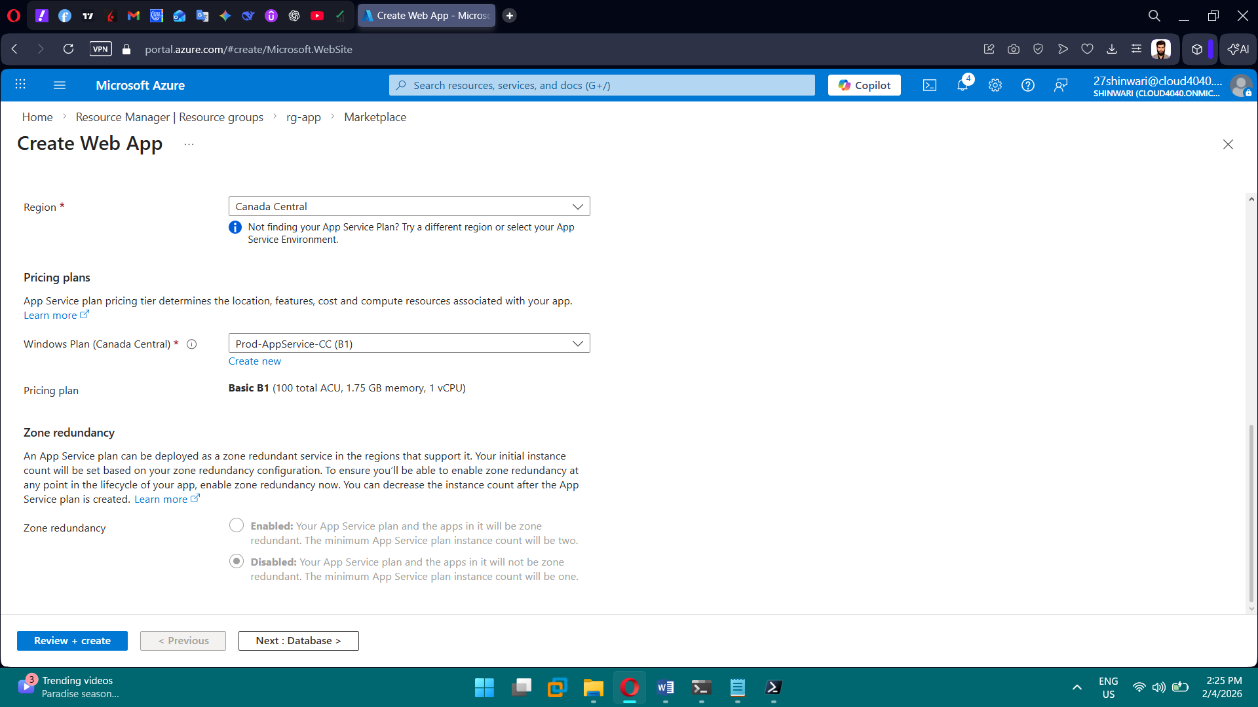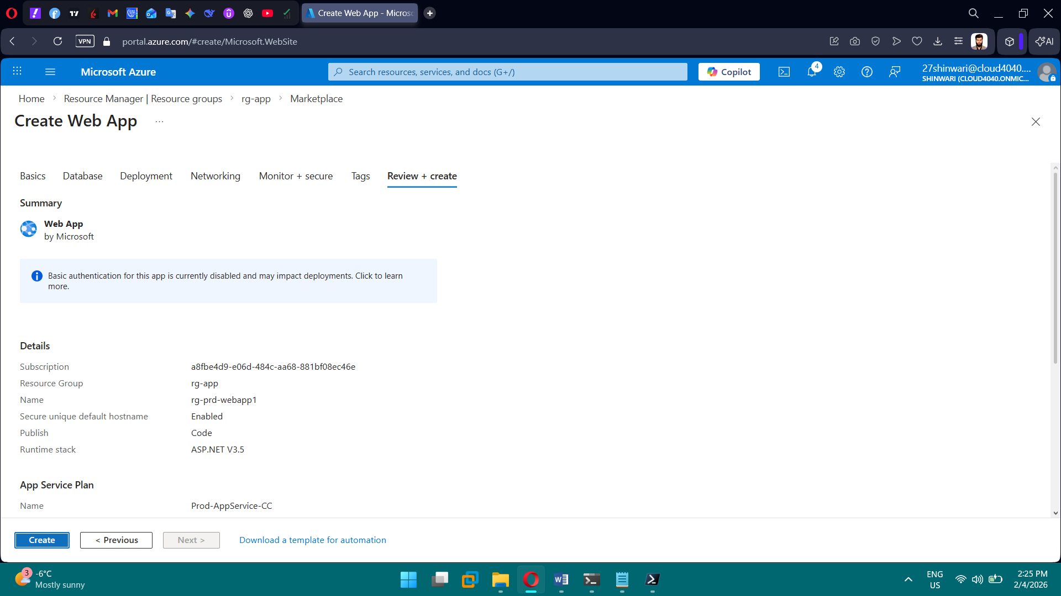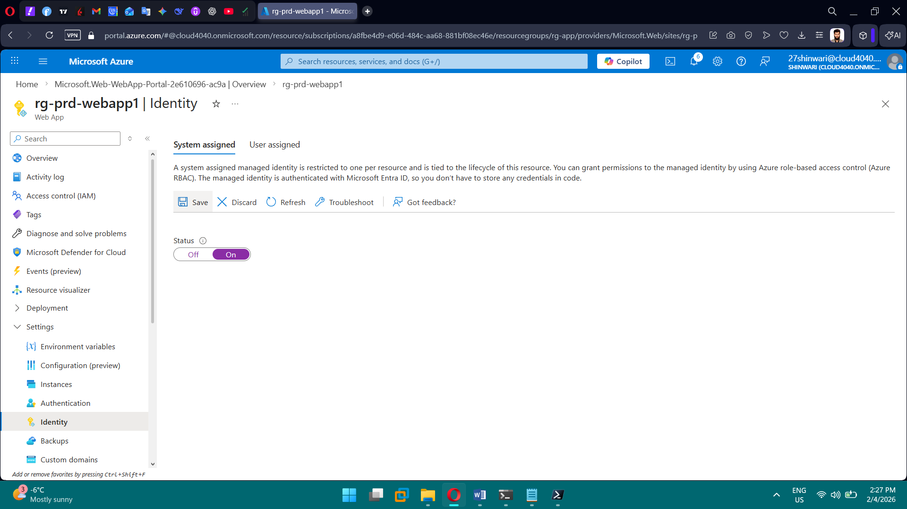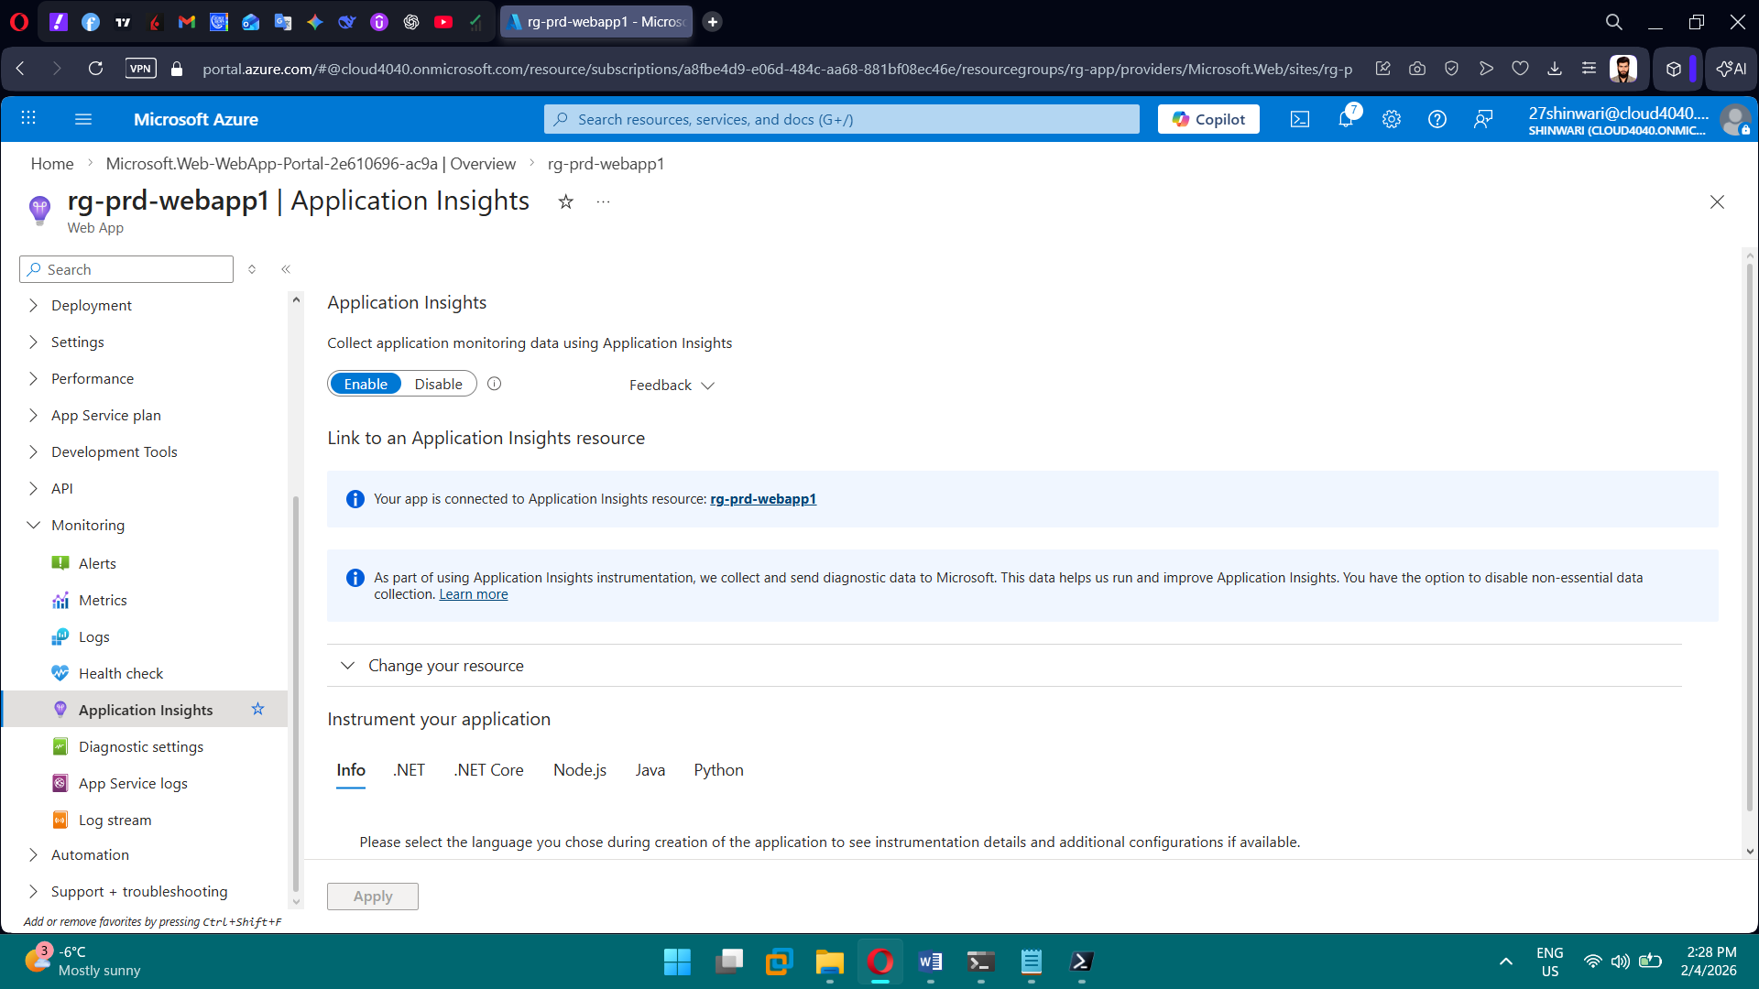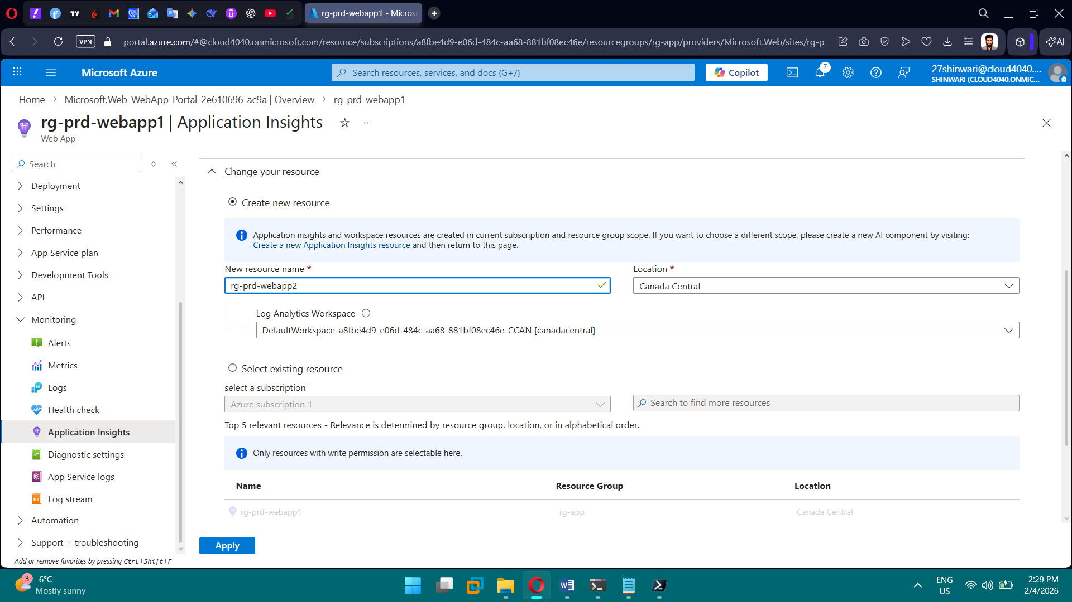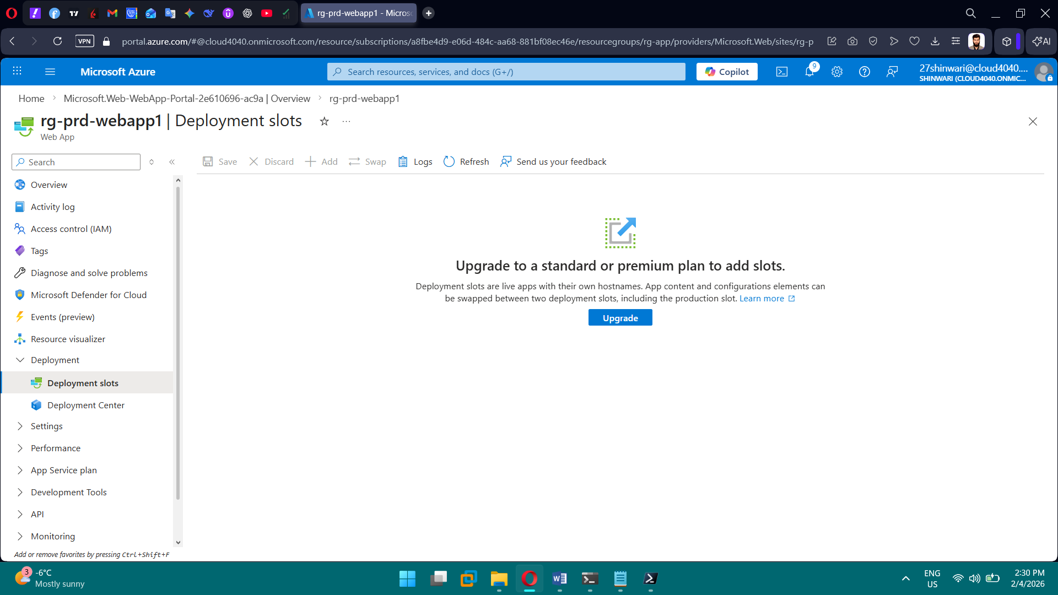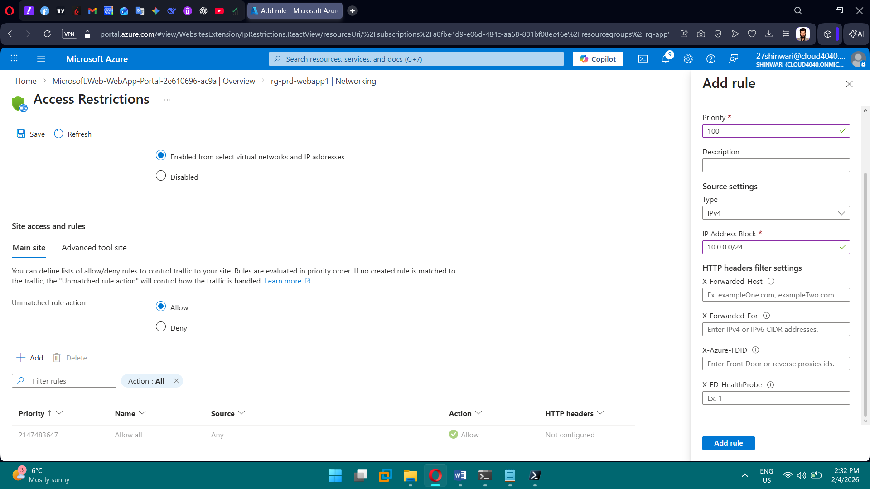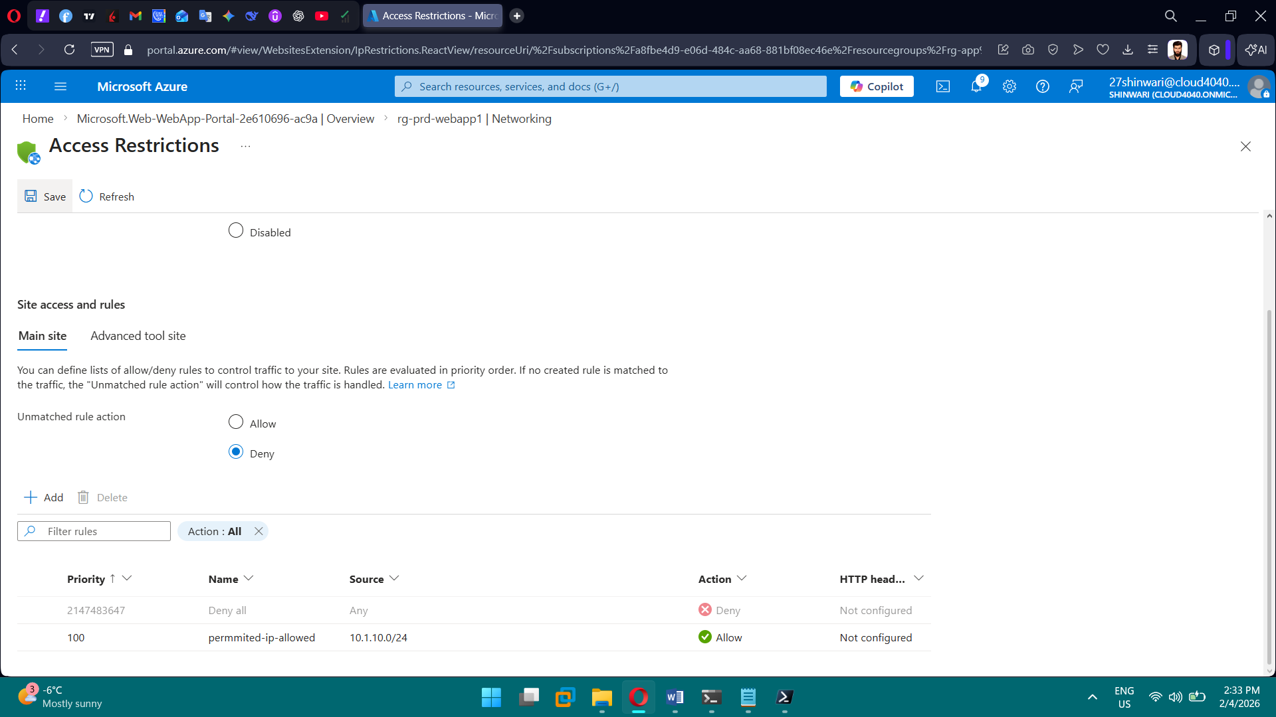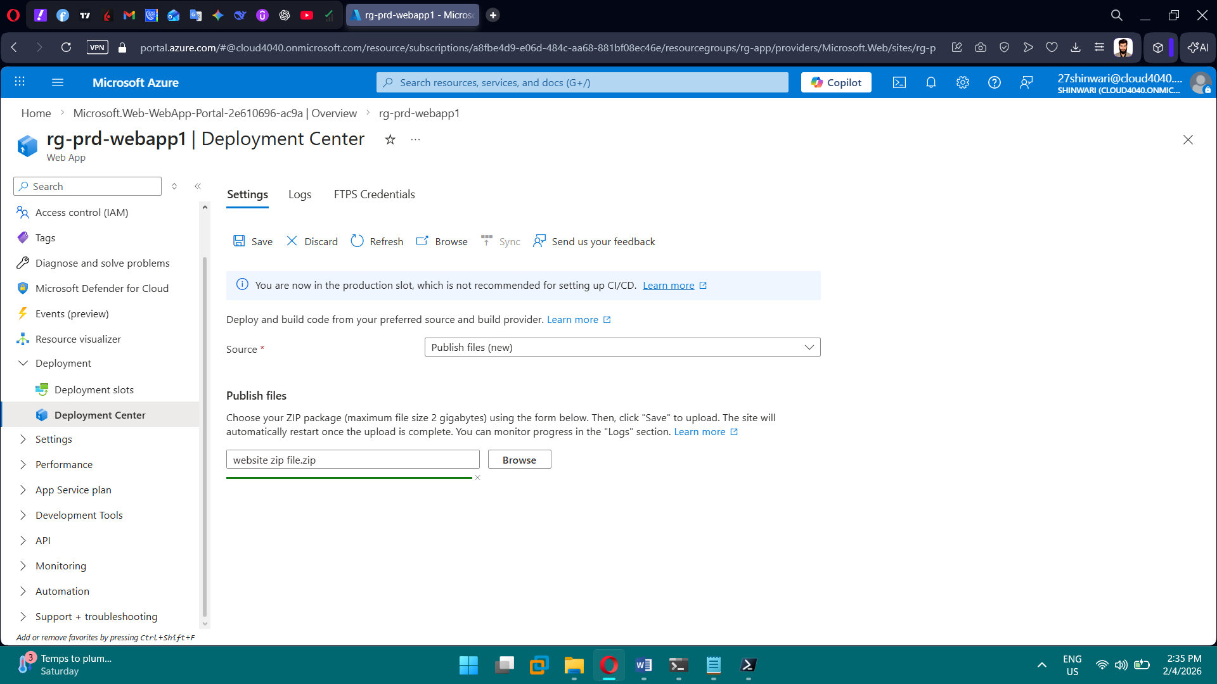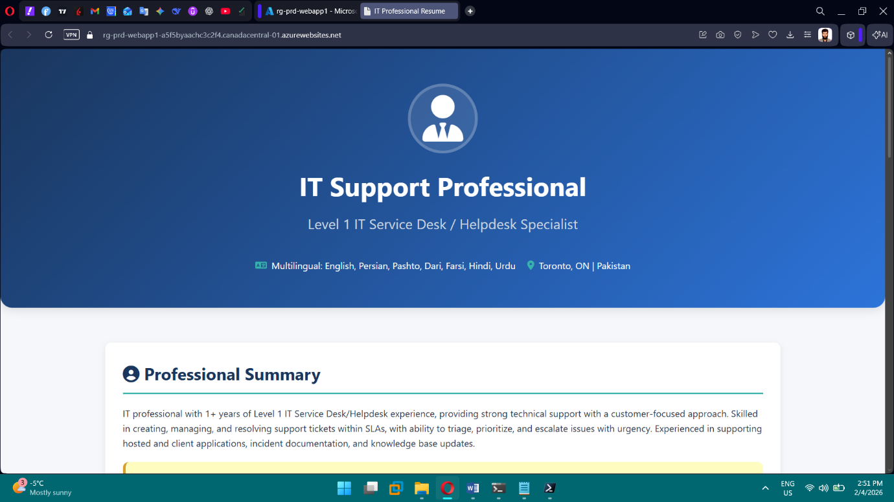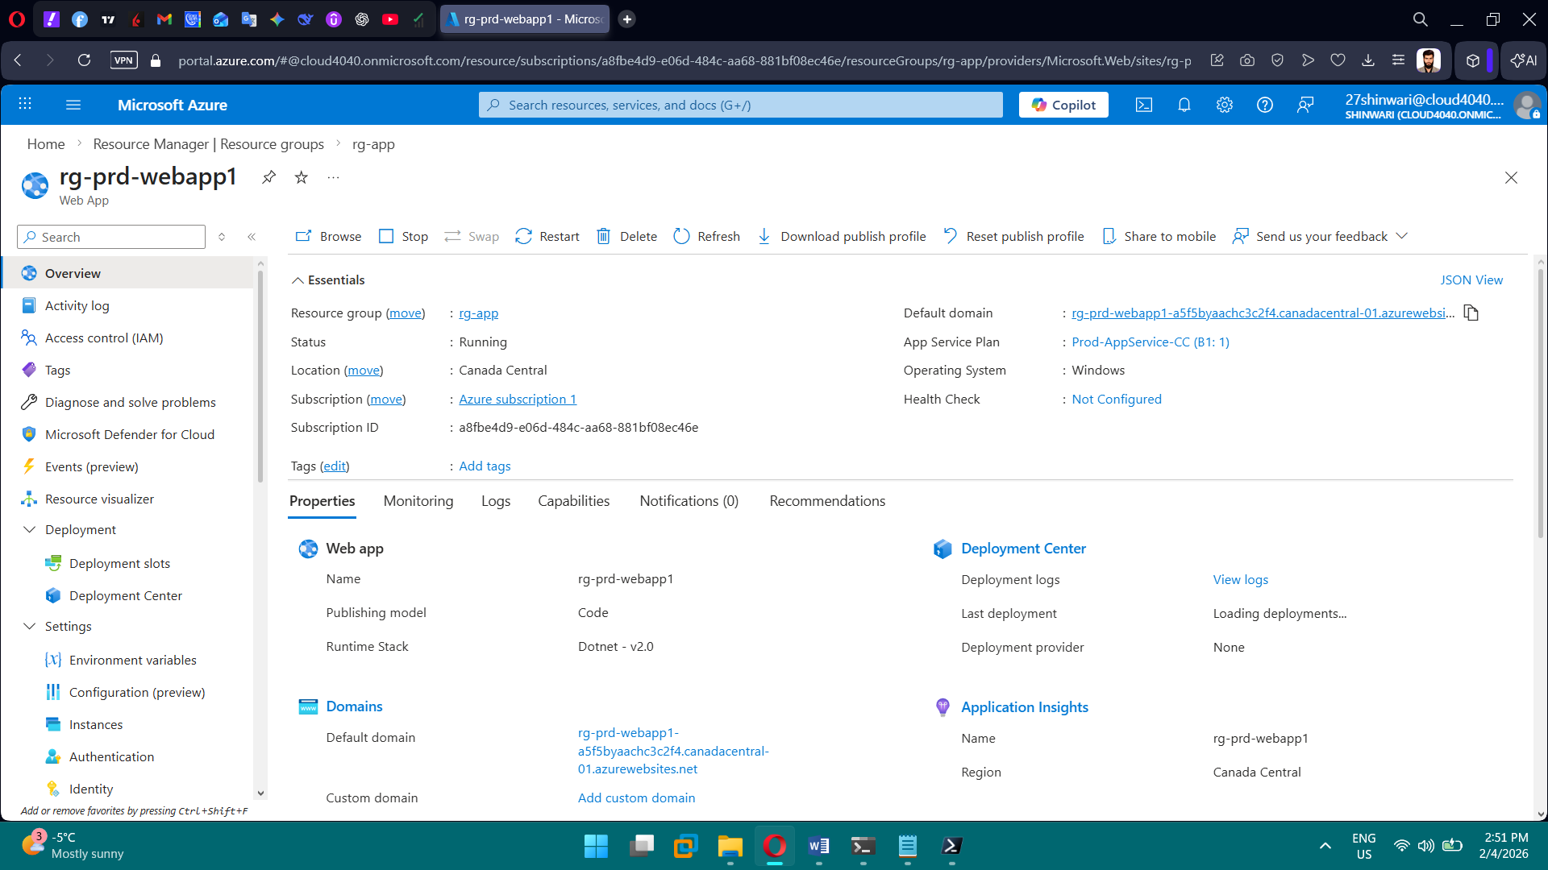

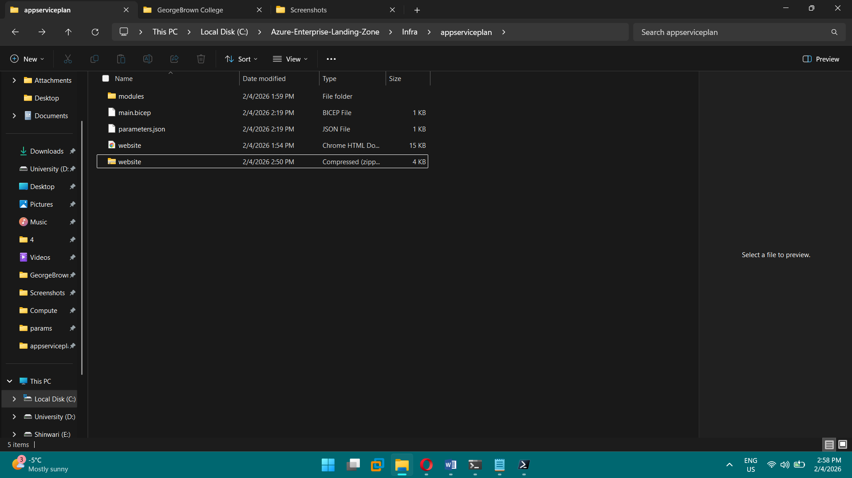

**PHASE 7 — Storage & Data**

**Tasks**

1. Create storage accounts per department
2. Storage accounts per department.
3. GRS enabled.
4. Soft delete enabled.
5. Versioning enabled.
6. Backup enabled.
7. Secure access.

**Brief Explanation:** In Phase 7, we deployed multiple Azure Storage Accounts using Bicep, organized by department (IT, Sales, Marketing, and HR).  
All storage accounts were created in a single resource group and region for consistency and easier management.  
Geo-Redundant Storage (GRS) was enabled to provide high availability and disaster recovery.  
We configured soft delete for Blob Storage through the Azure Portal to protect against accidental data loss.  
We reviewed Azure Backup and confirmed it applies to Azure File Shares, not Blob Storage.  
This phase established a secure, resilient, and enterprise-ready storage layer for the landing zone.

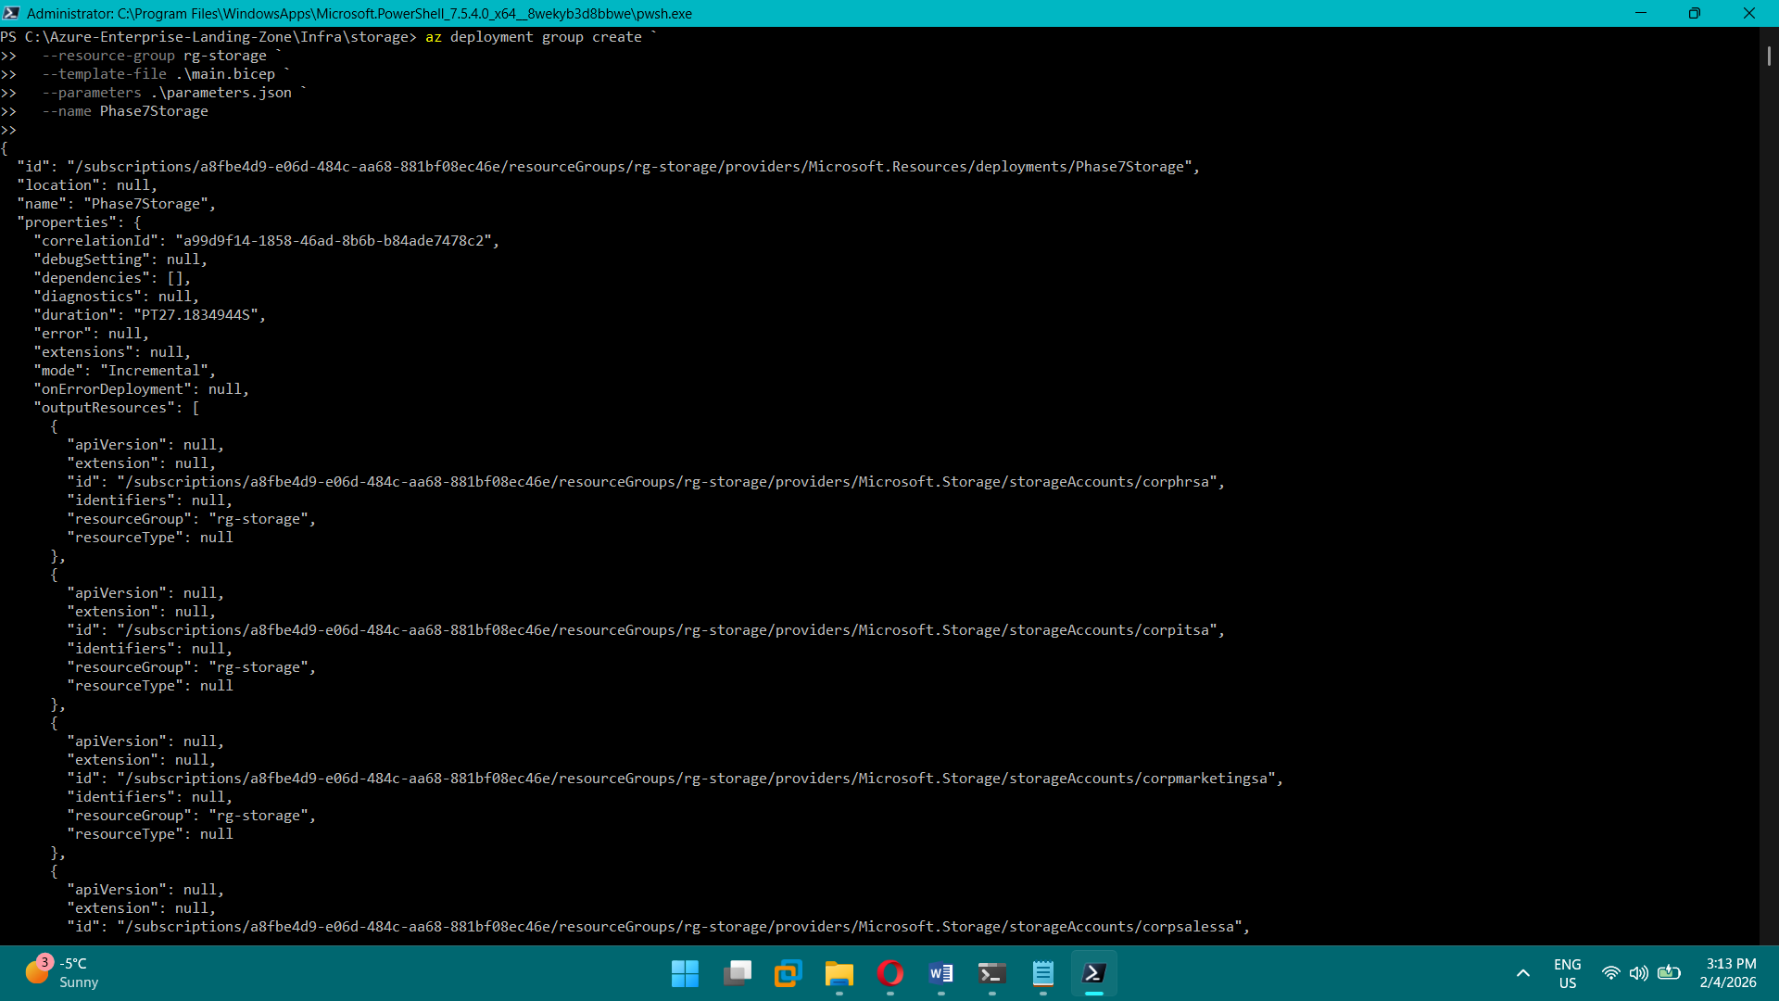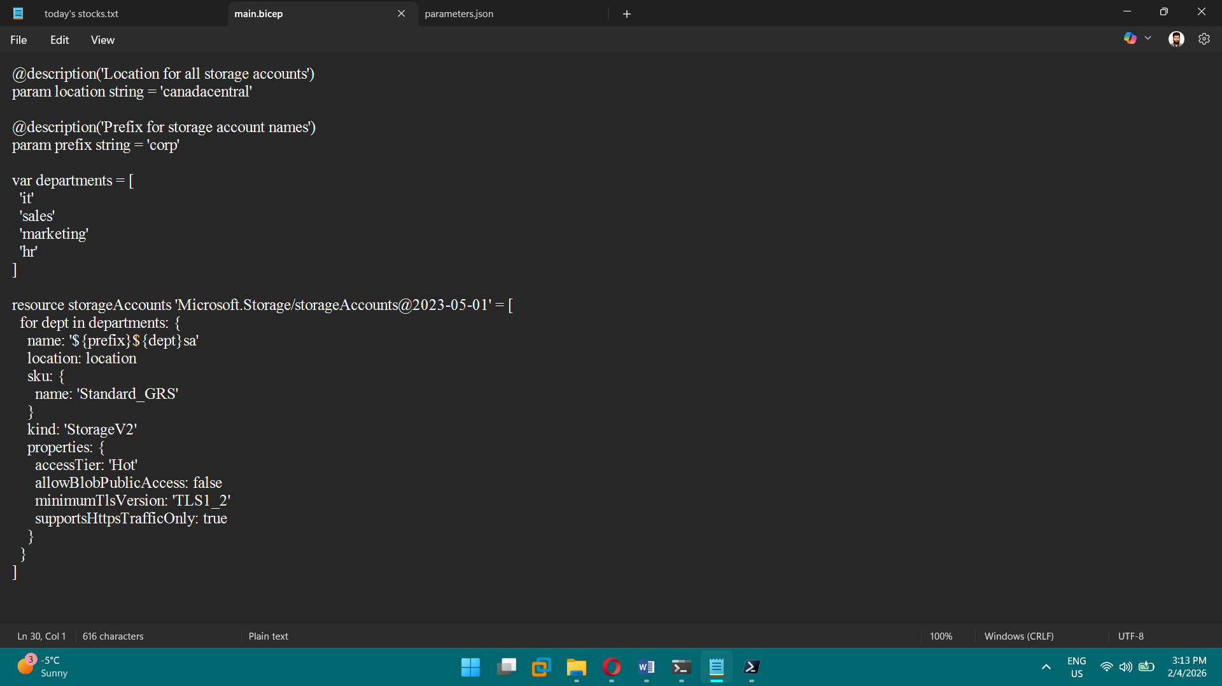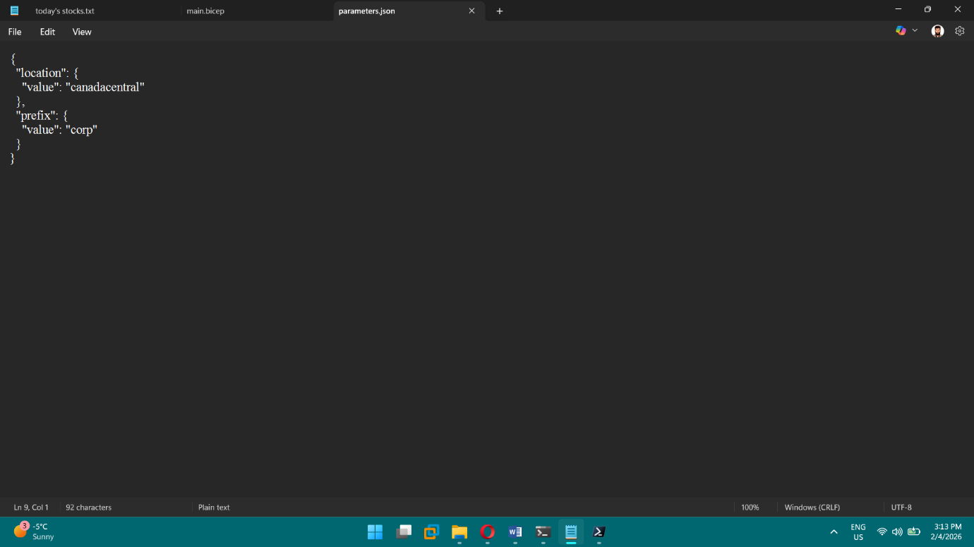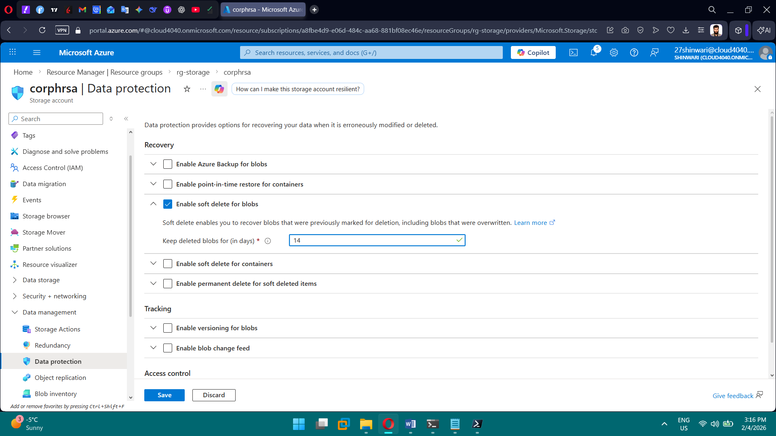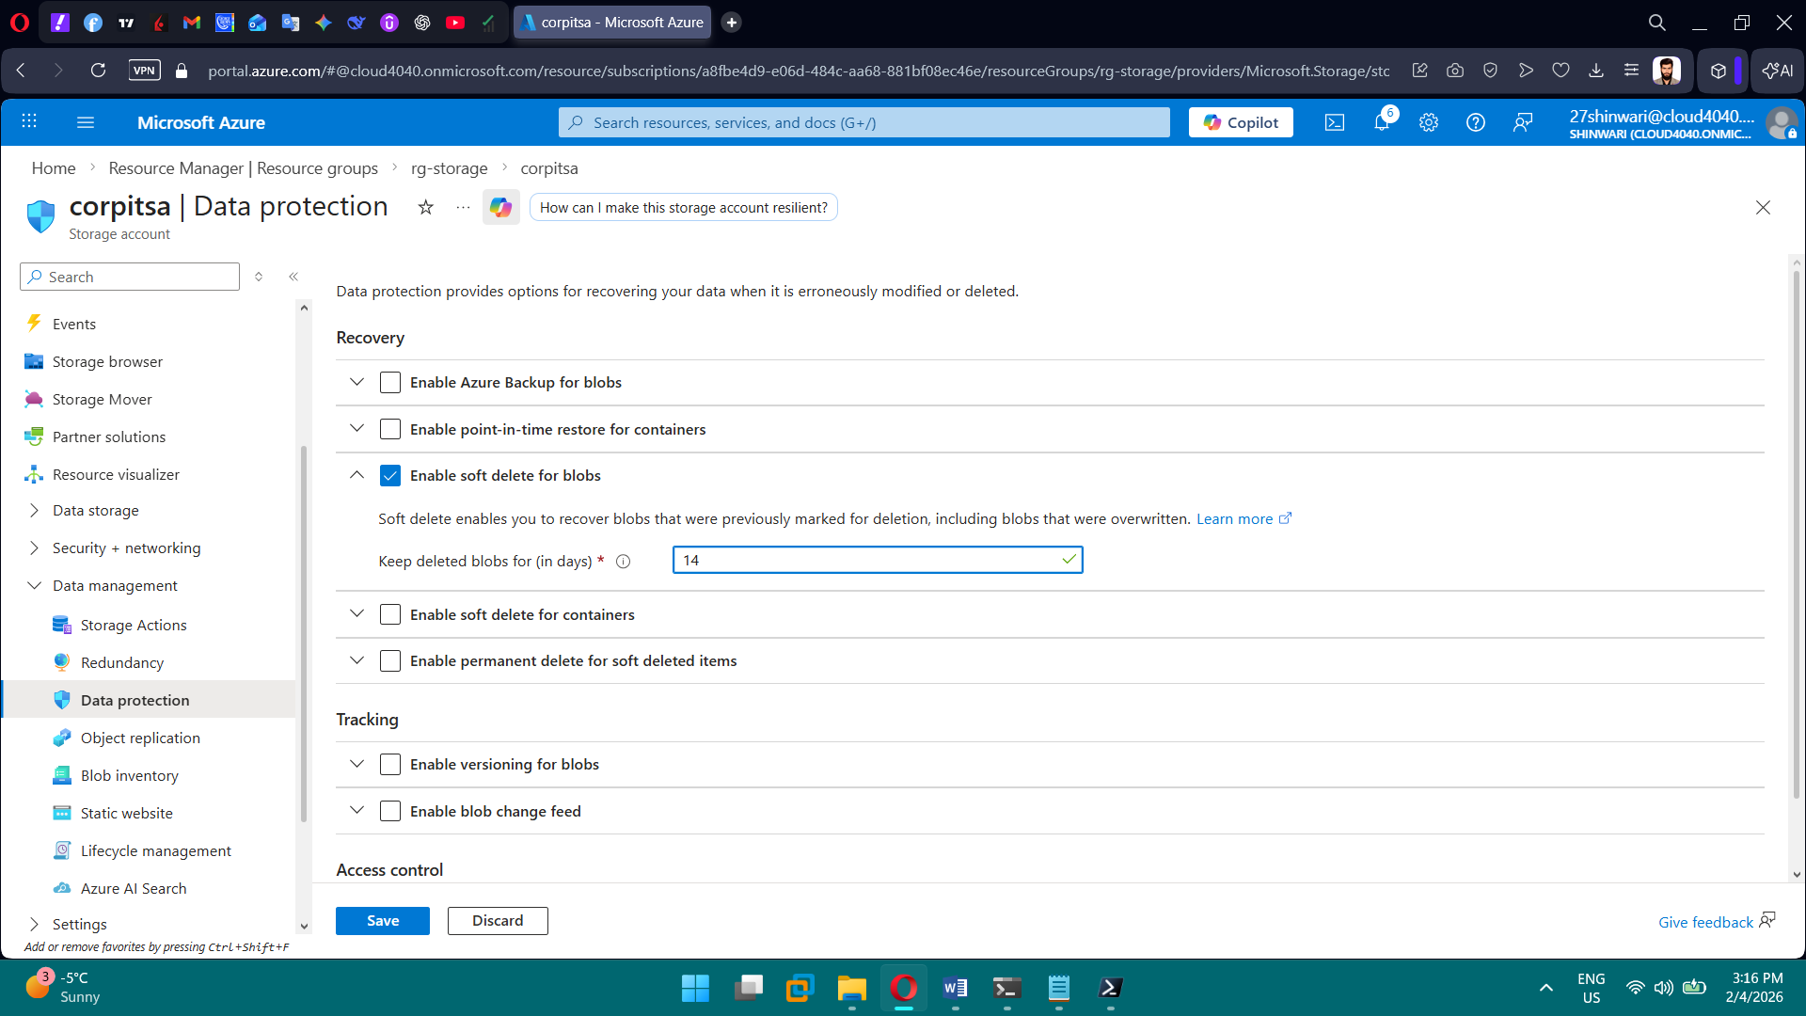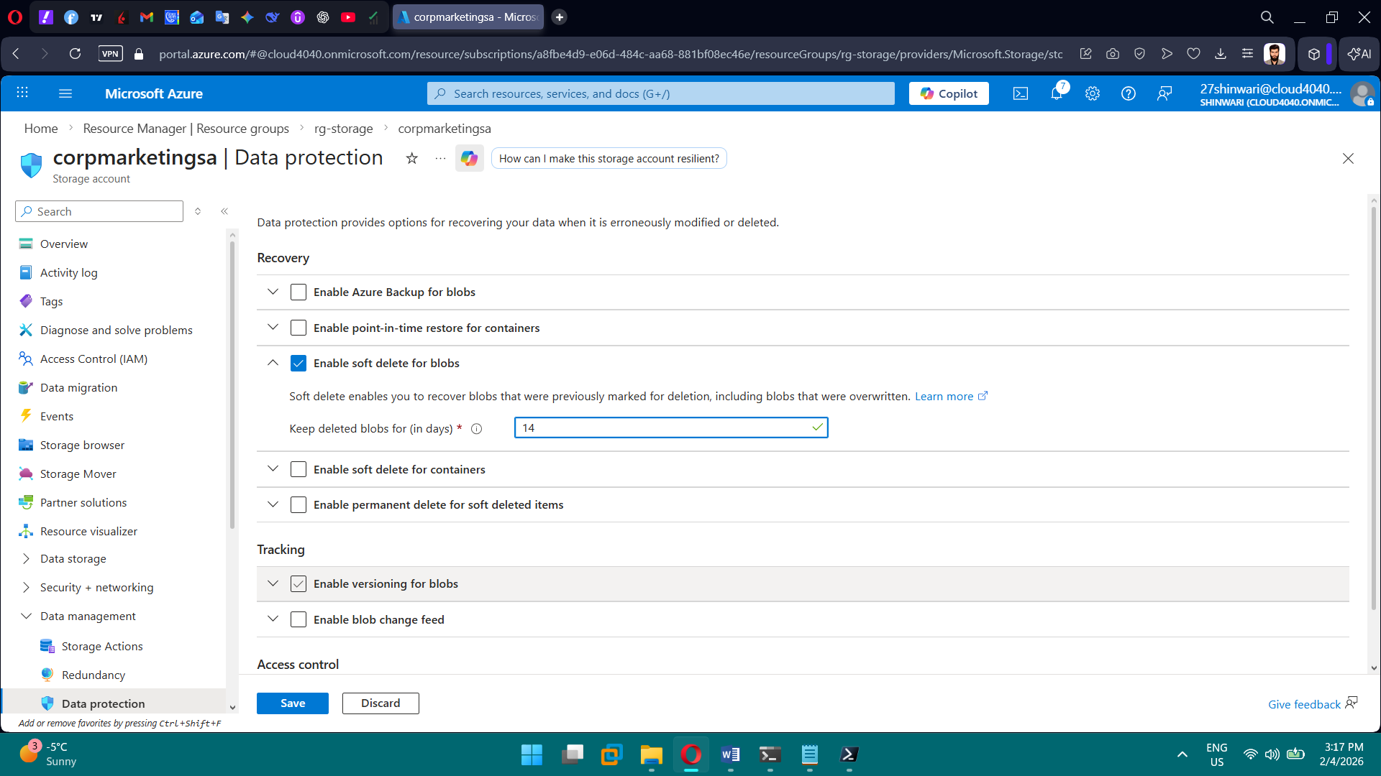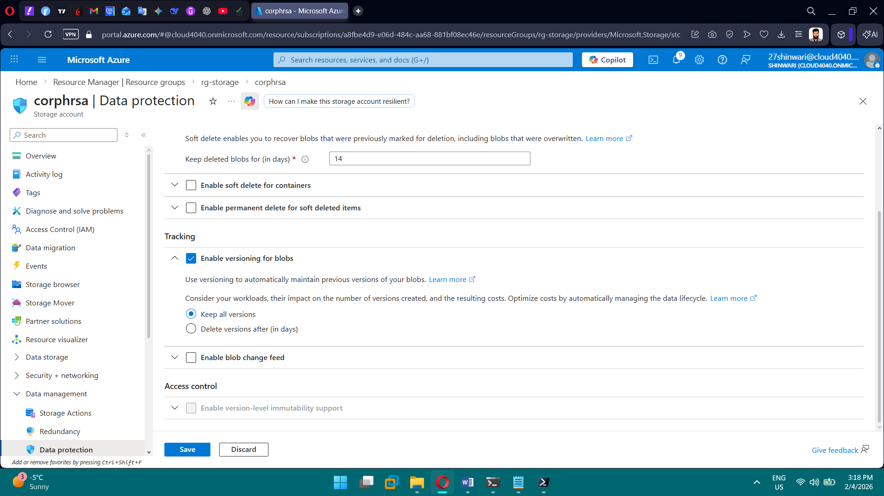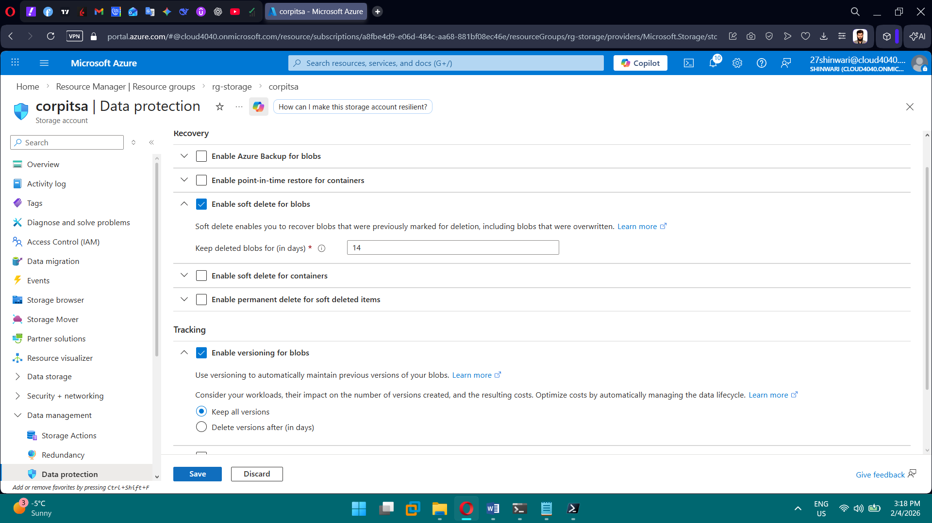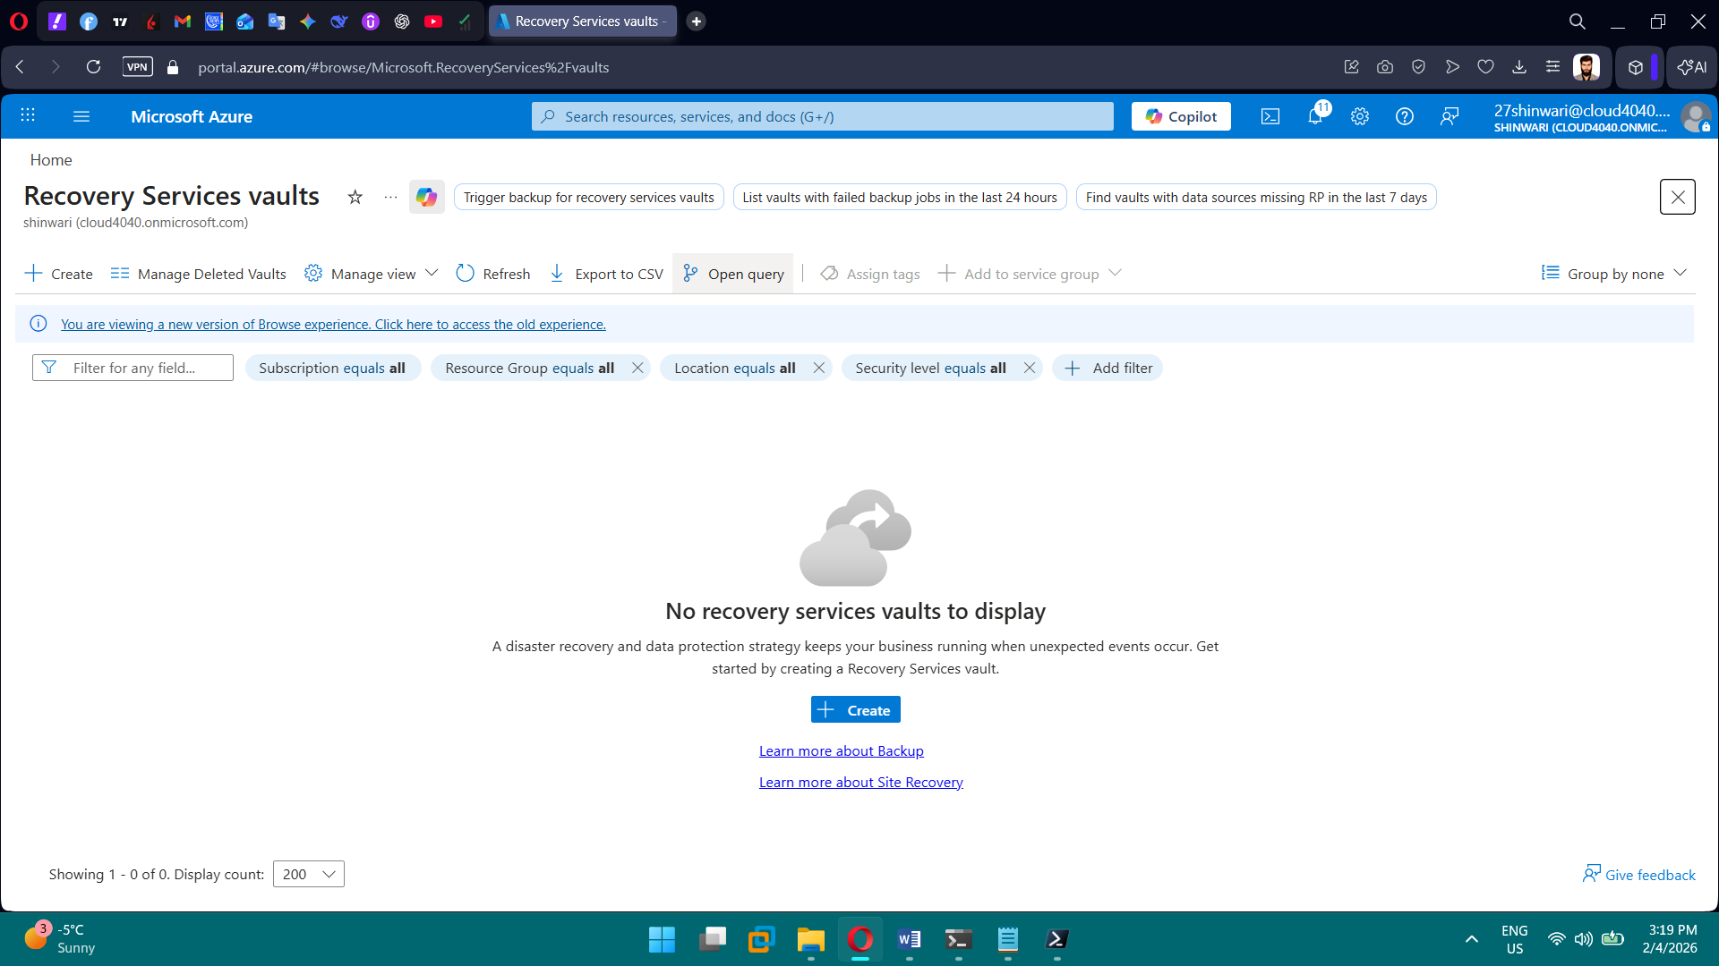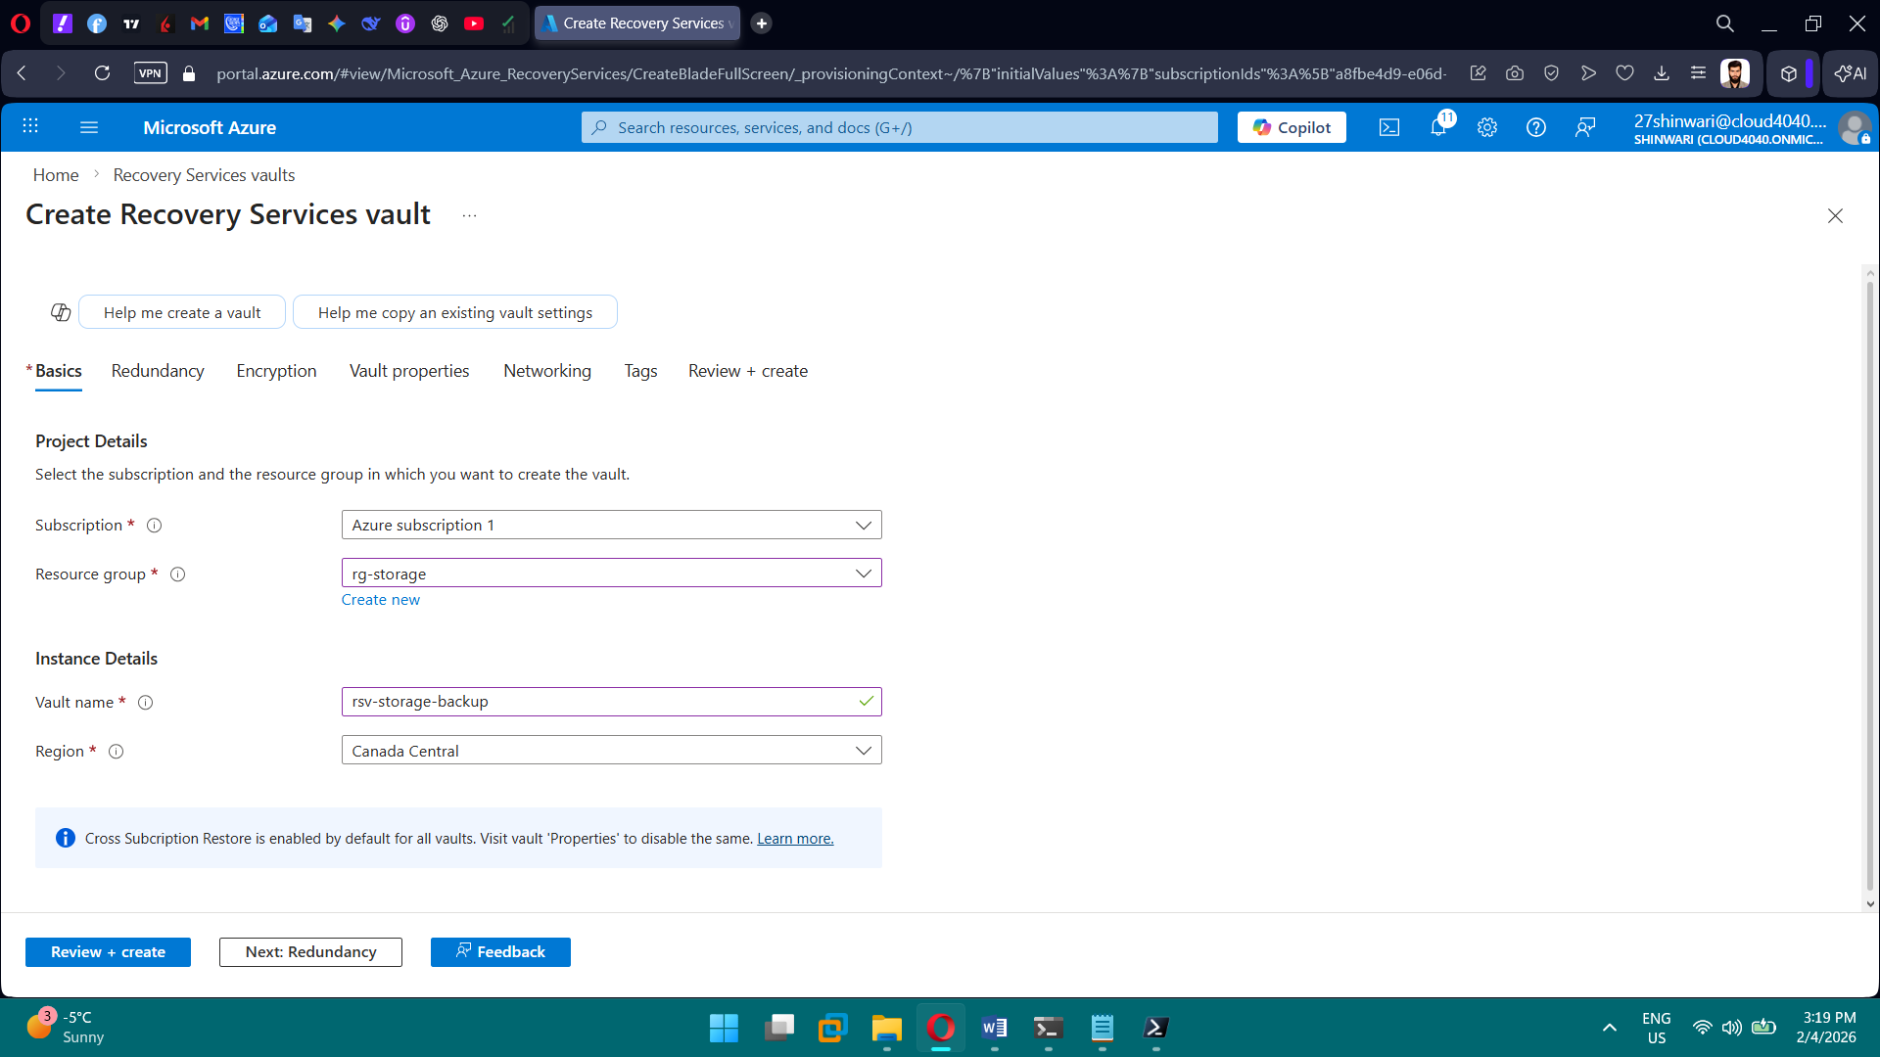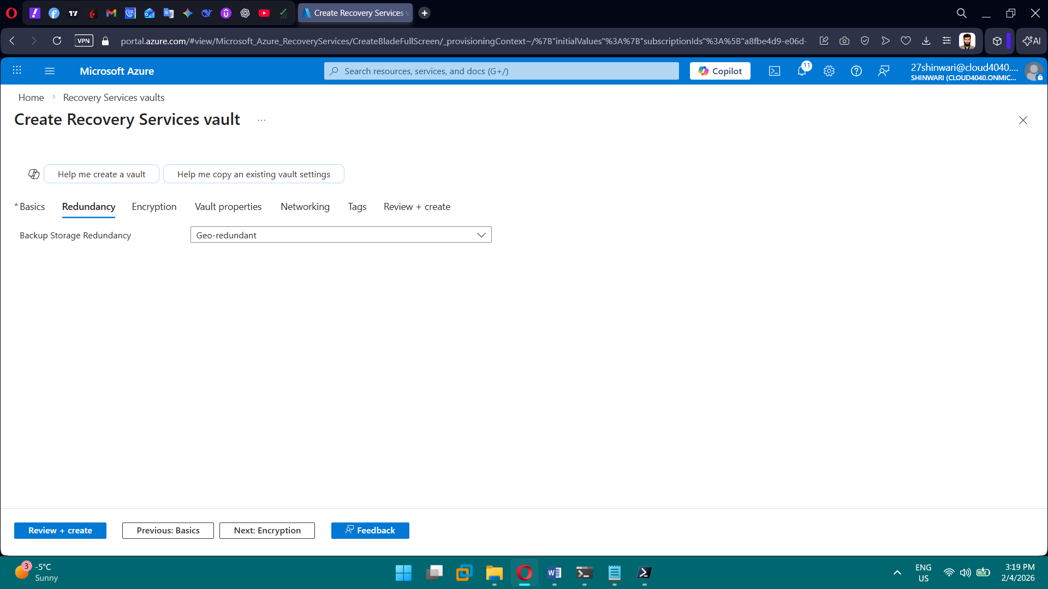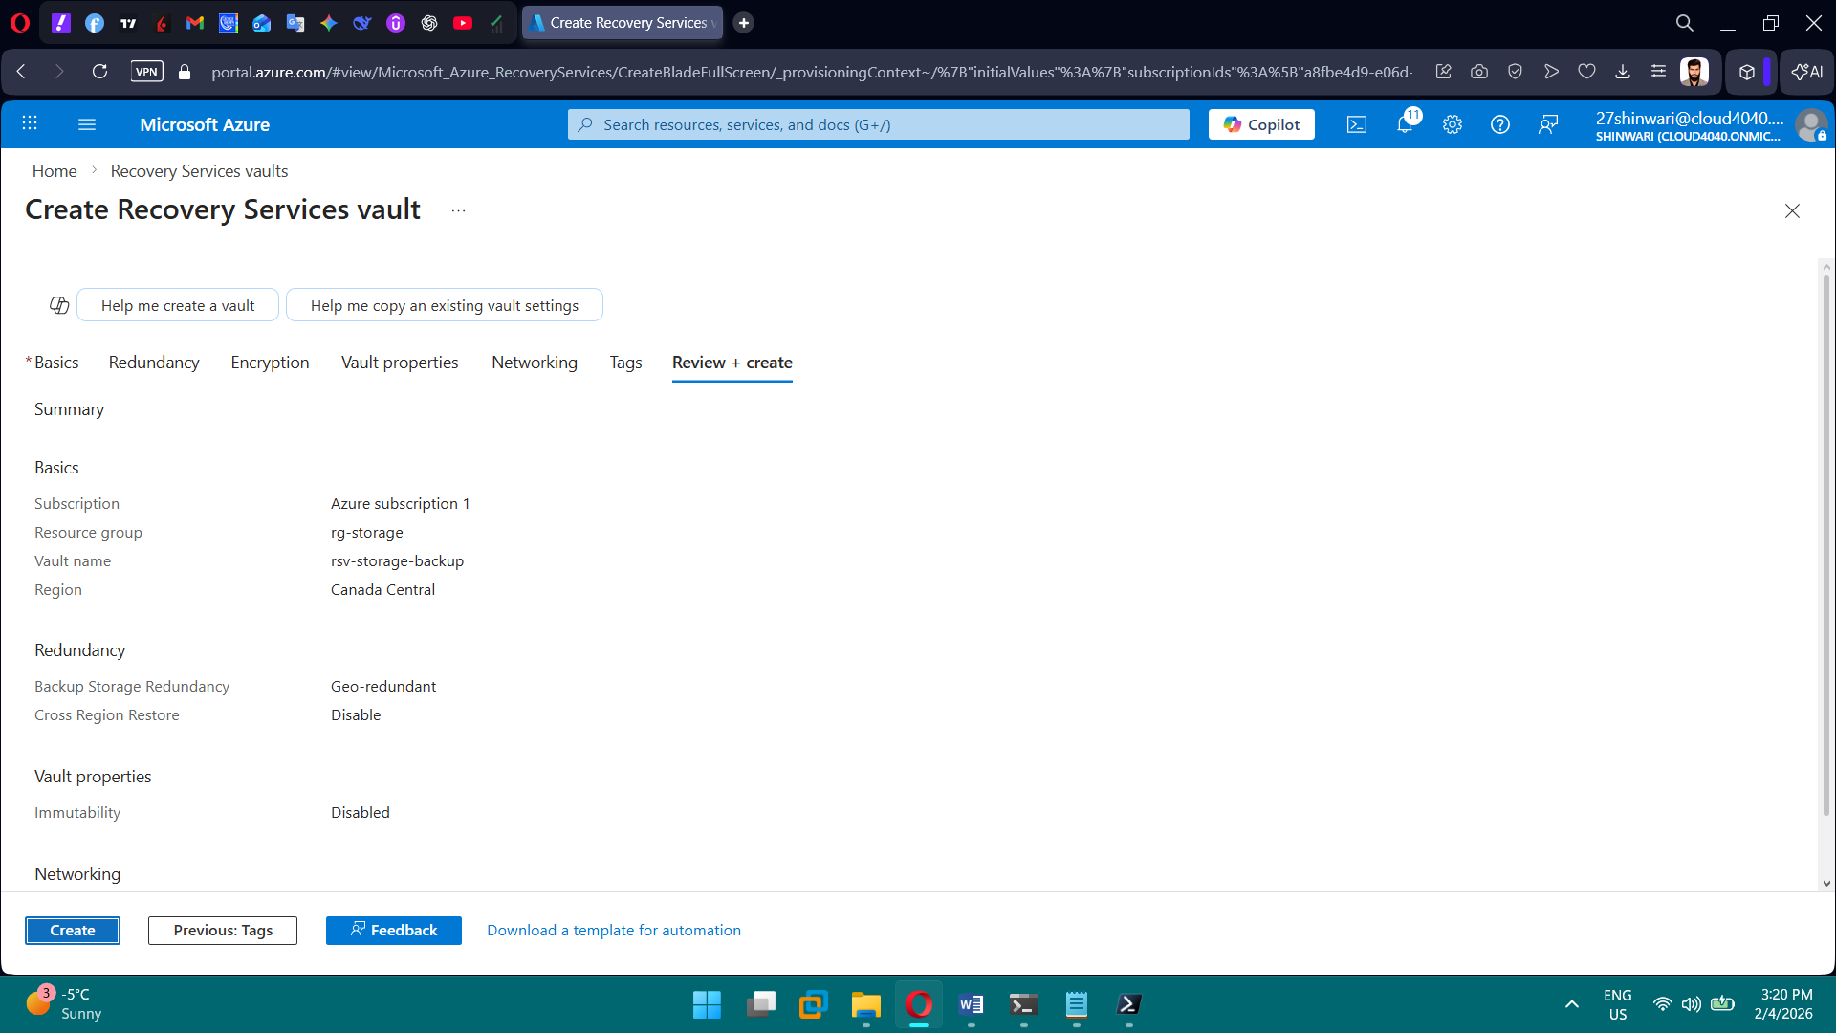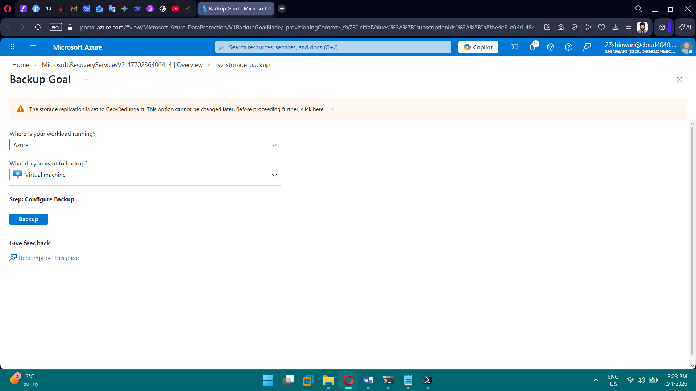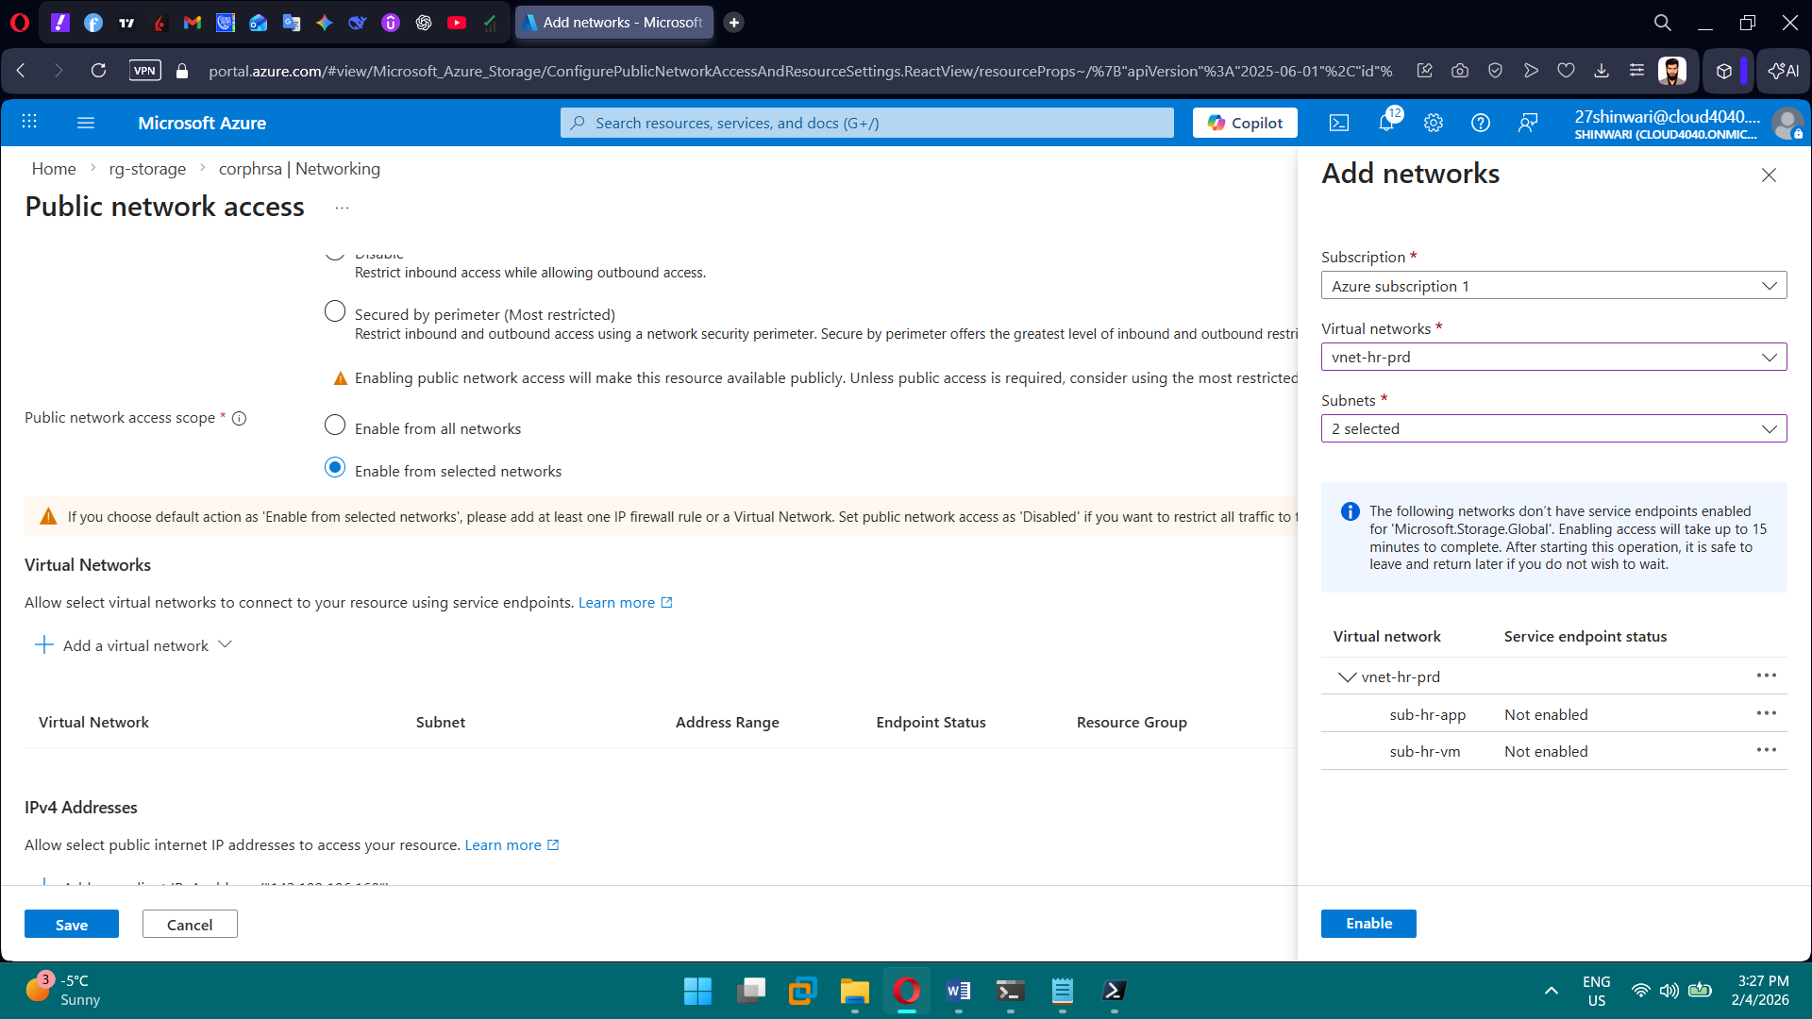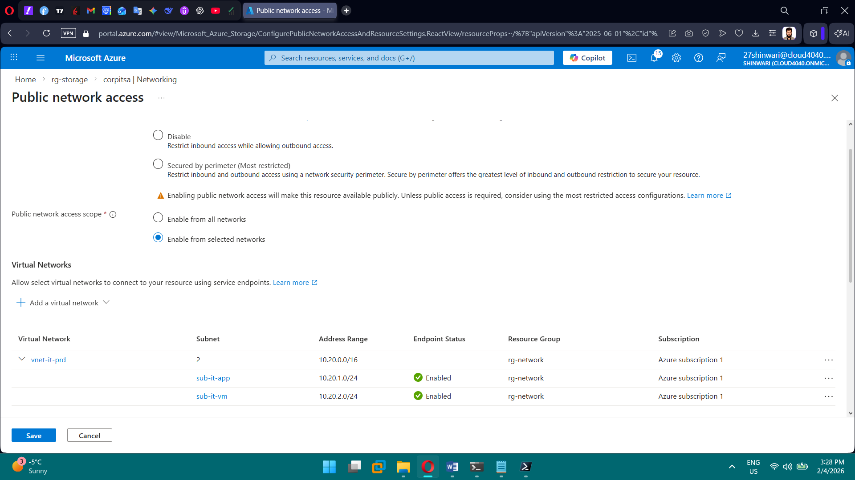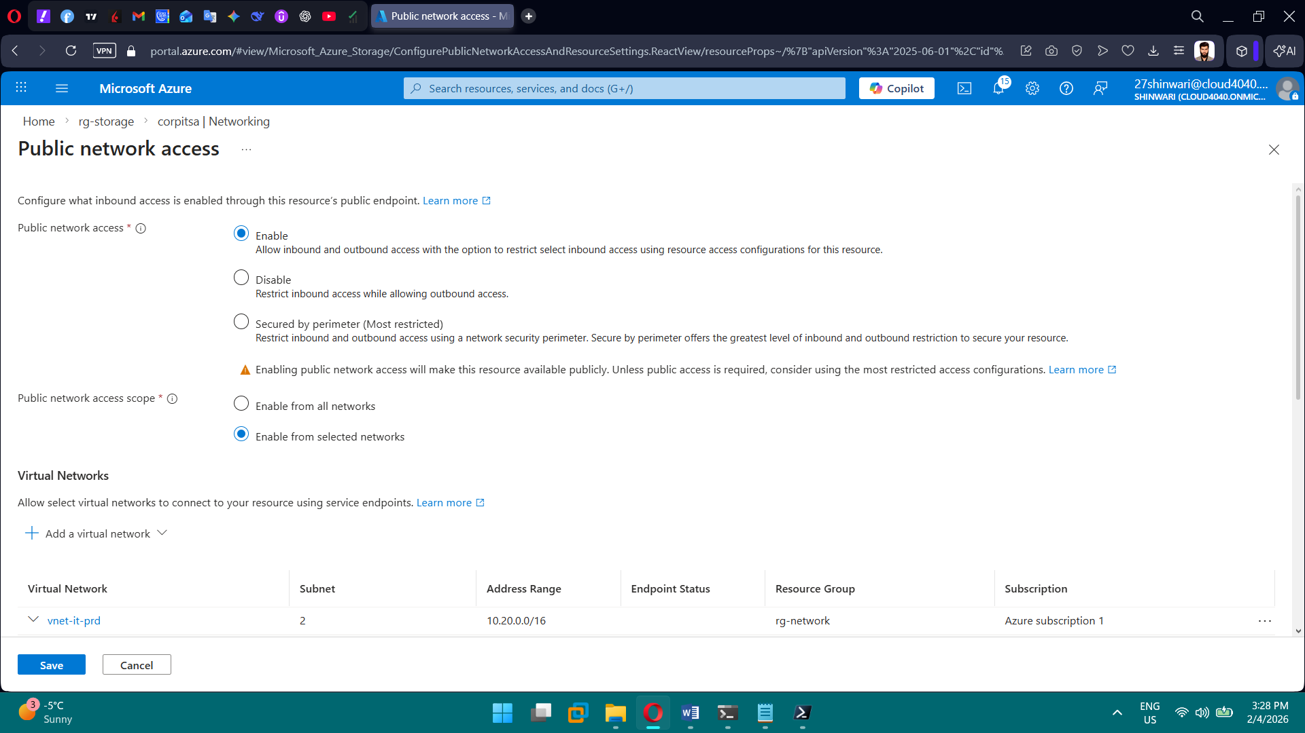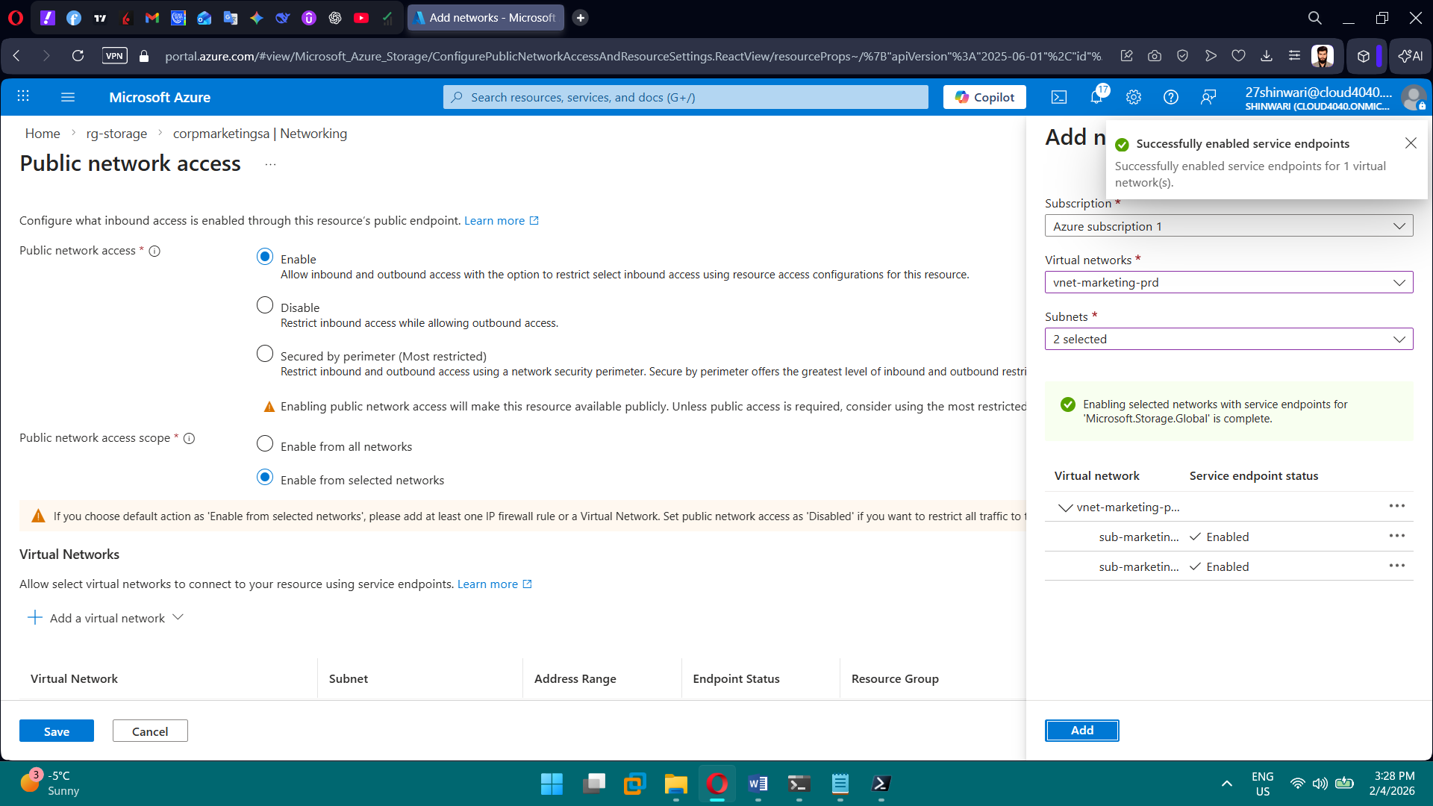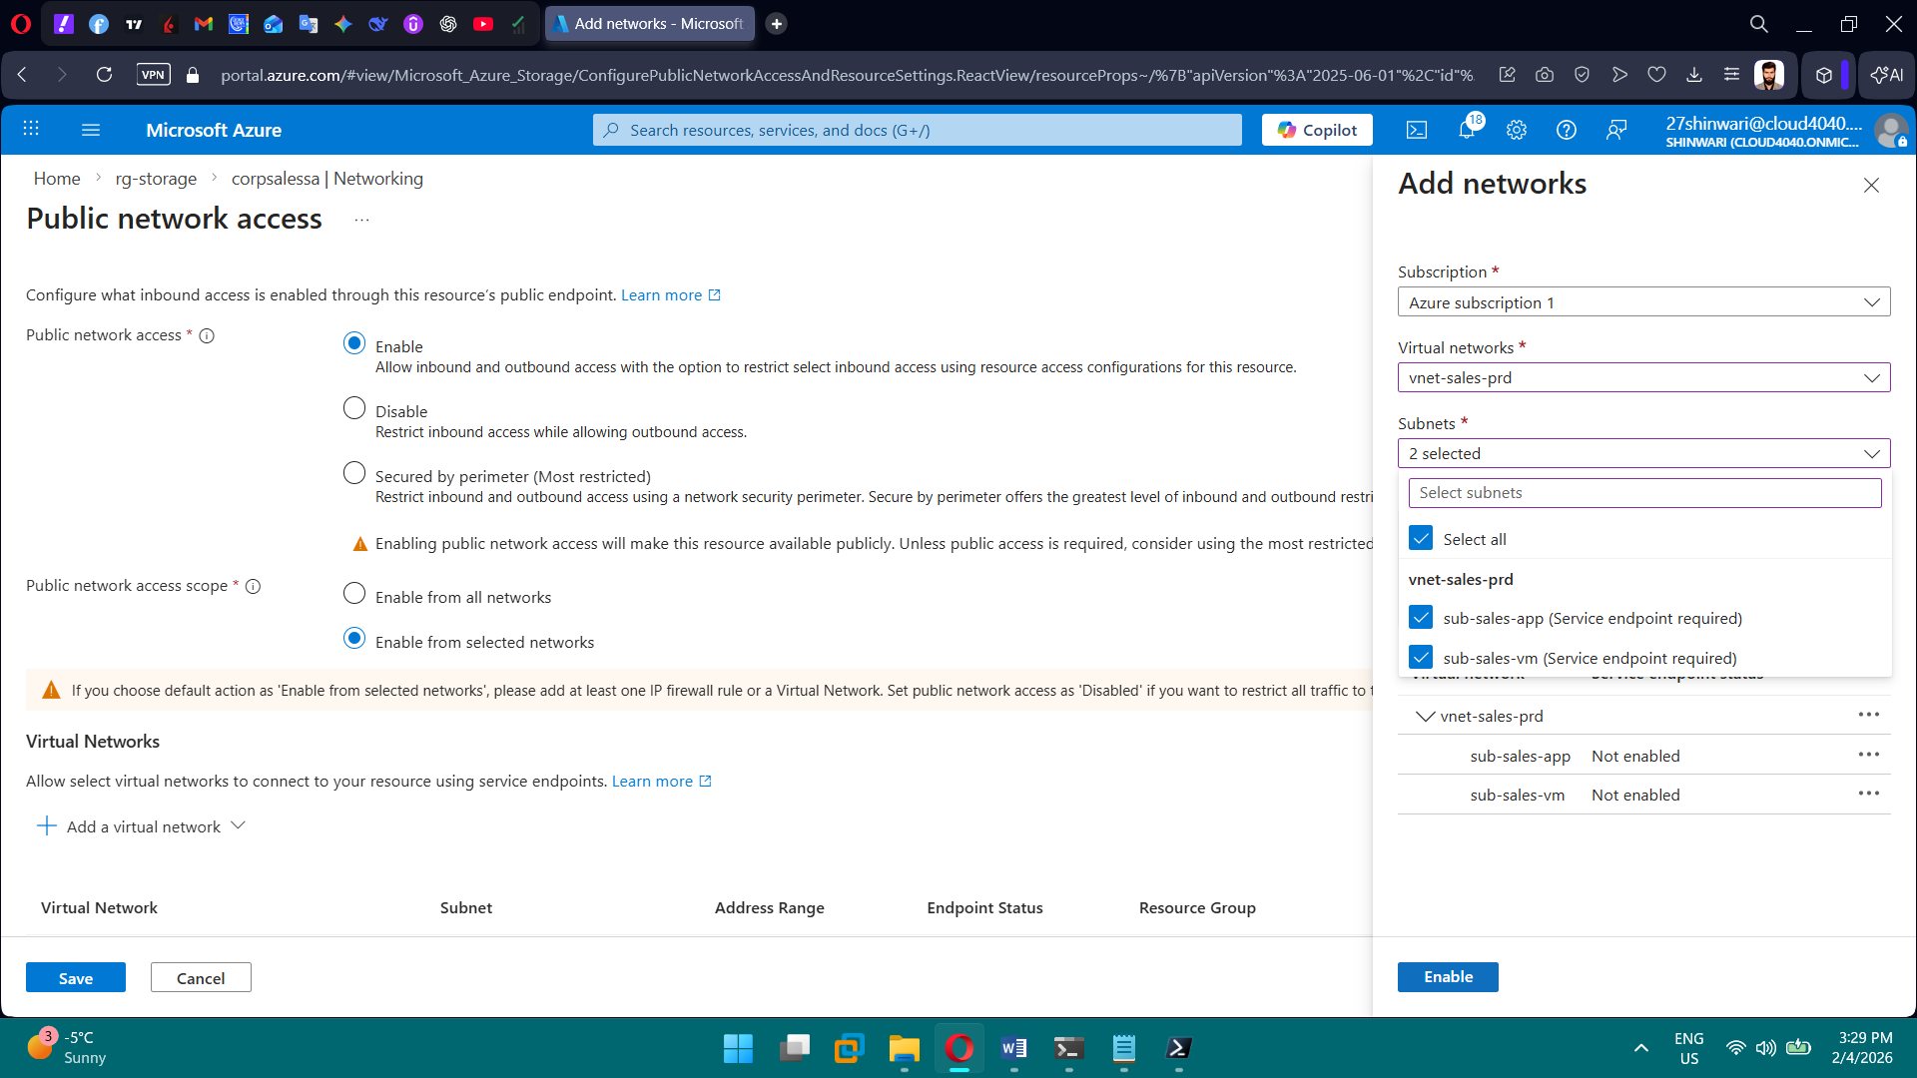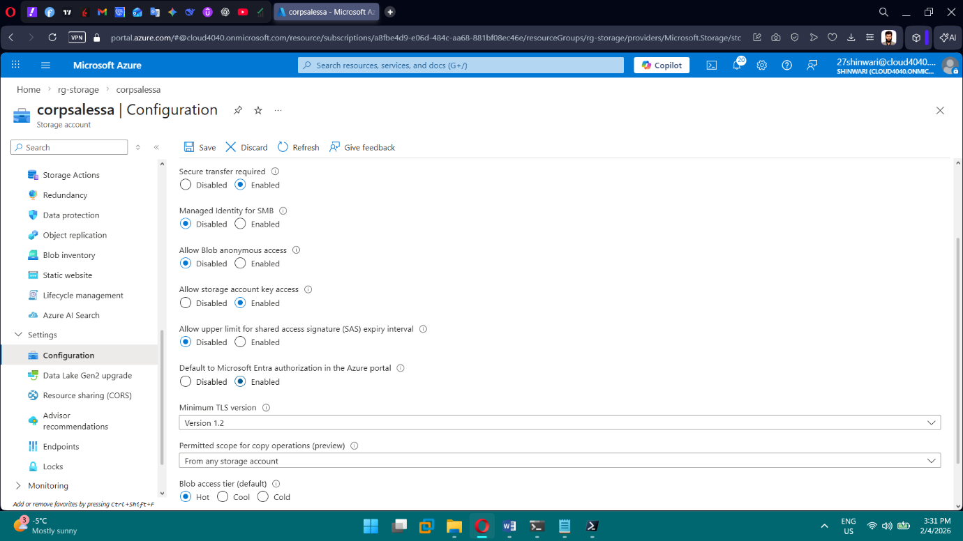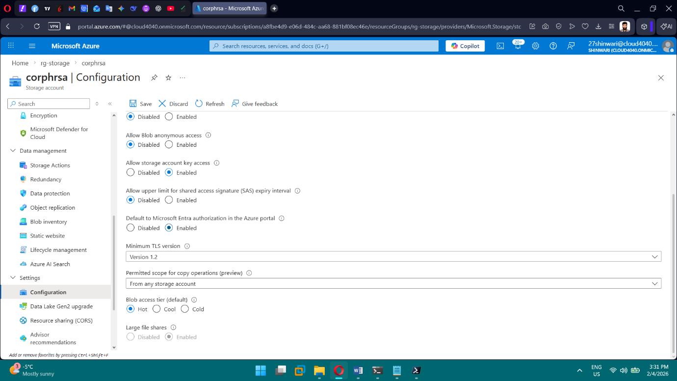

**PHASE 8 — Key Vault & Secrets**

**Tasks**

1. Create Key Vault
2. Enable RBAC
3. Enable soft delete
4. Enable purge protection
5. Store app secrets
6. Connect apps using managed identity

**Brief Explanation:**

We implemented Azure Key Vault as part of the security foundation using Infrastructure as Code.  
The Key Vault was deployed with Azure RBAC enabled, avoiding legacy access policies.  
Soft delete and purge protection were enforced to prevent accidental or malicious data loss.  
Application secrets were securely stored in the vault instead of being hardcoded.  
Applications were granted access using managed identities, eliminating the need for credentials.  
This setup ensures secure, compliant, and centralized secret management for the organization.

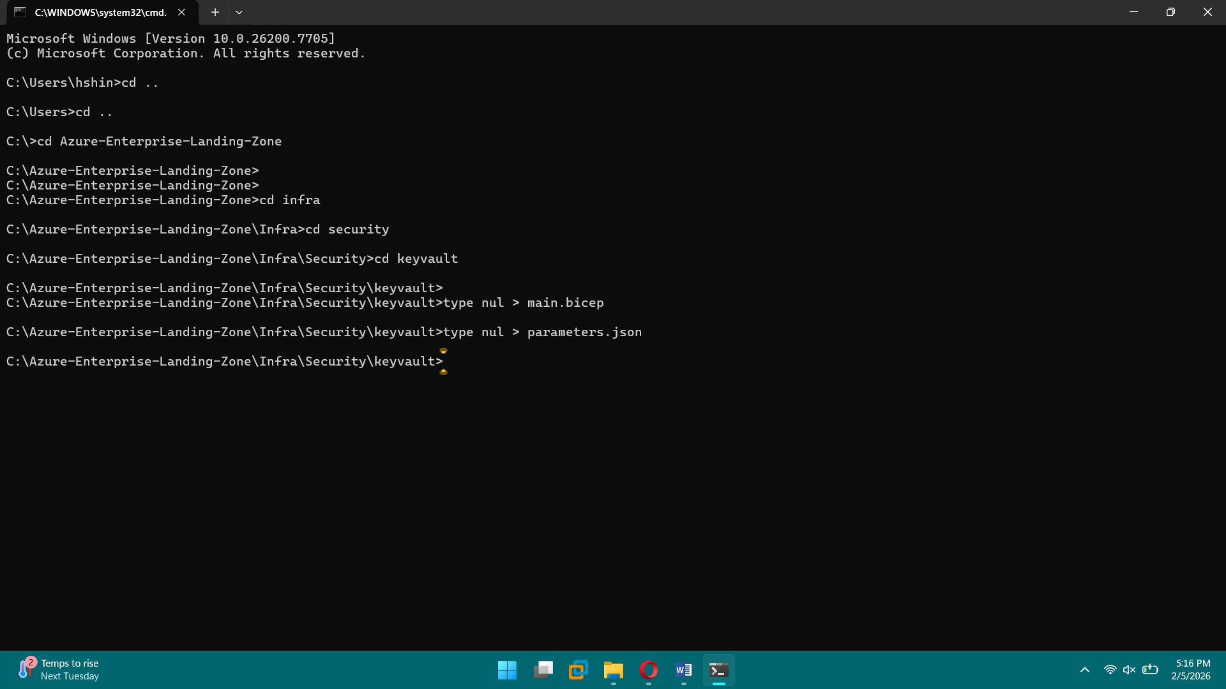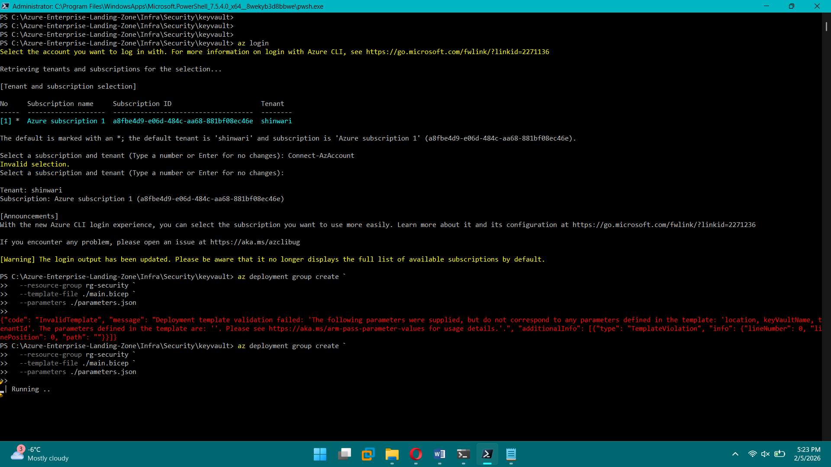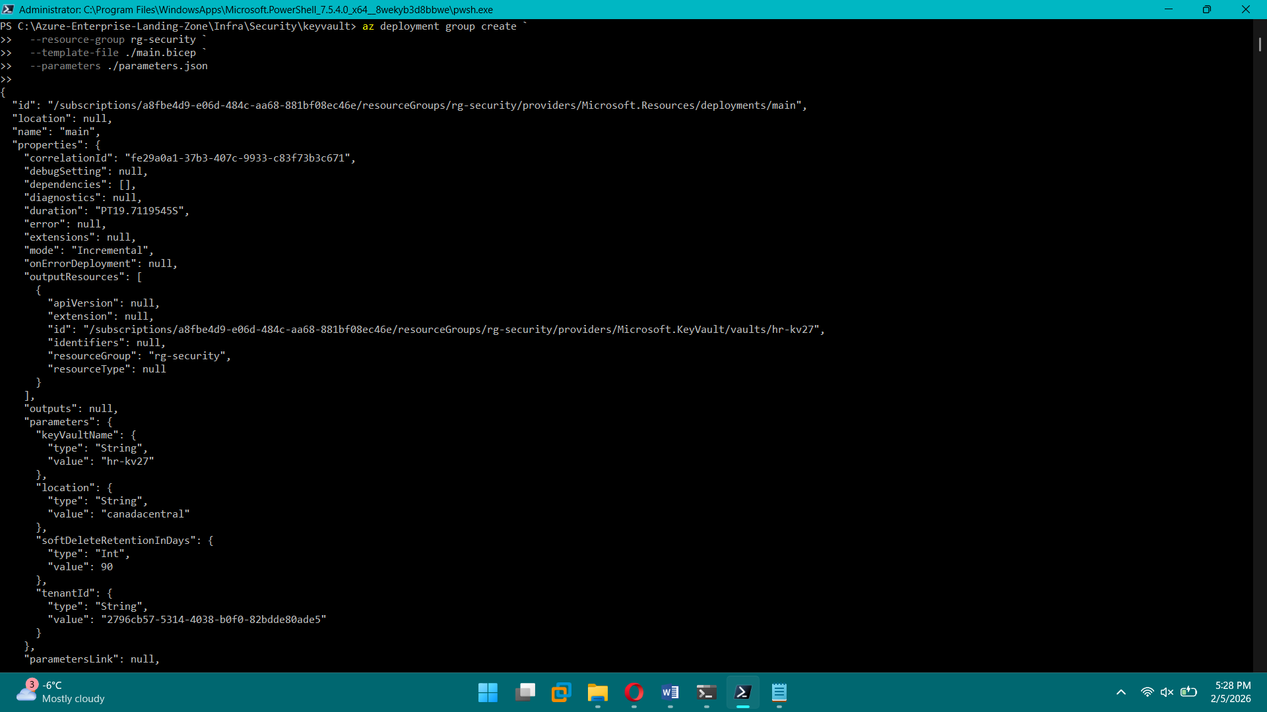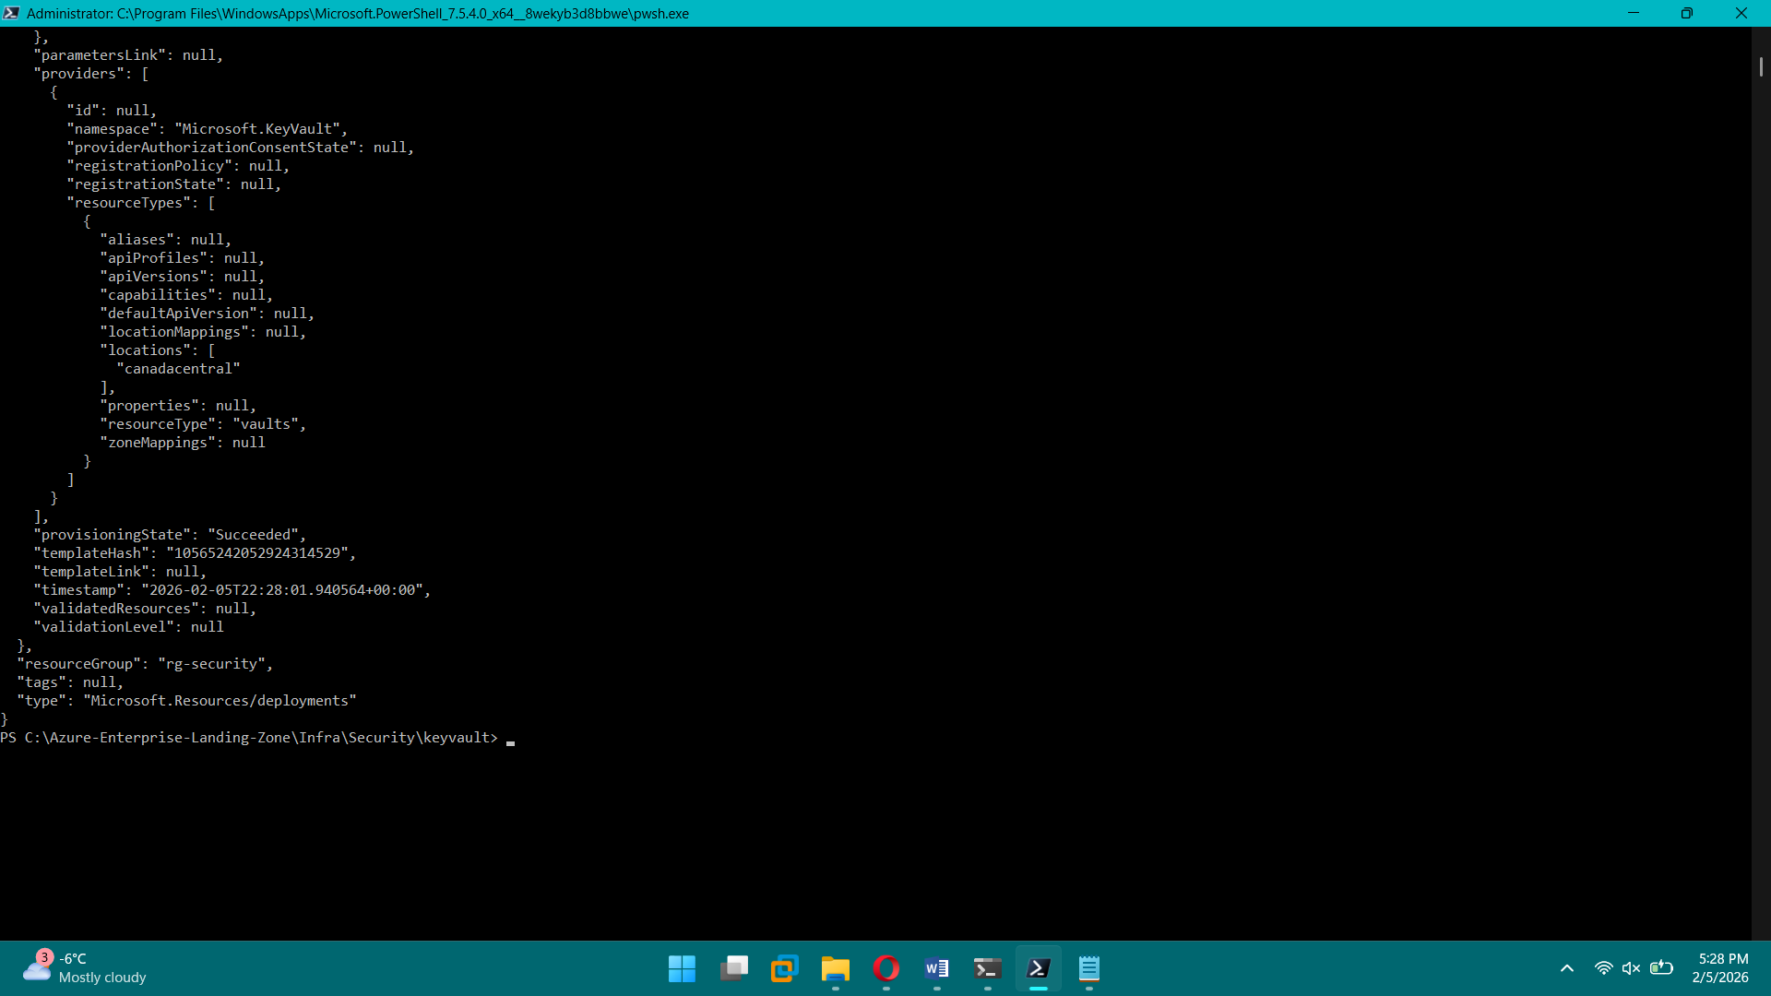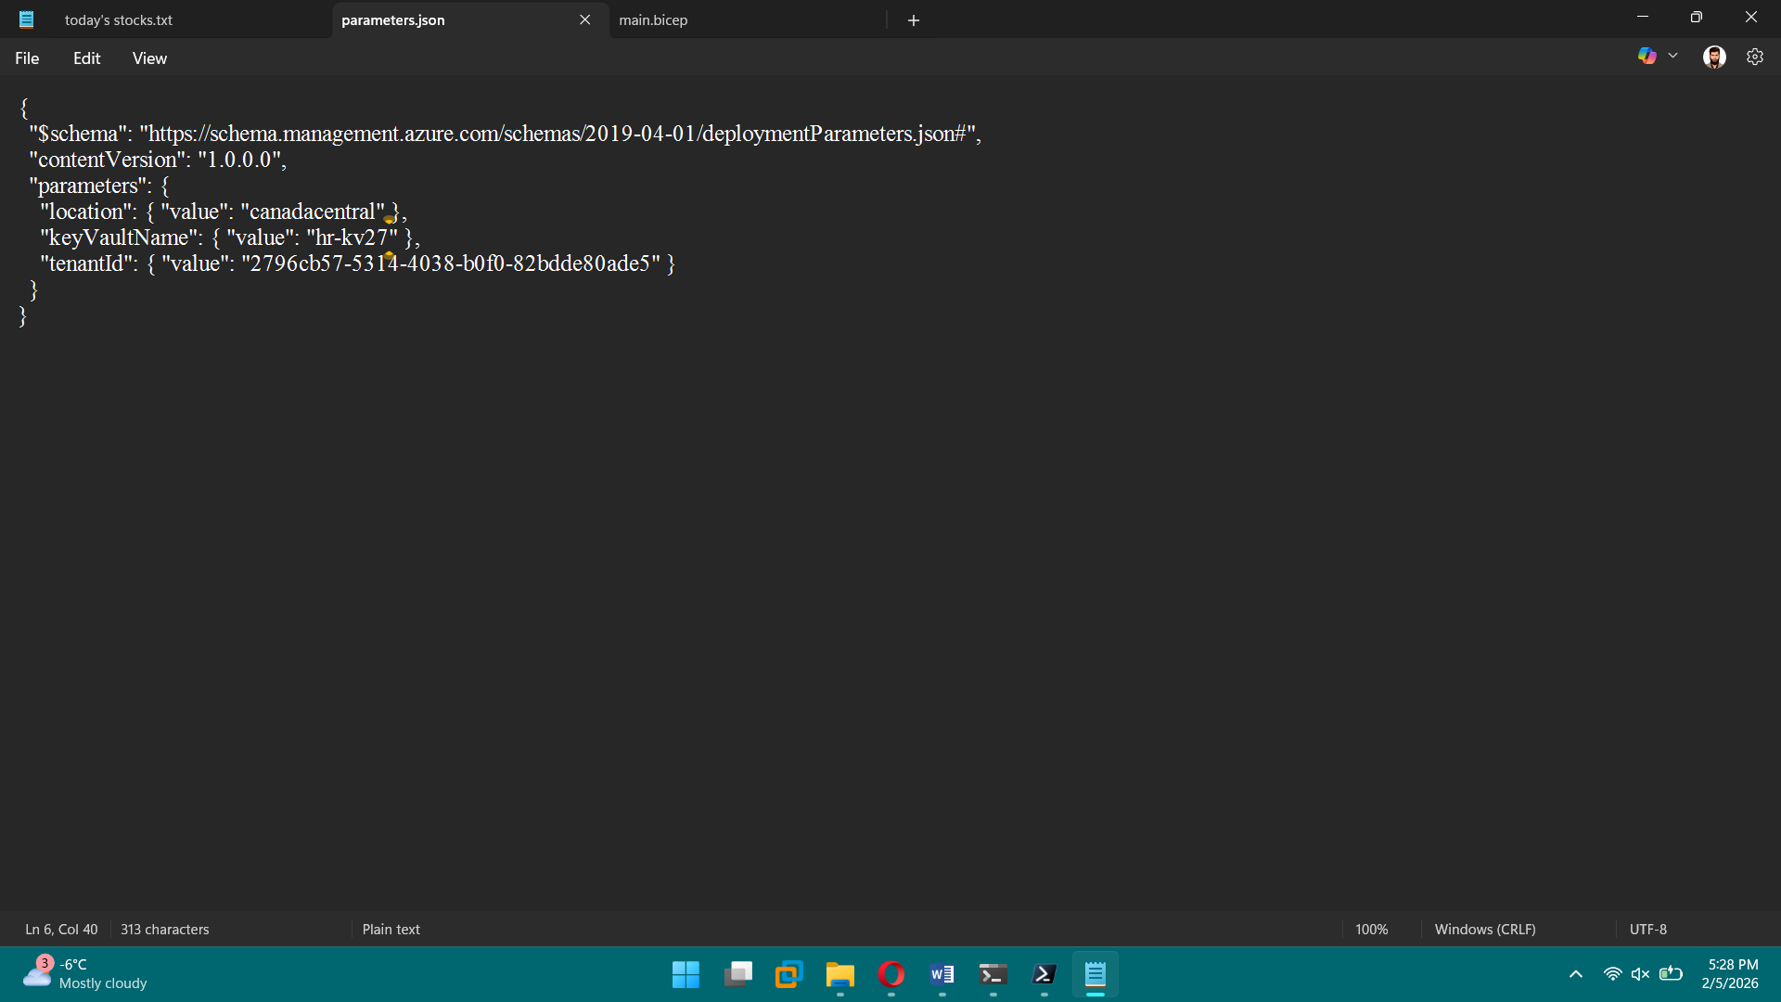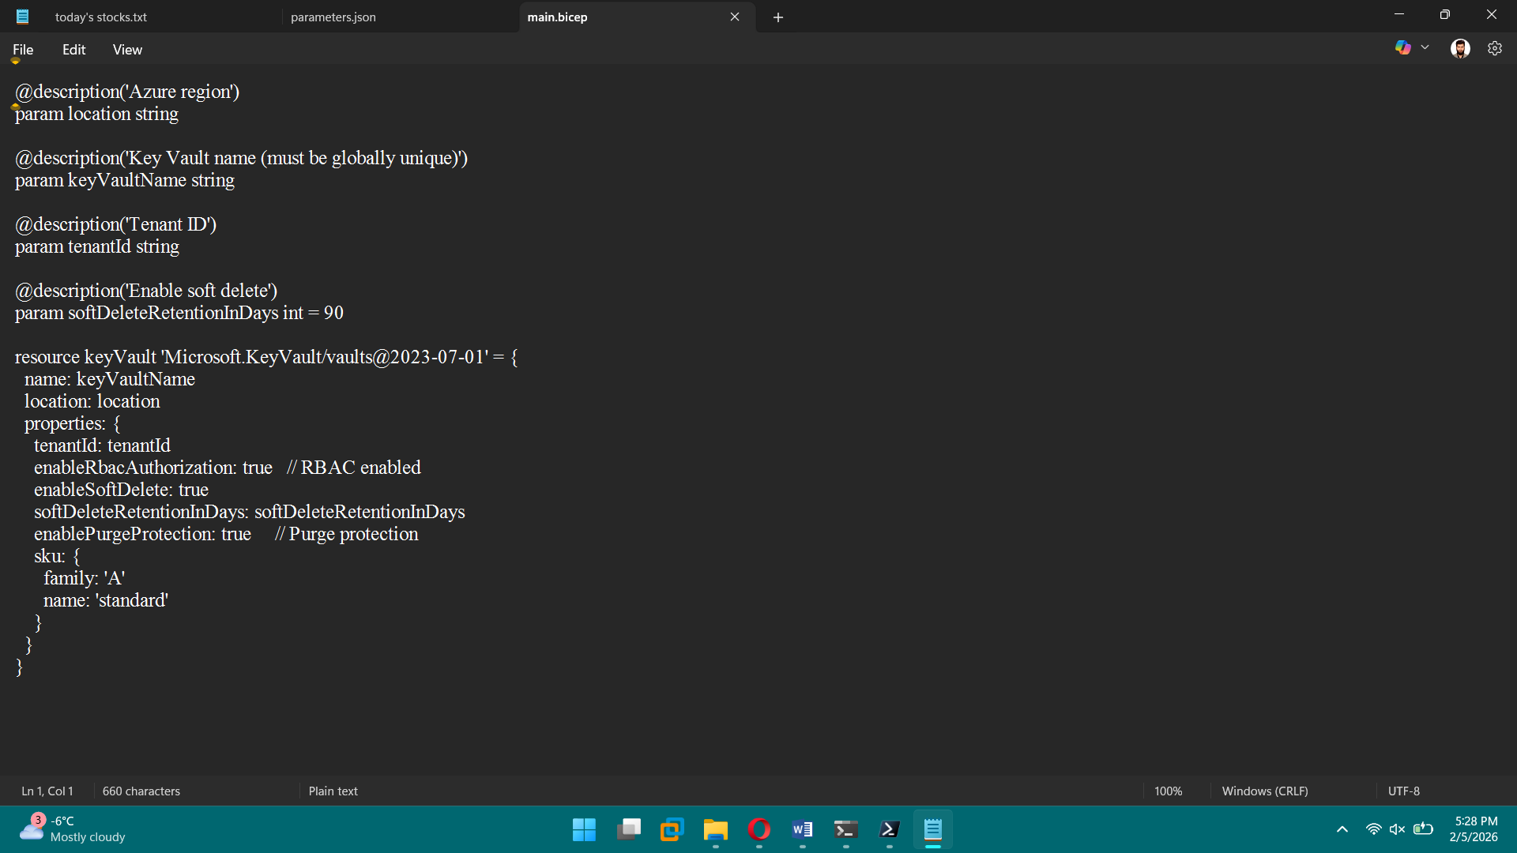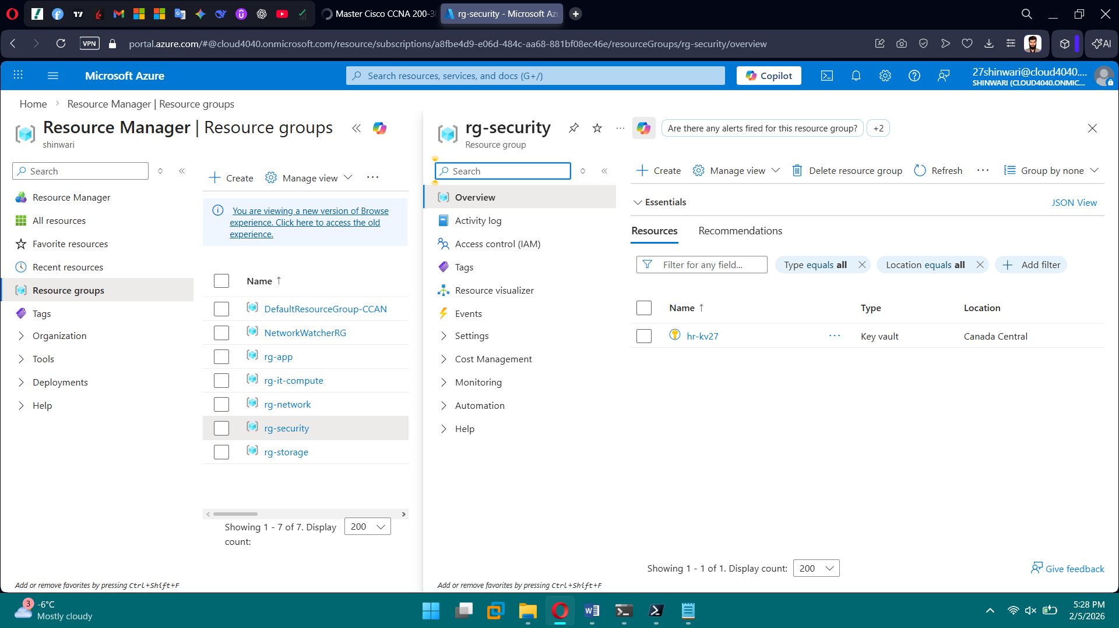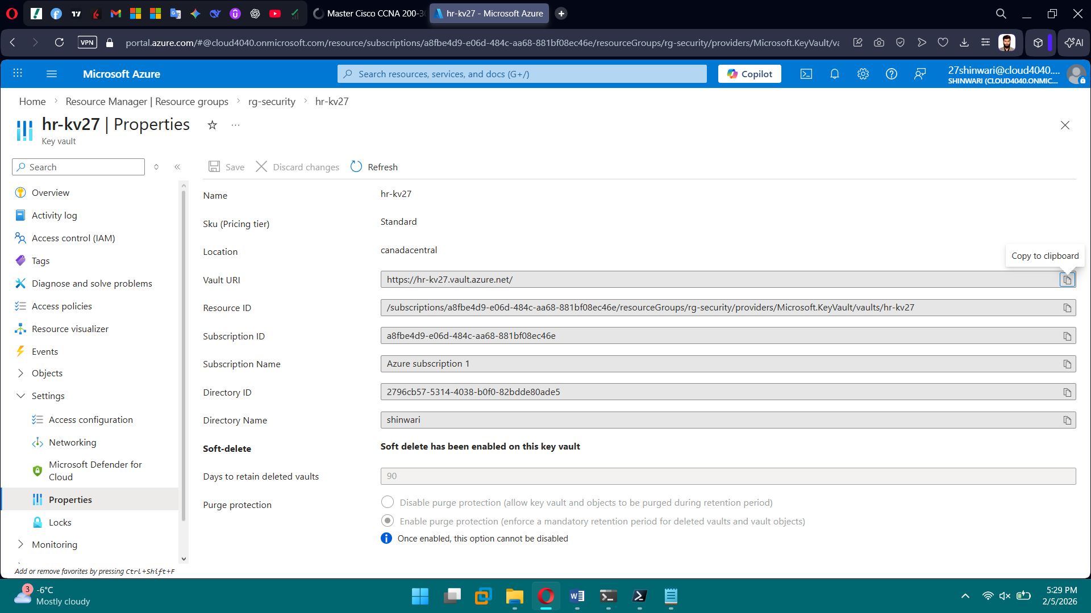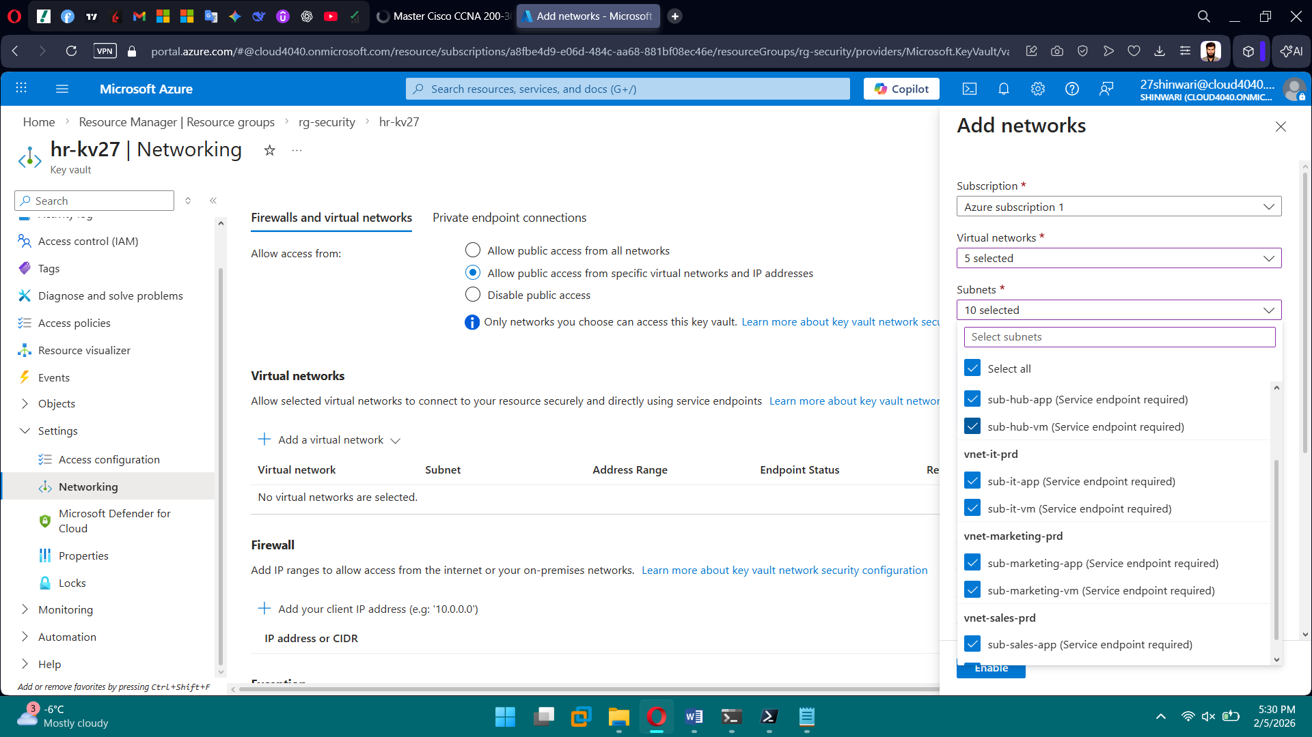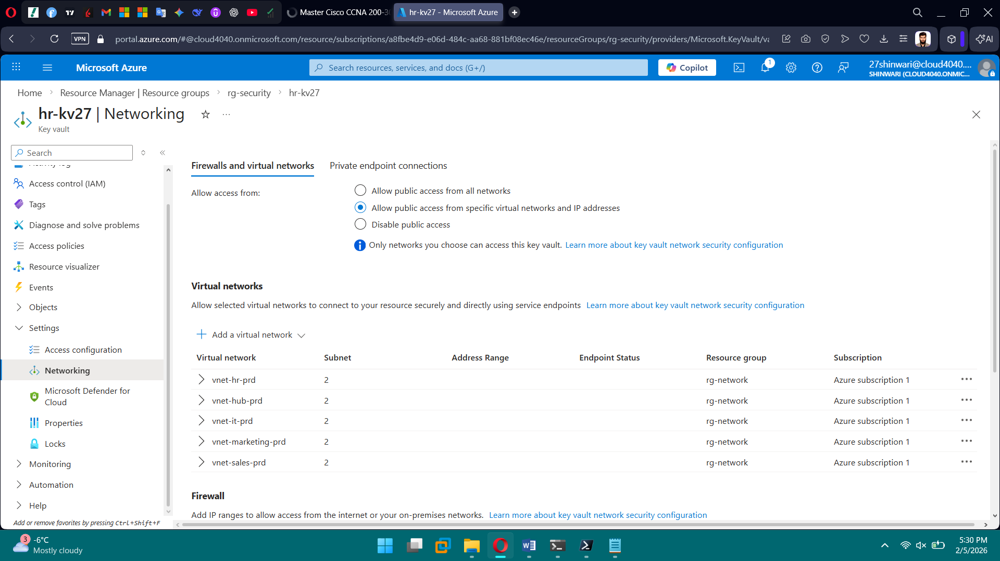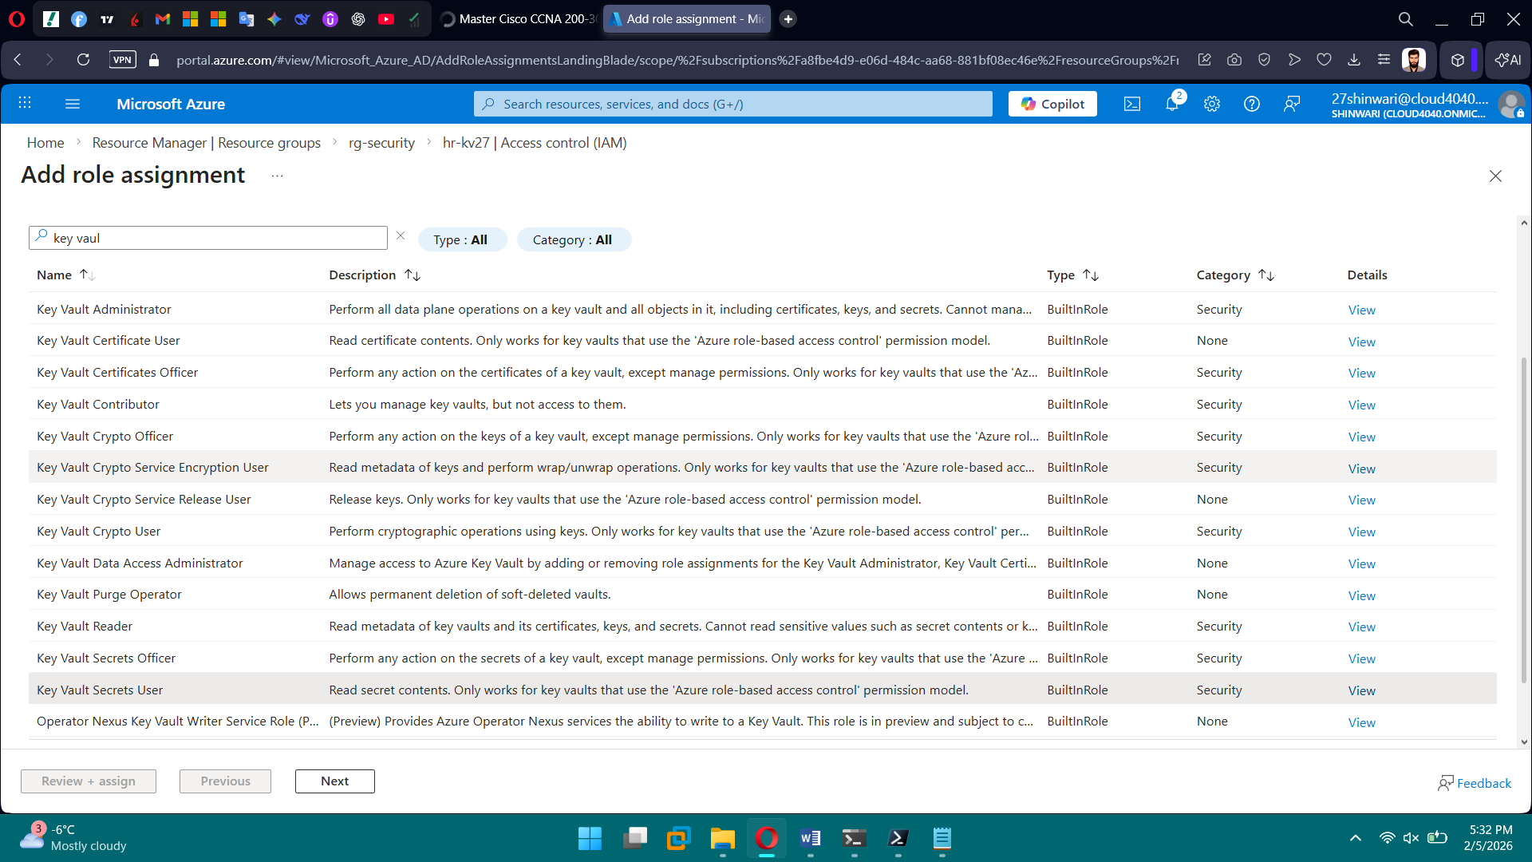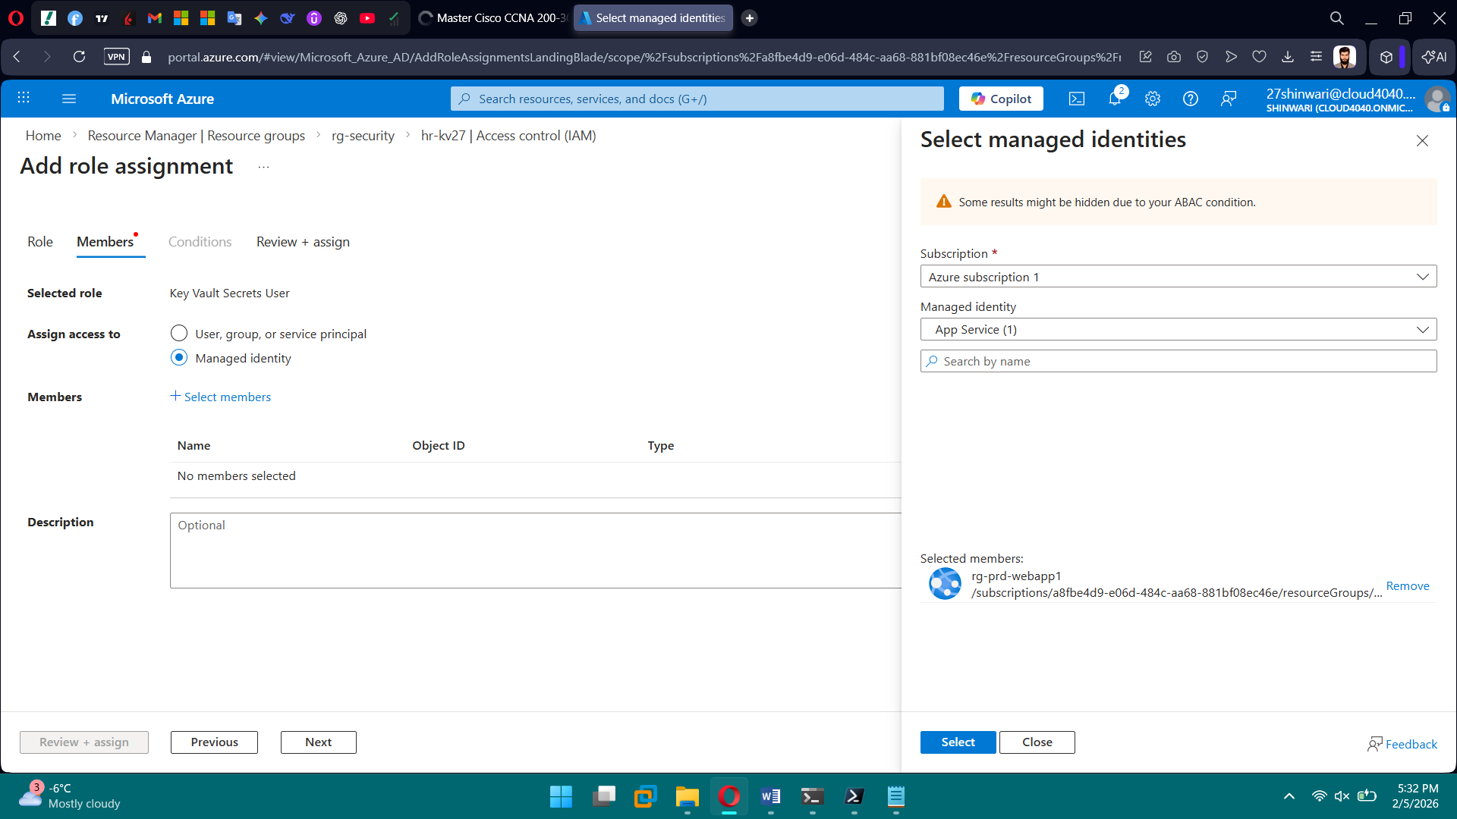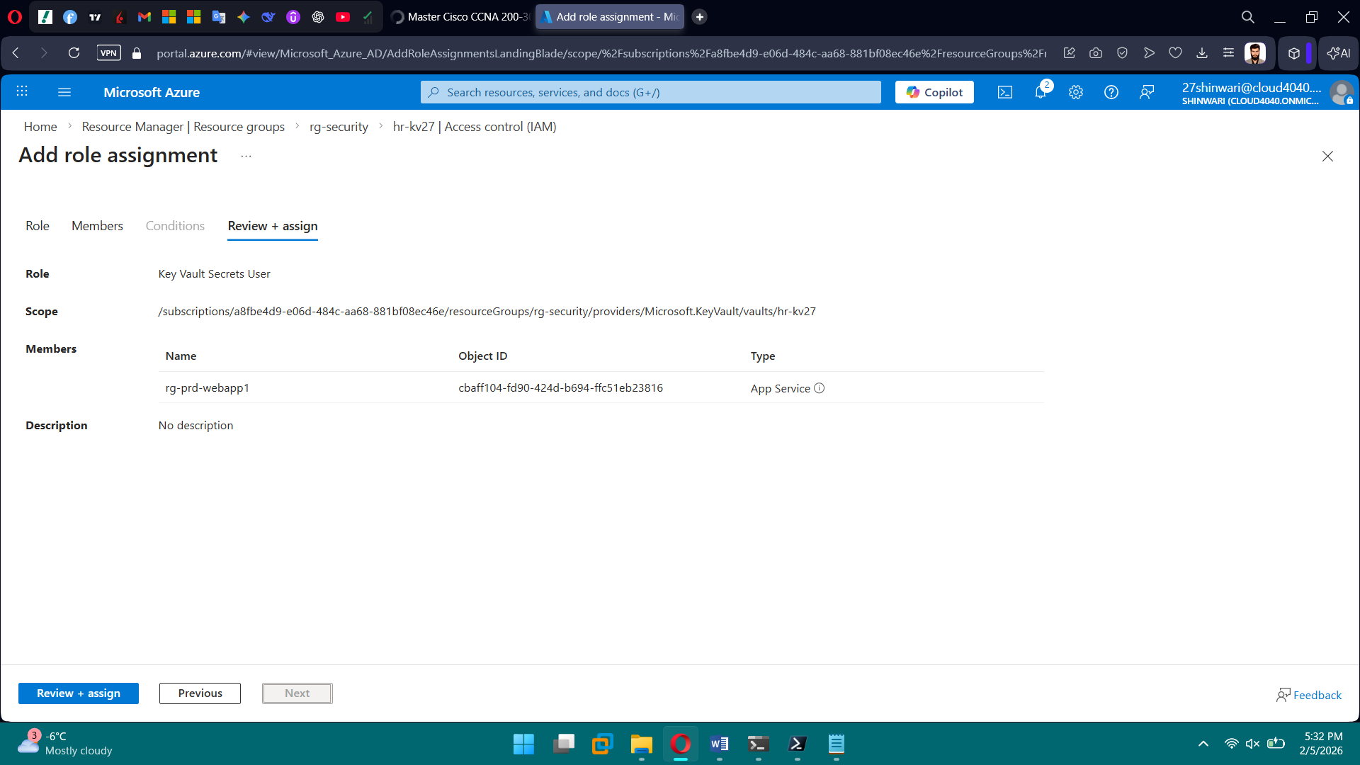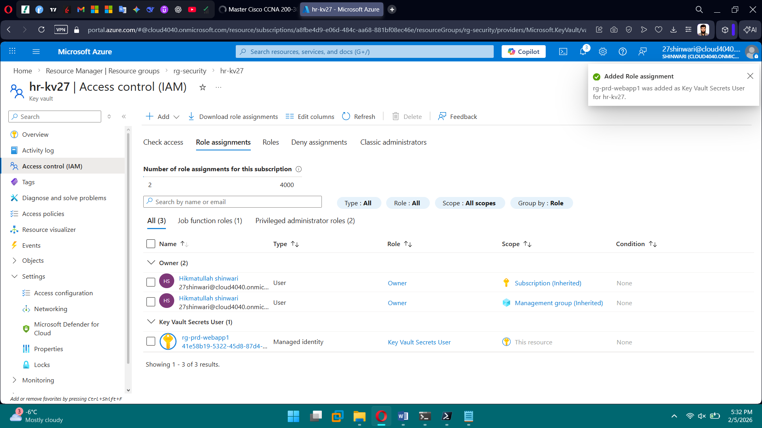

**PHASE 9 — Security & Zero Trust**

**Tasks**

1. Configure Conditional Access (advanced)
2. Enable Defender for Cloud
3. Review Secure Score
4. Configure identity protection

Brief Explanation: We implemented advanced Conditional Access policies to enforce MFA, location-based controls, and Zero Trust access. Microsoft Defender for Cloud was enabled to monitor and protect workloads across the subscription. Secure Score was reviewed to assess the overall security posture and recommended improvements. Identity Protection policies were configured to mitigate risky sign-ins and compromised accounts.

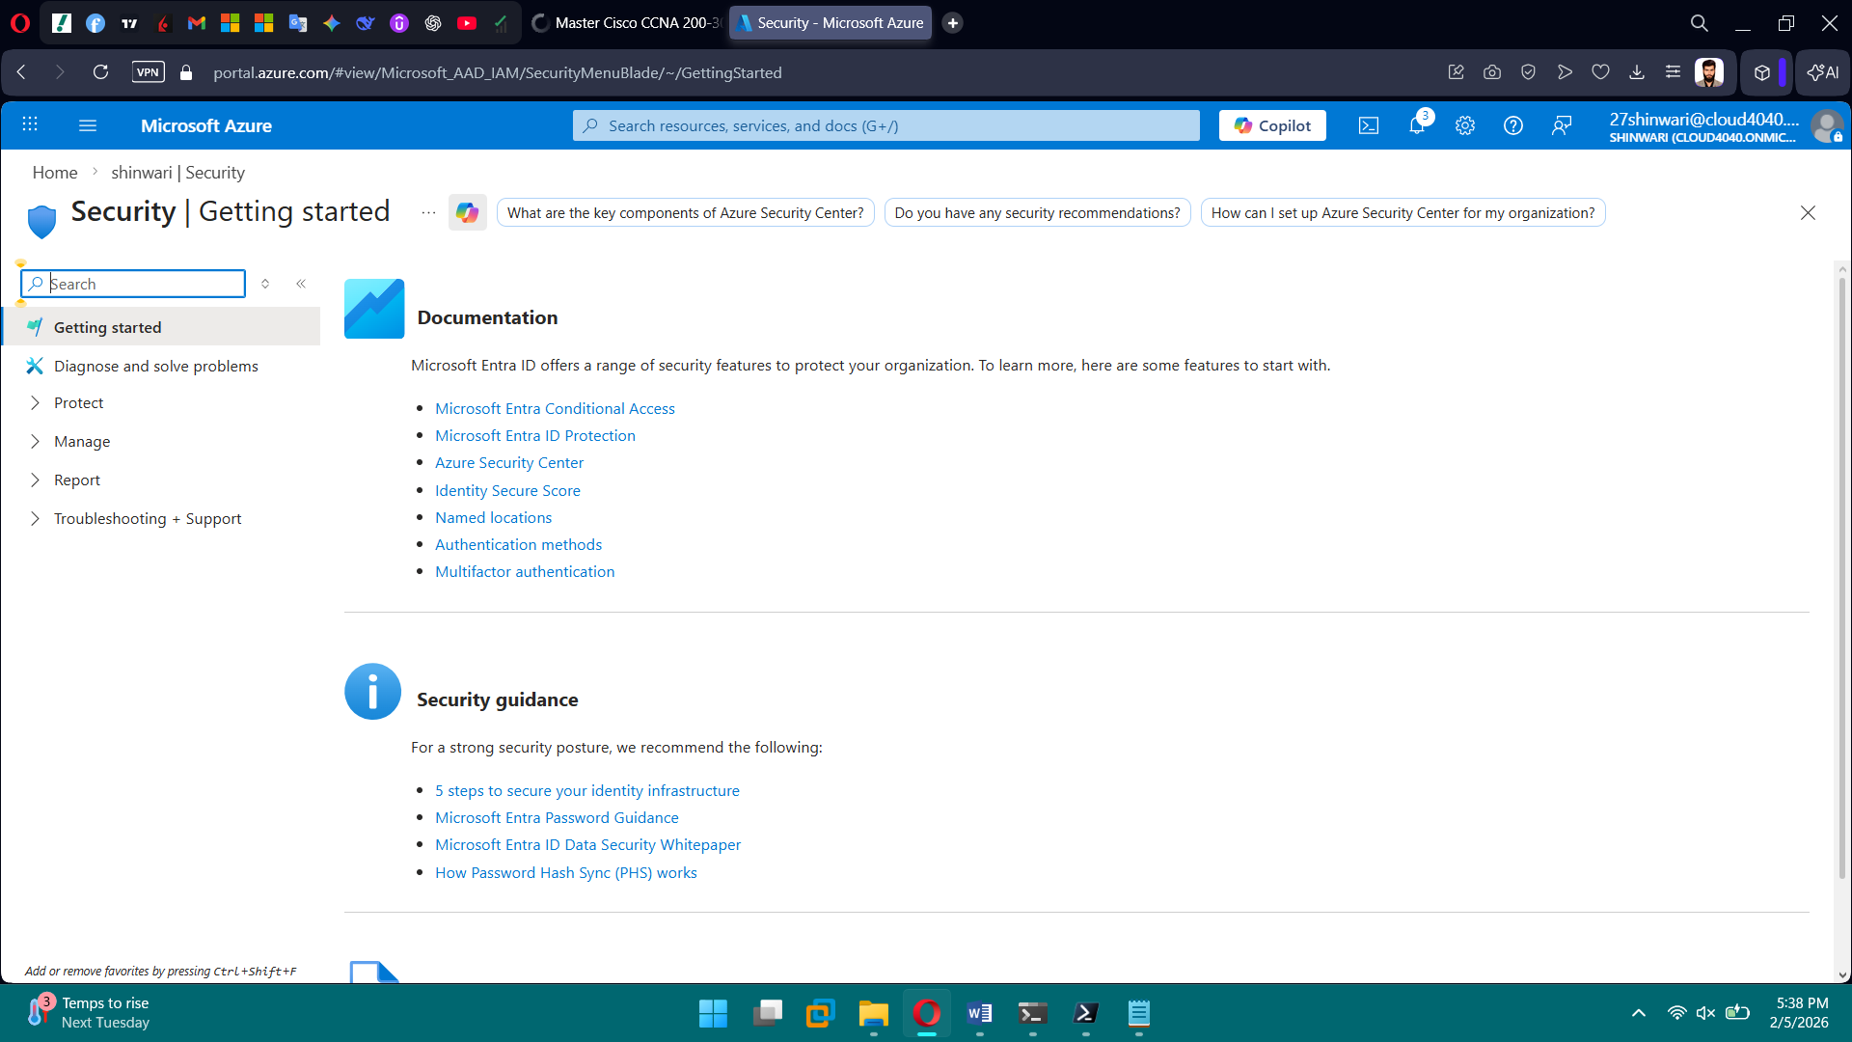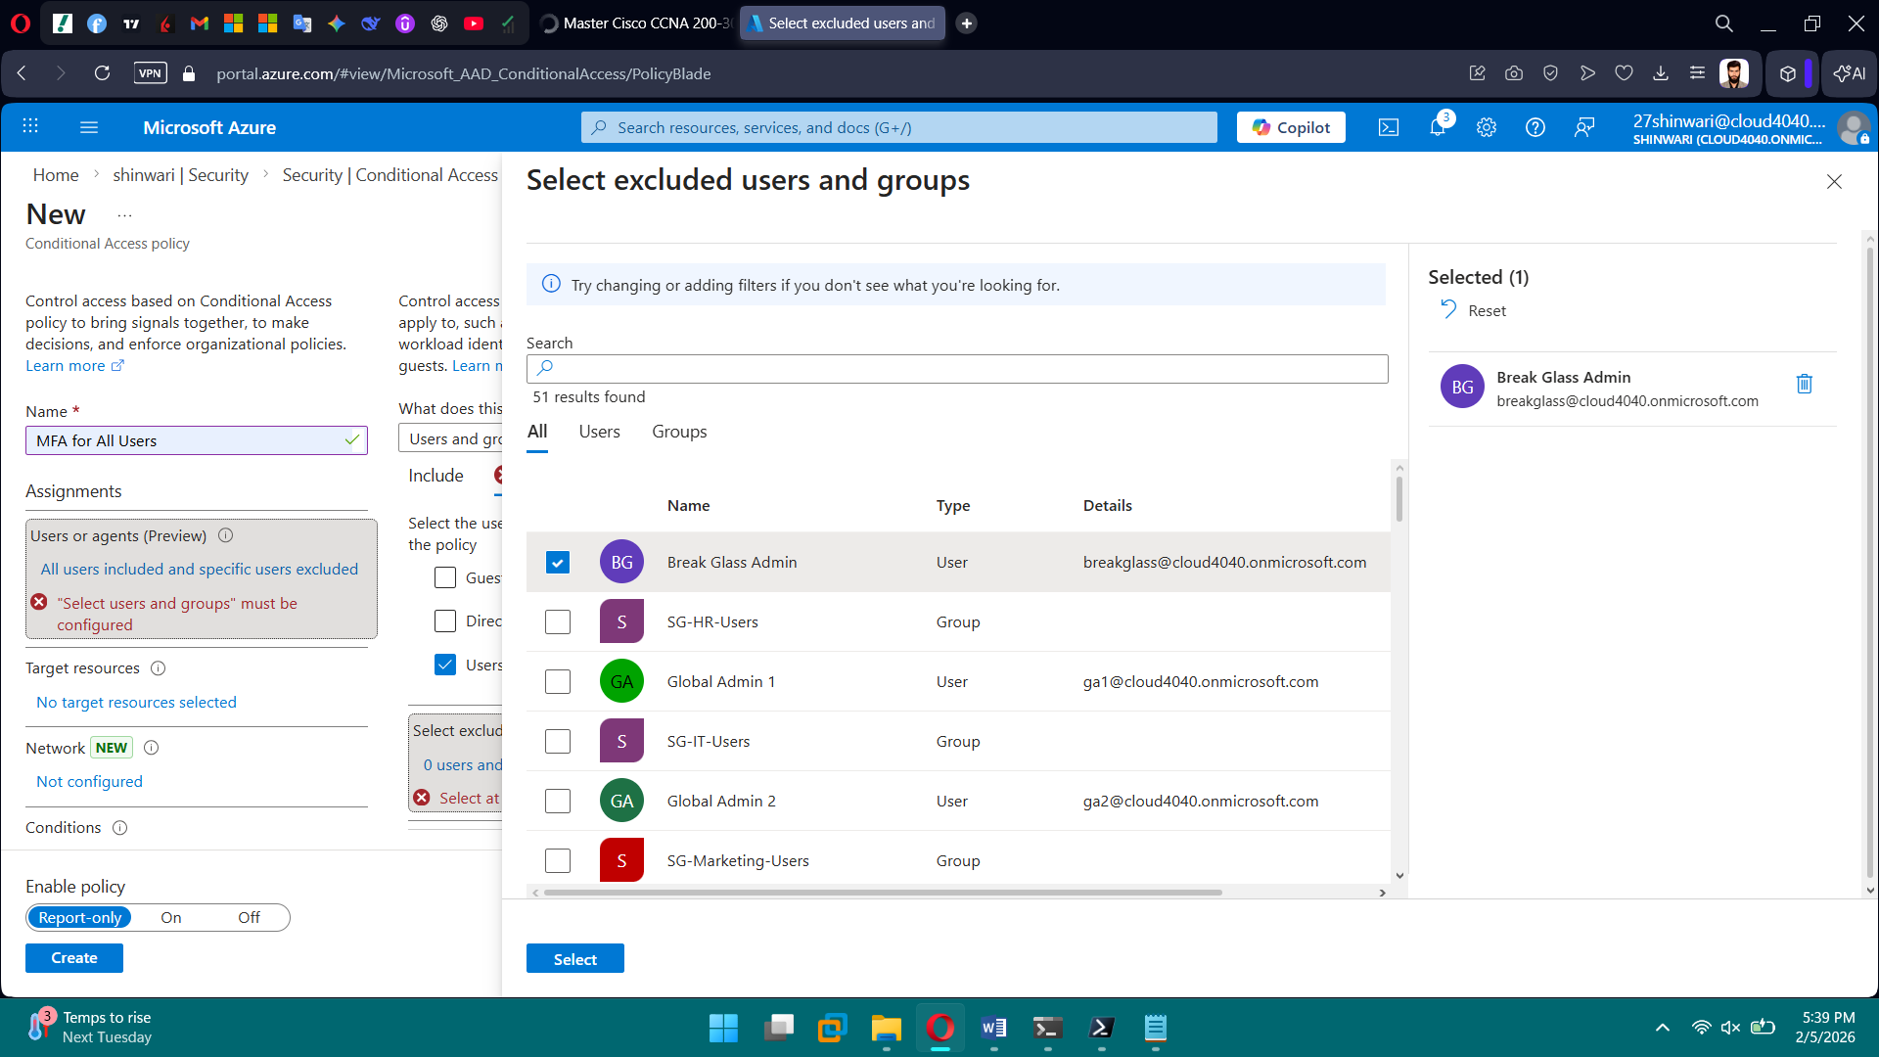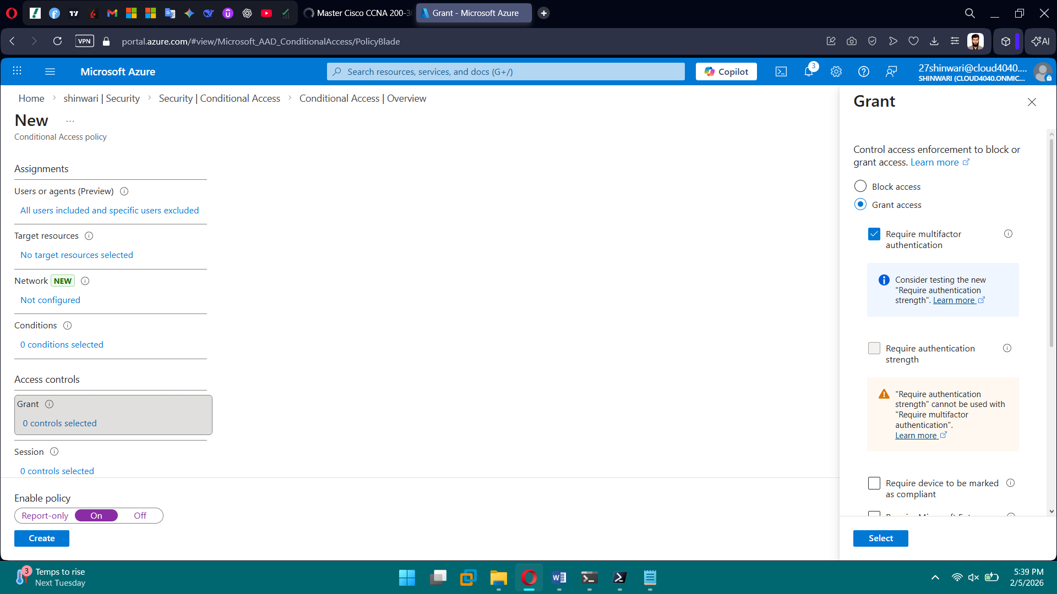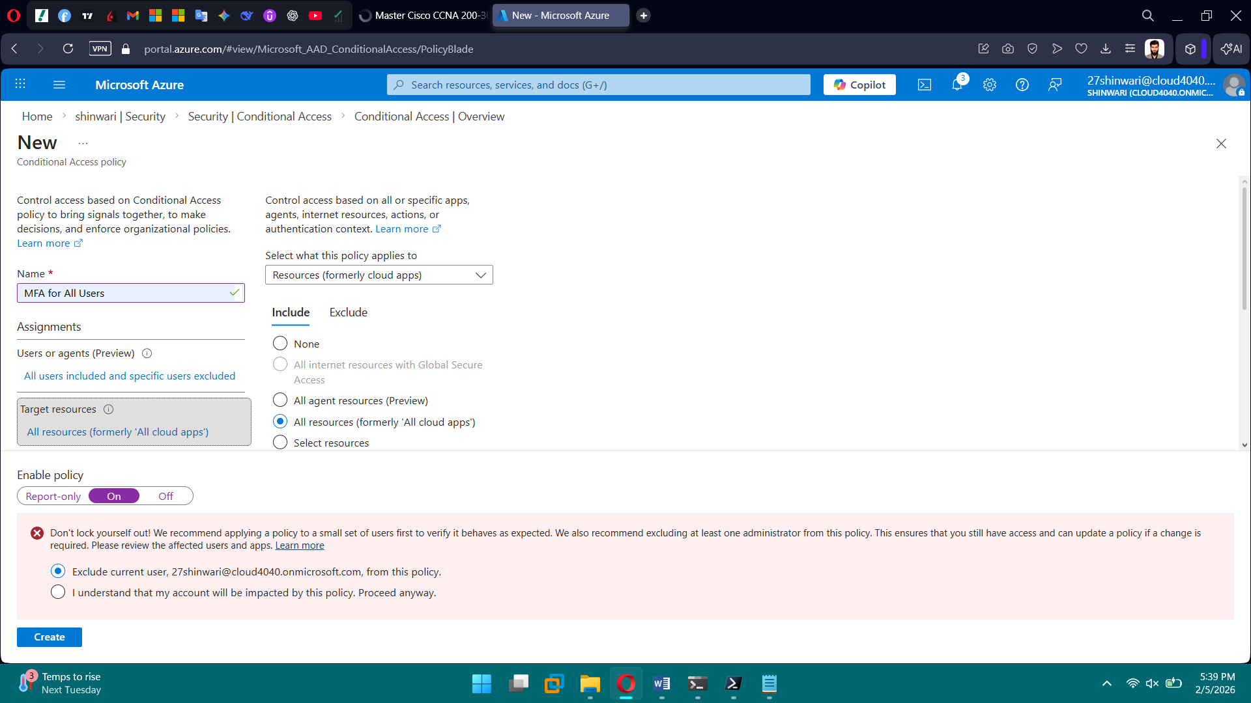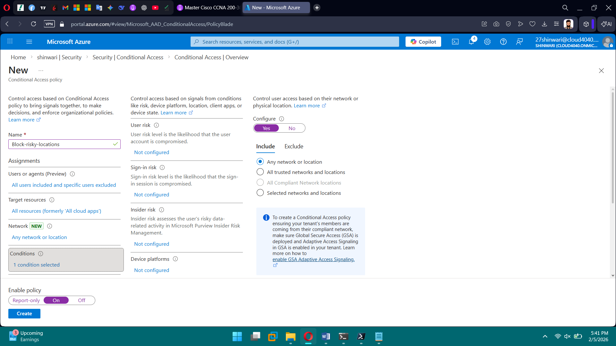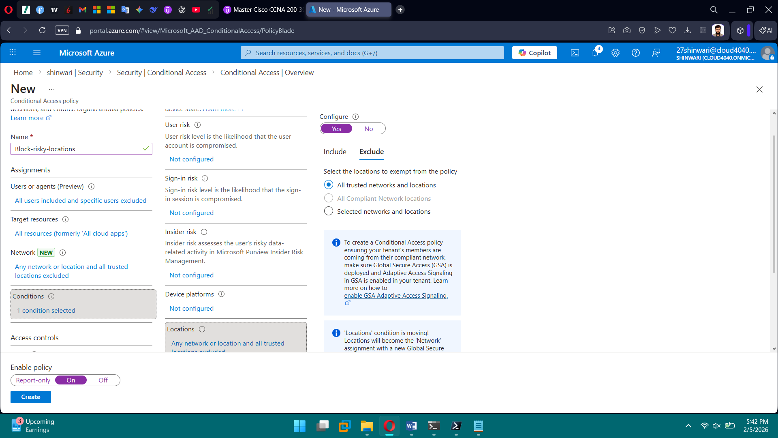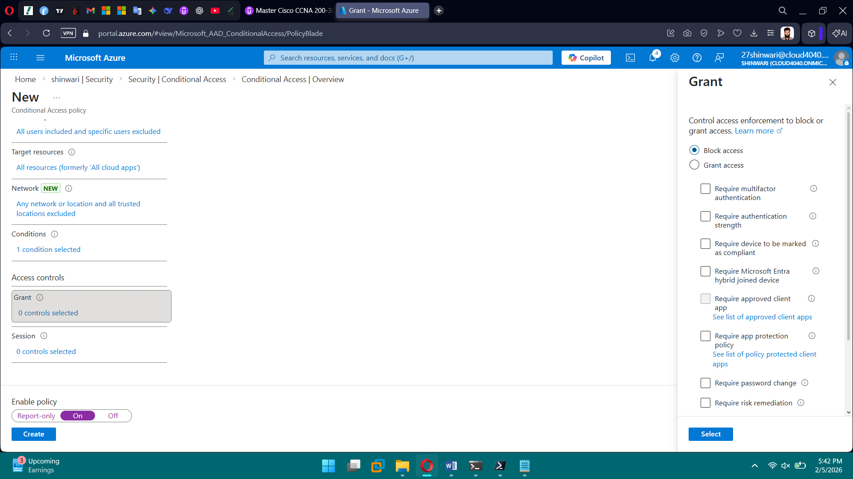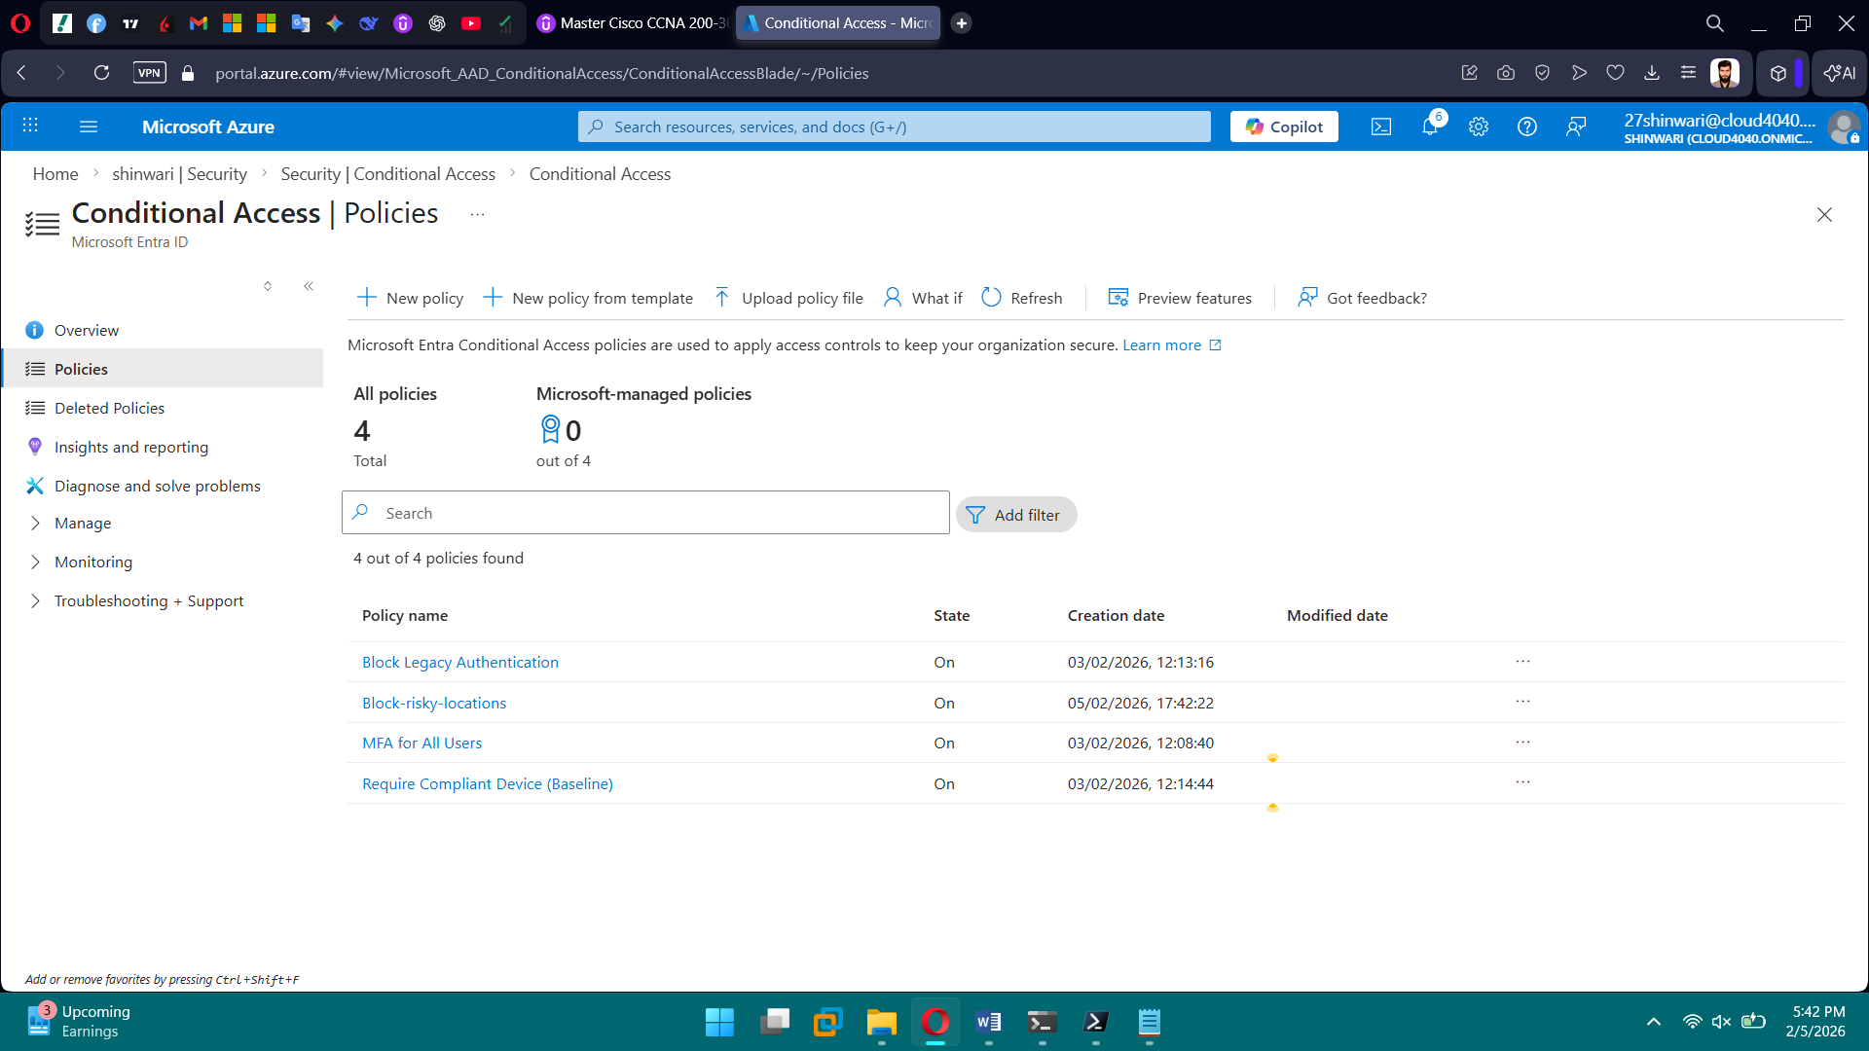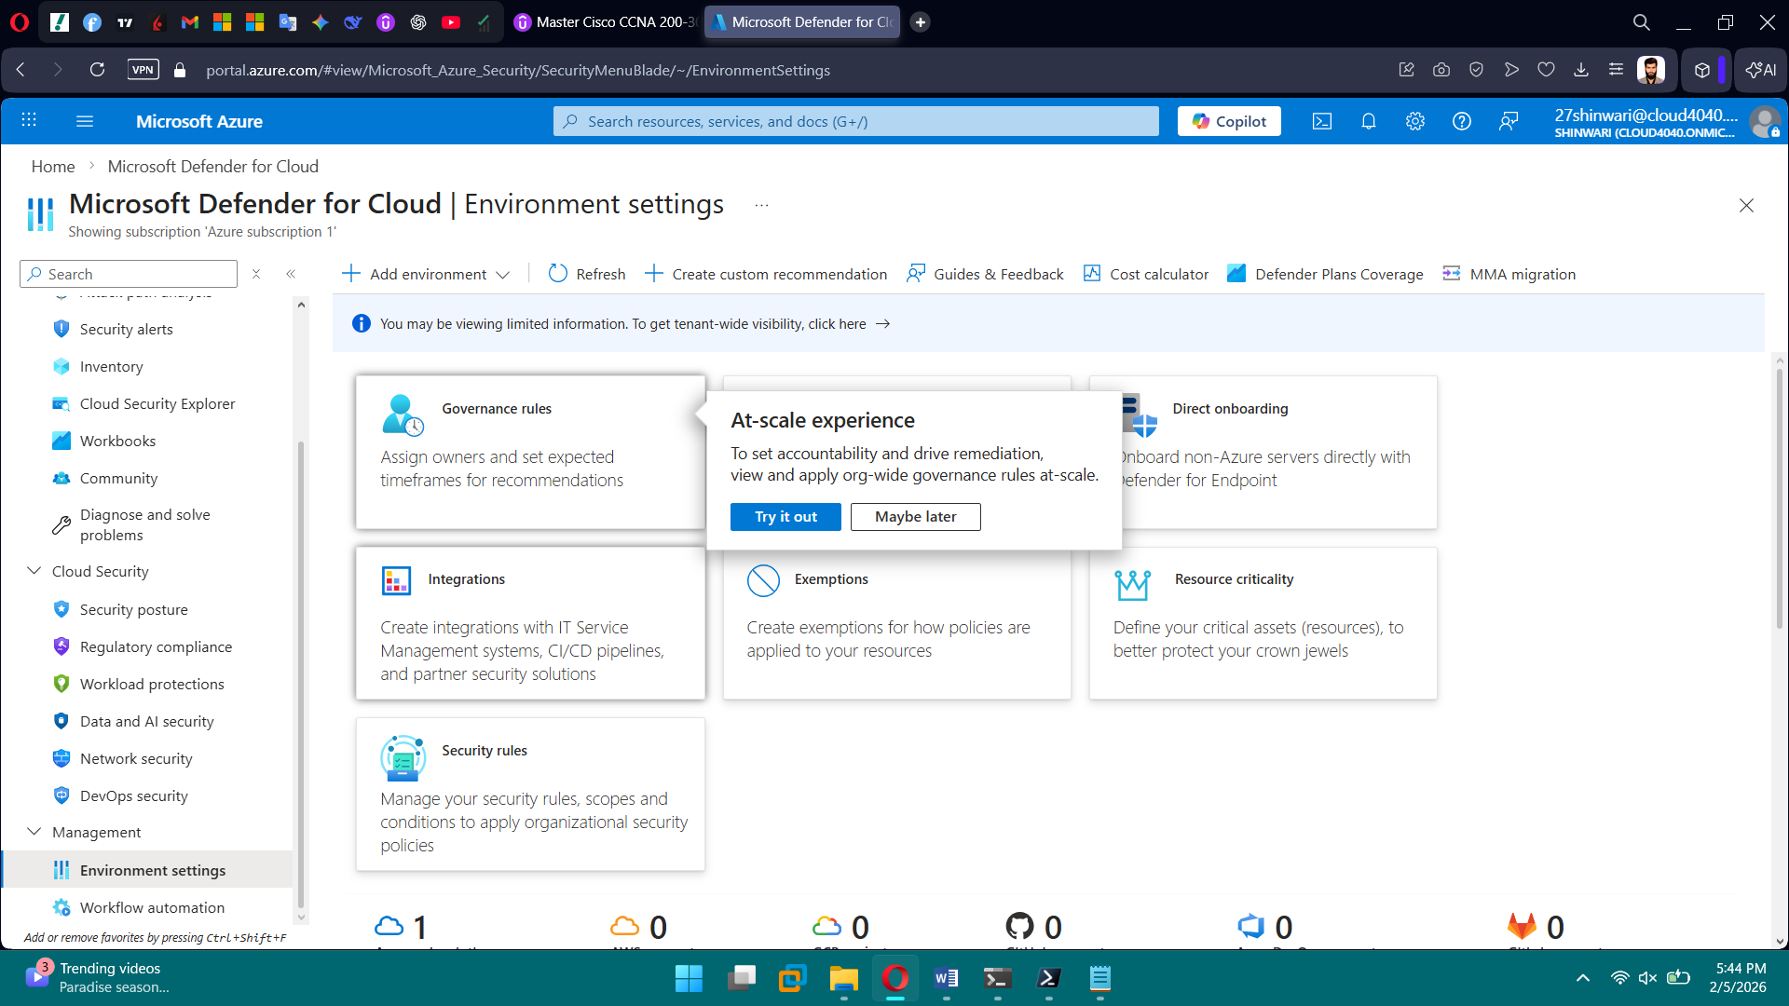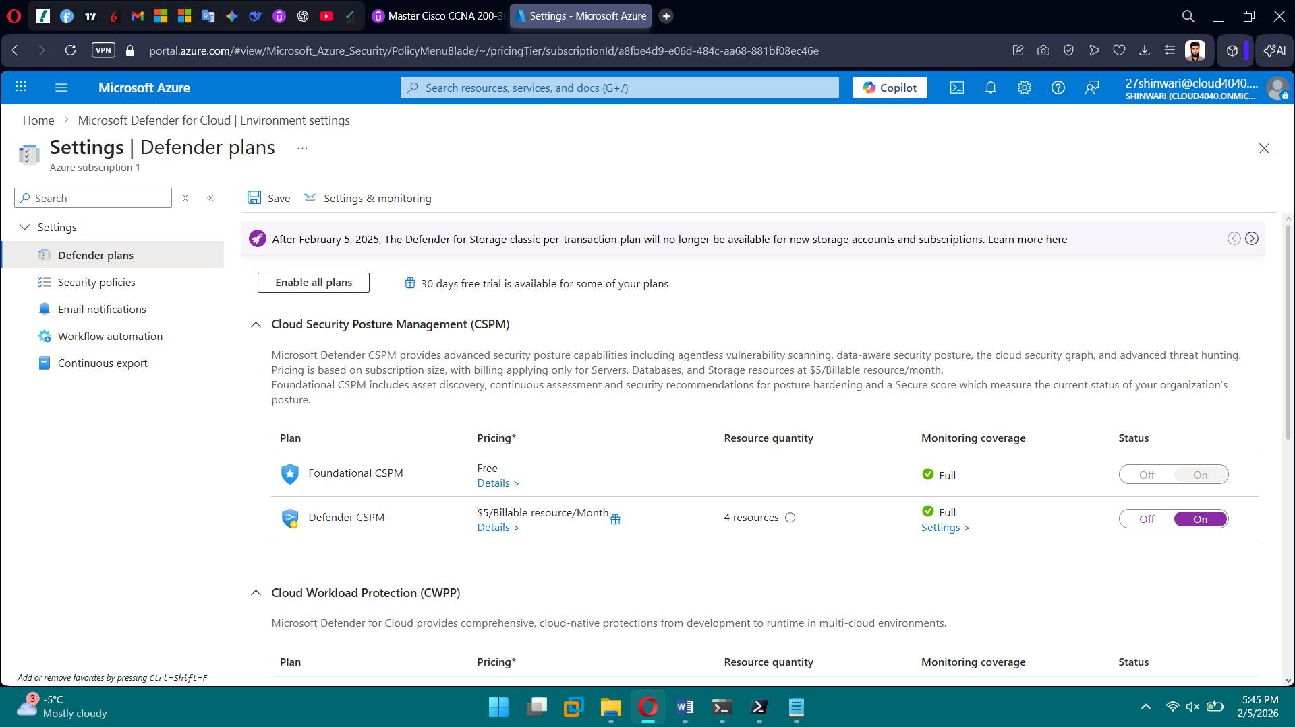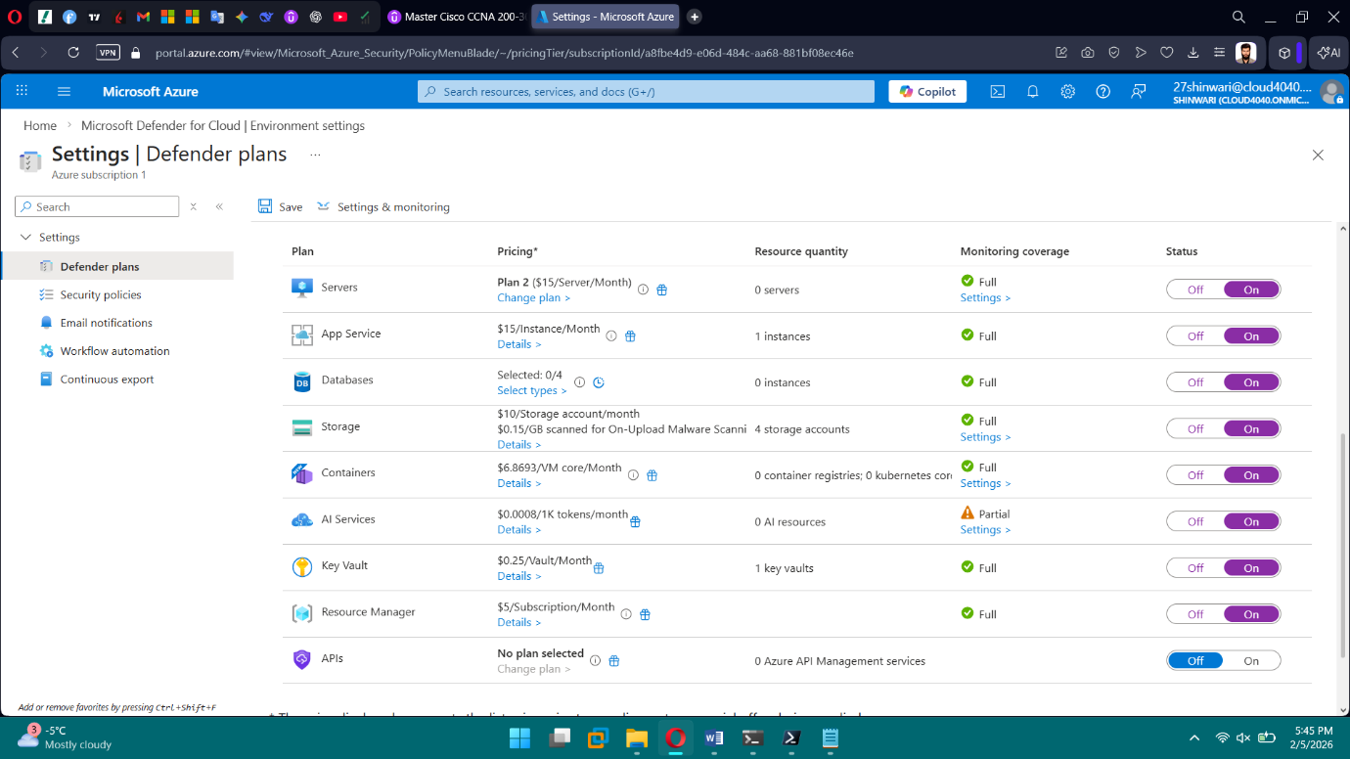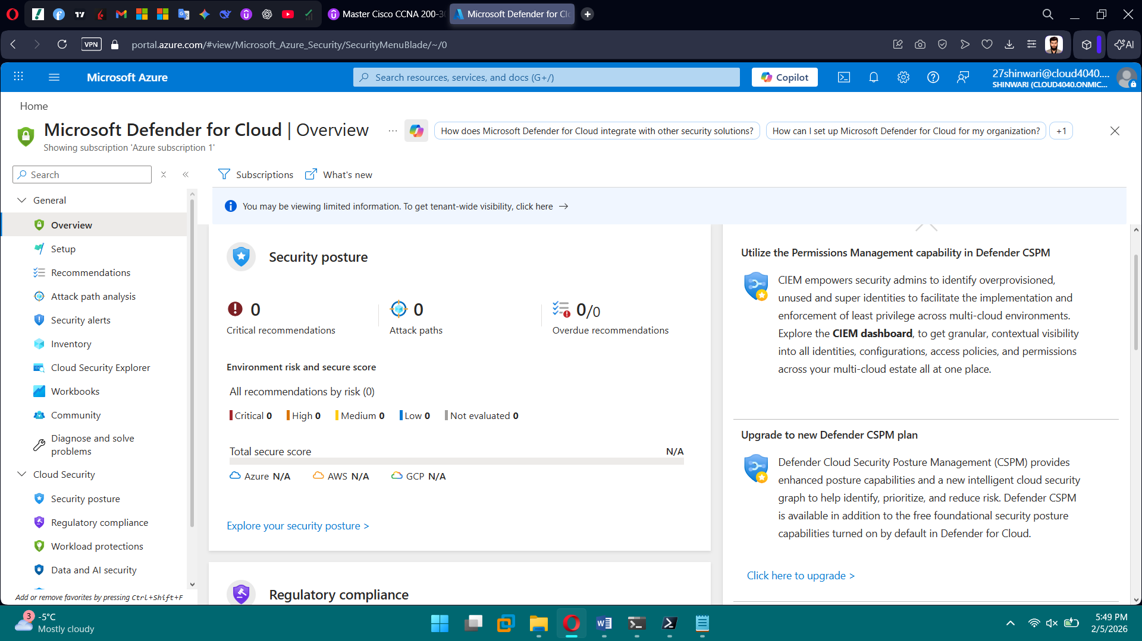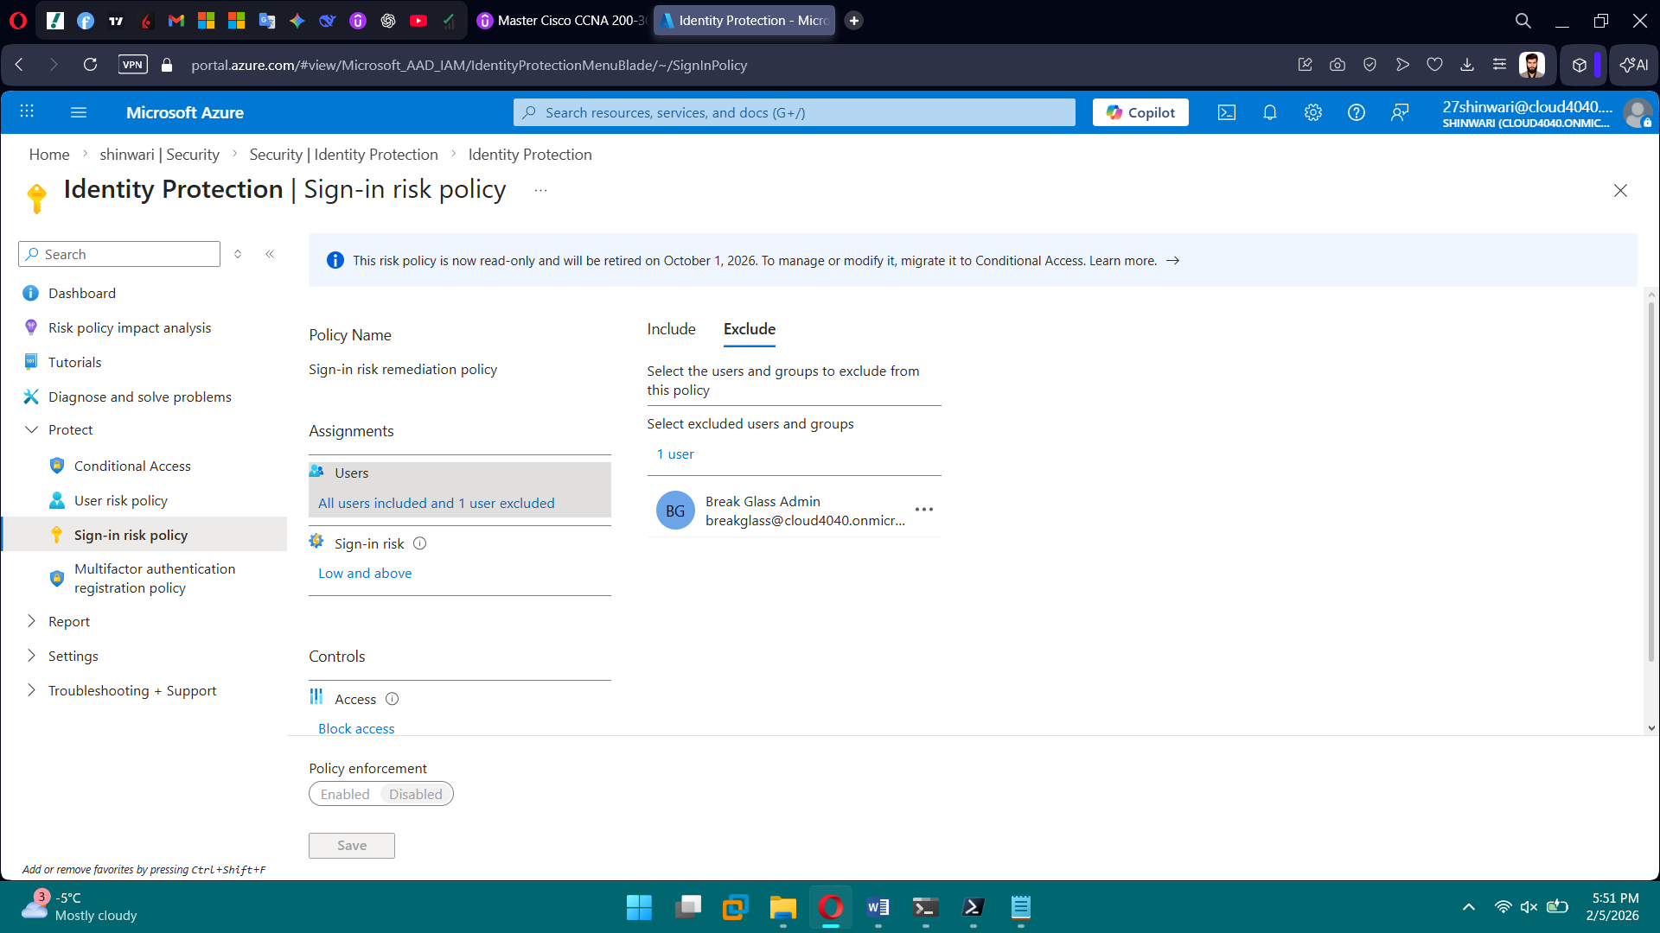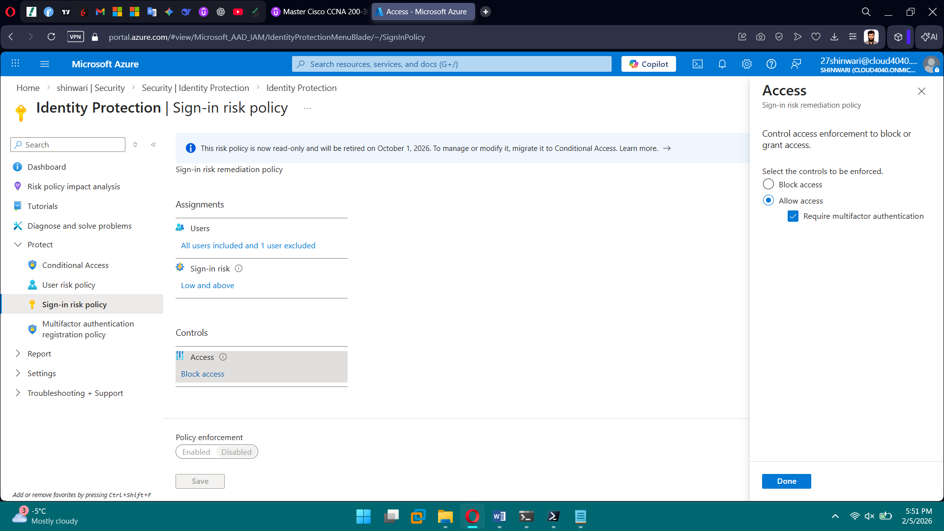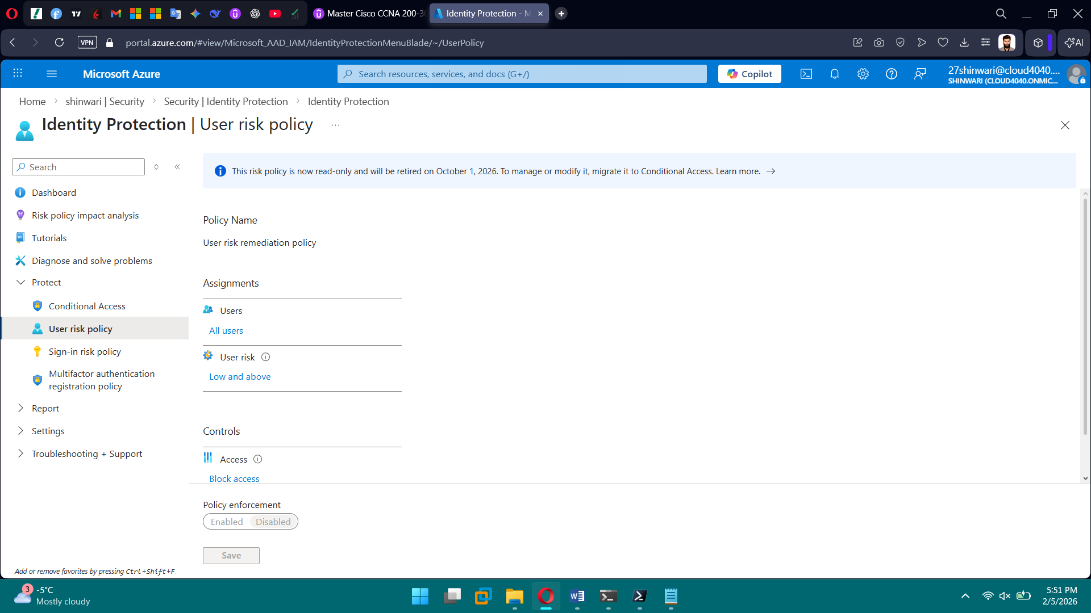

**PHASE 10 — Monitoring & Logging**

**Tasks**

1. Create Log Analytics Workspace
2. Enable diagnostic settings
3. Centralize logs
4. Create alerts:
   * Service health

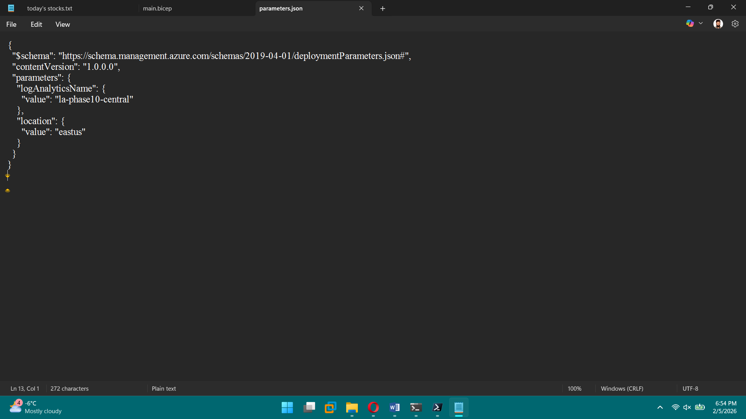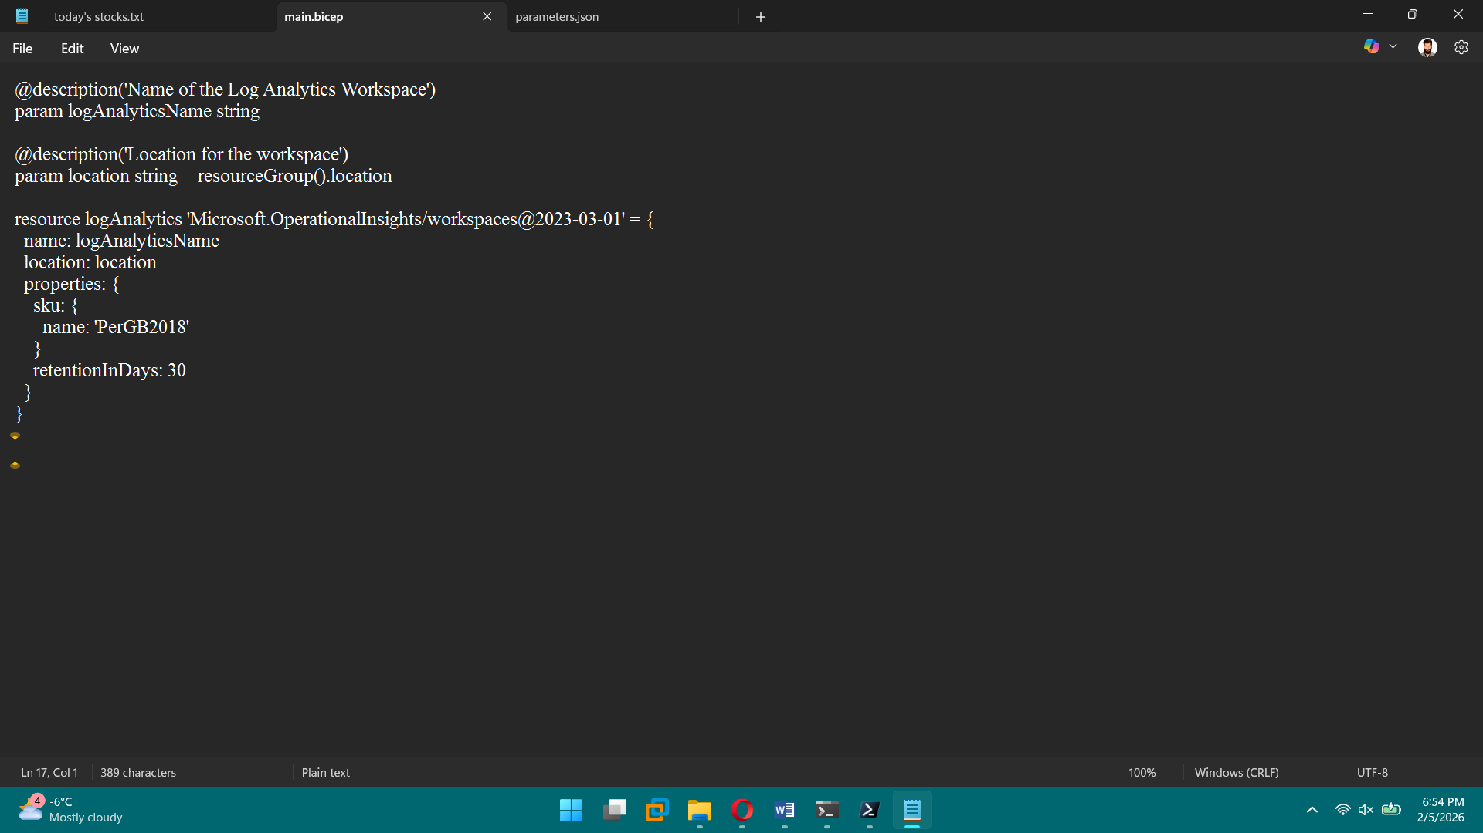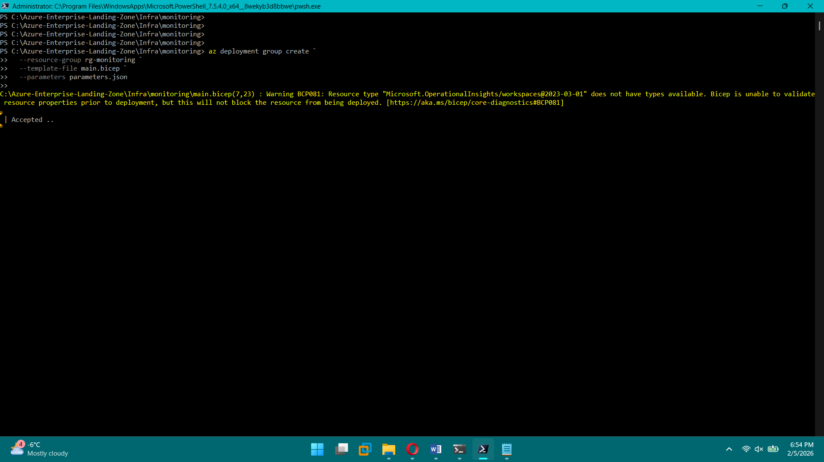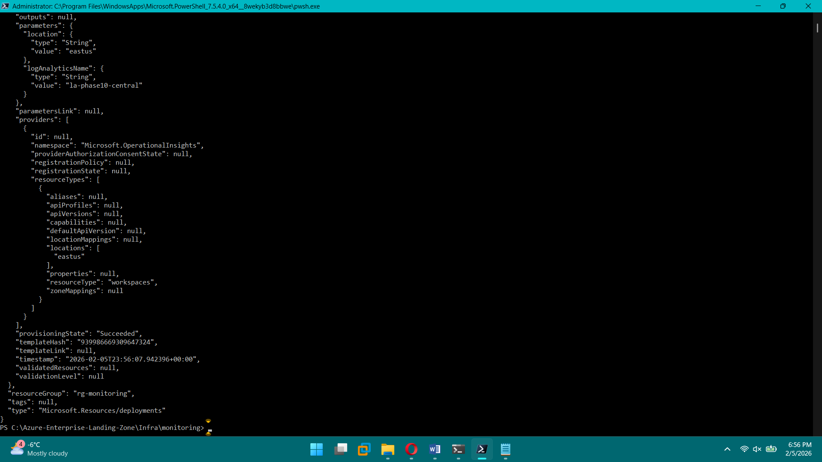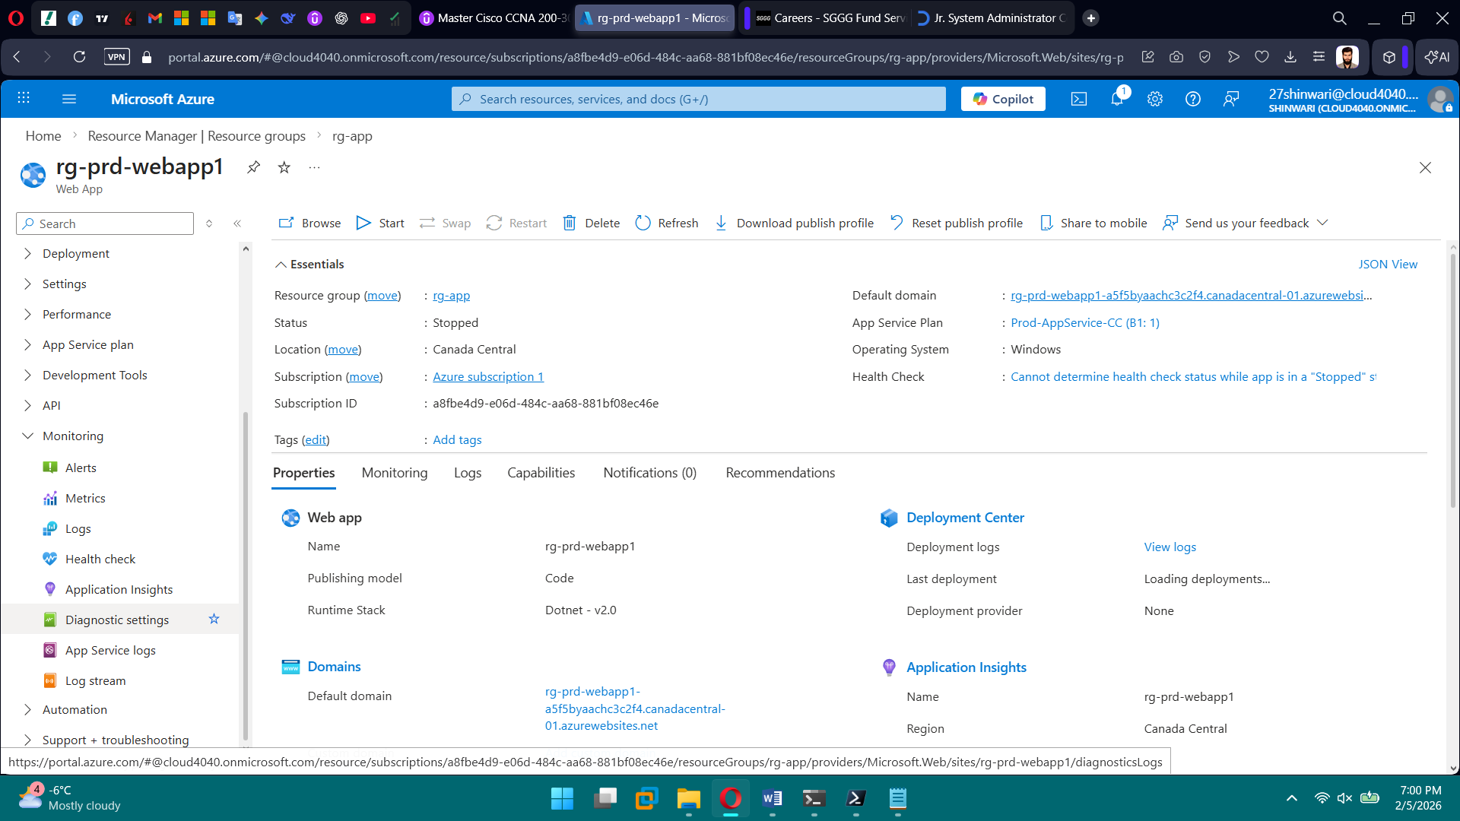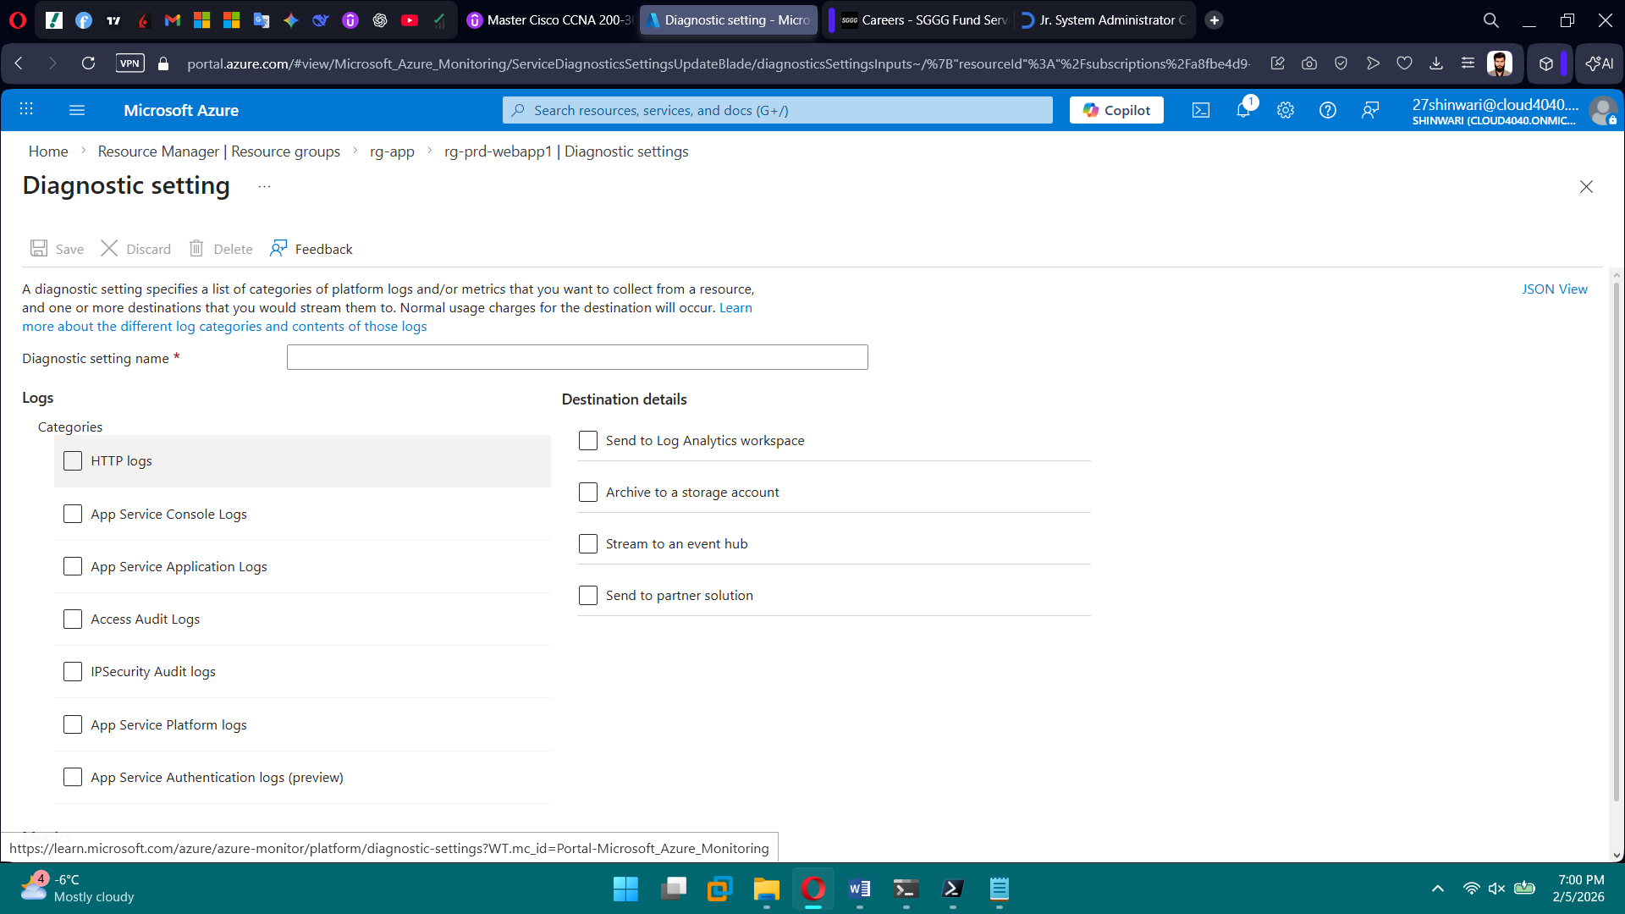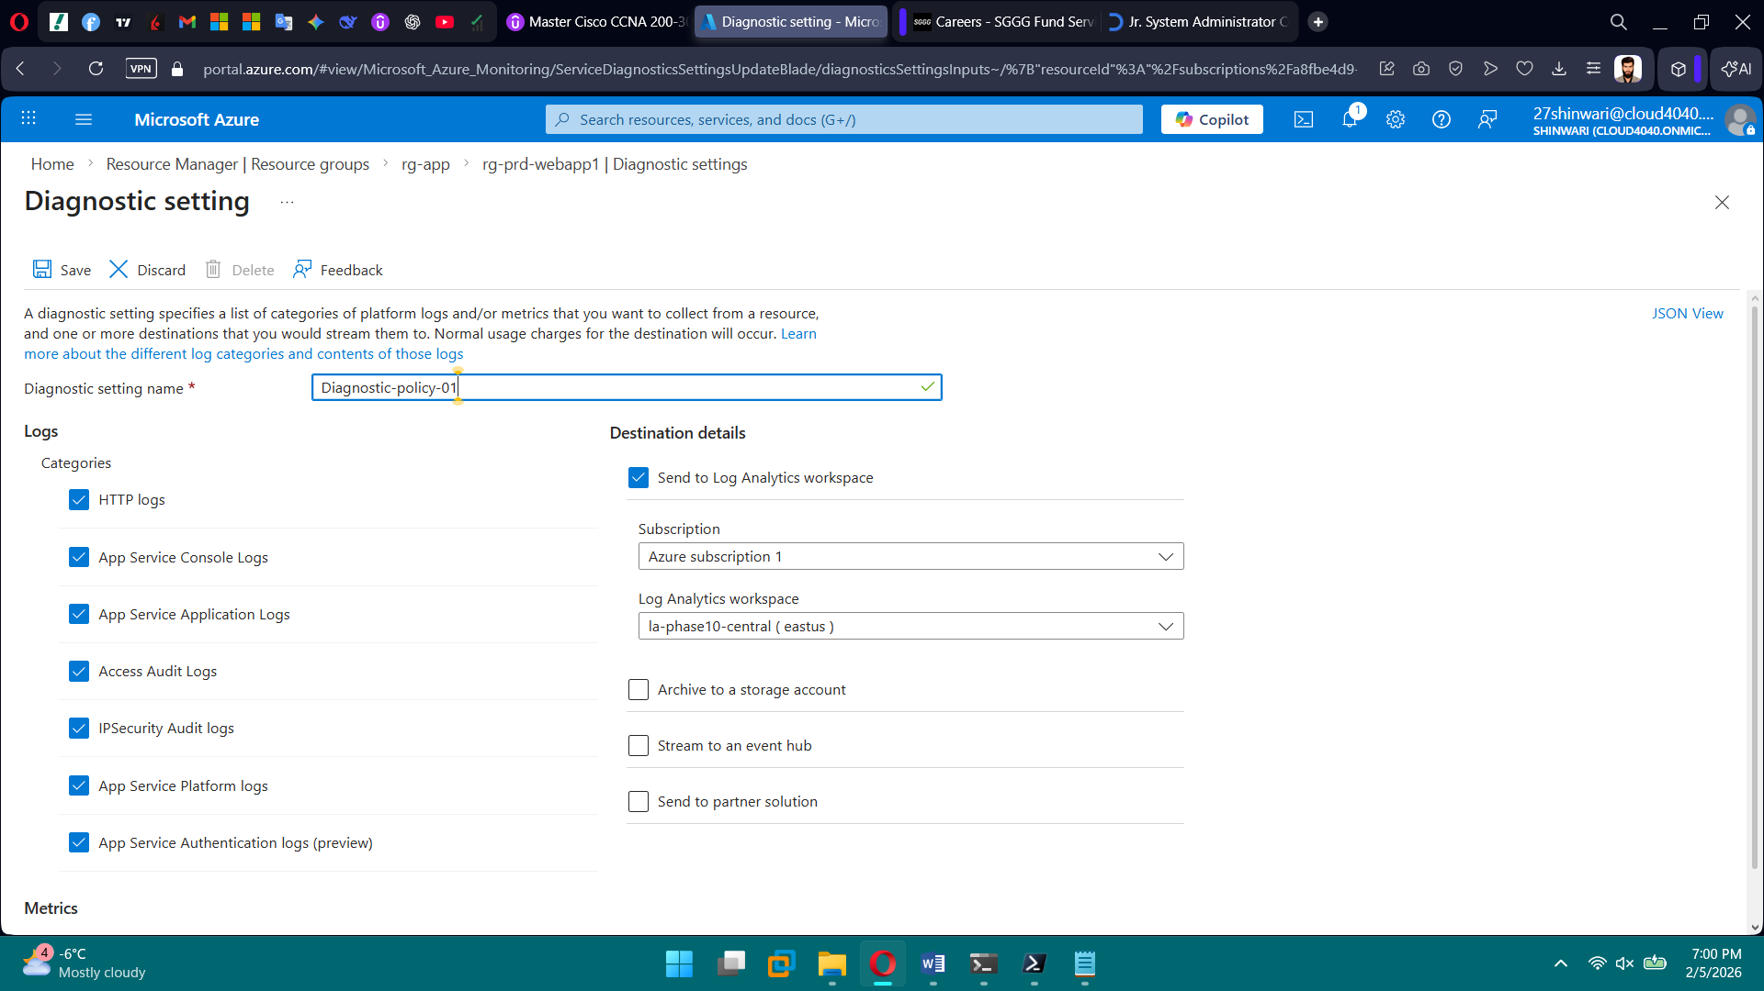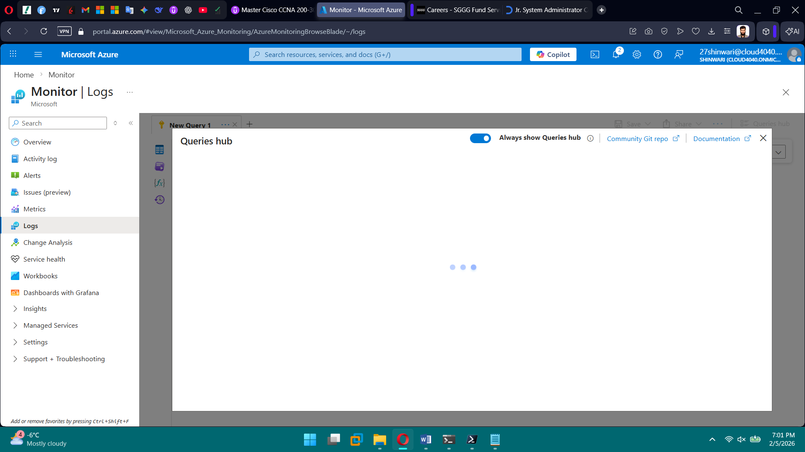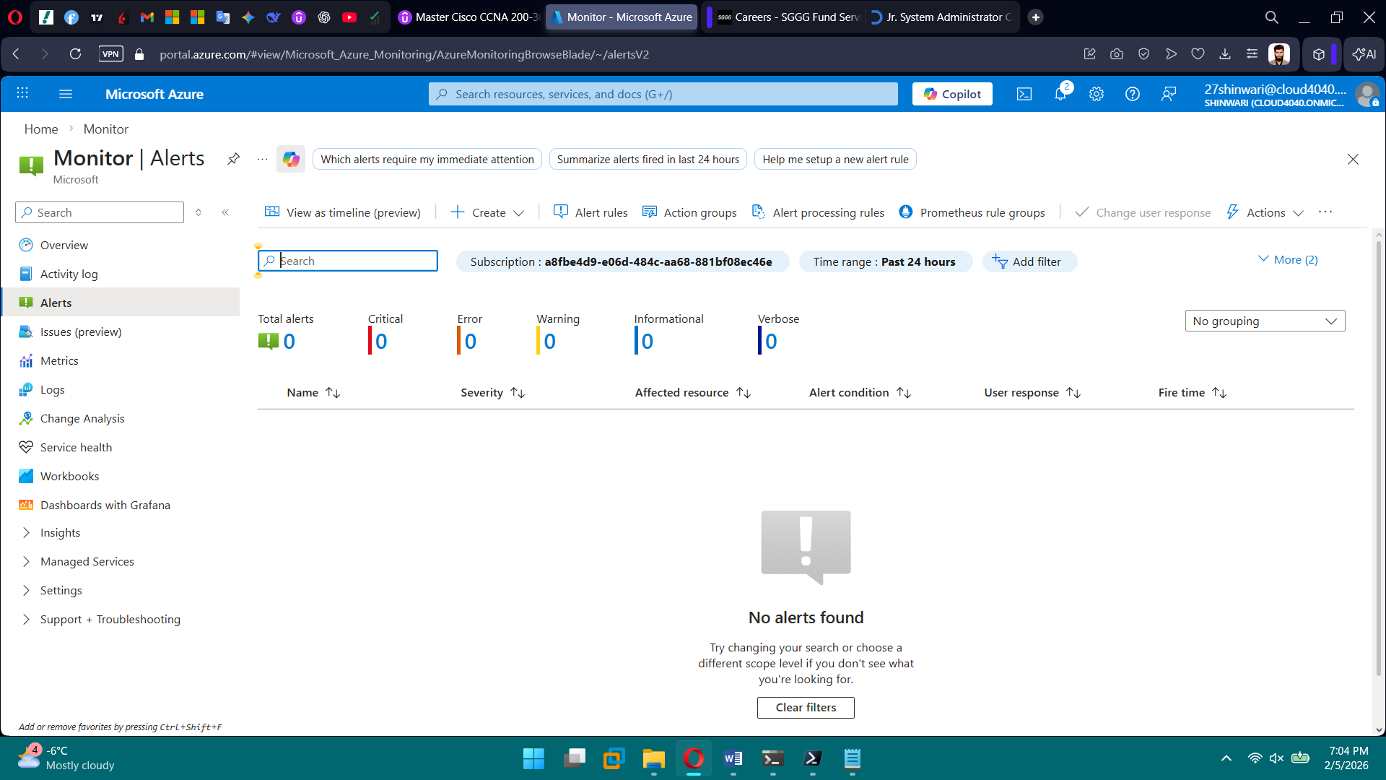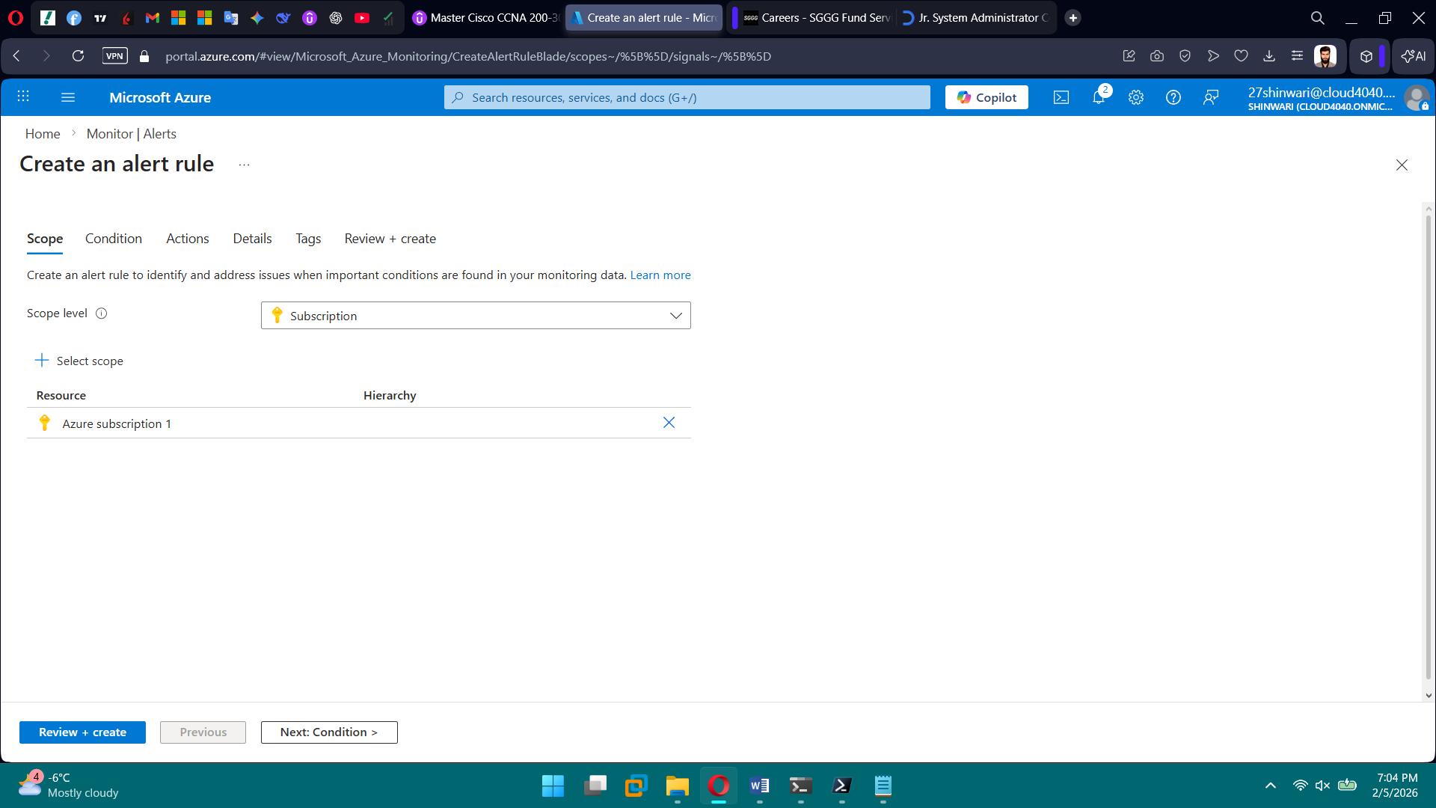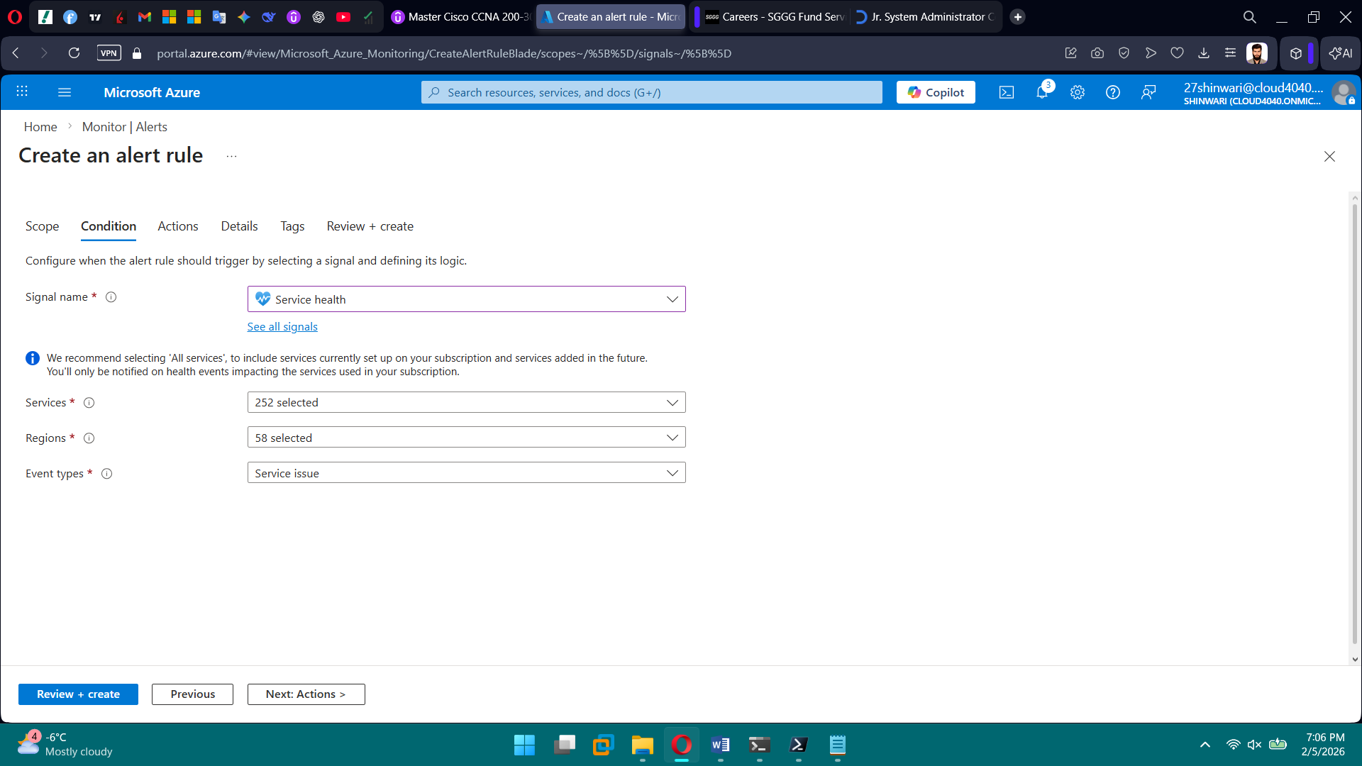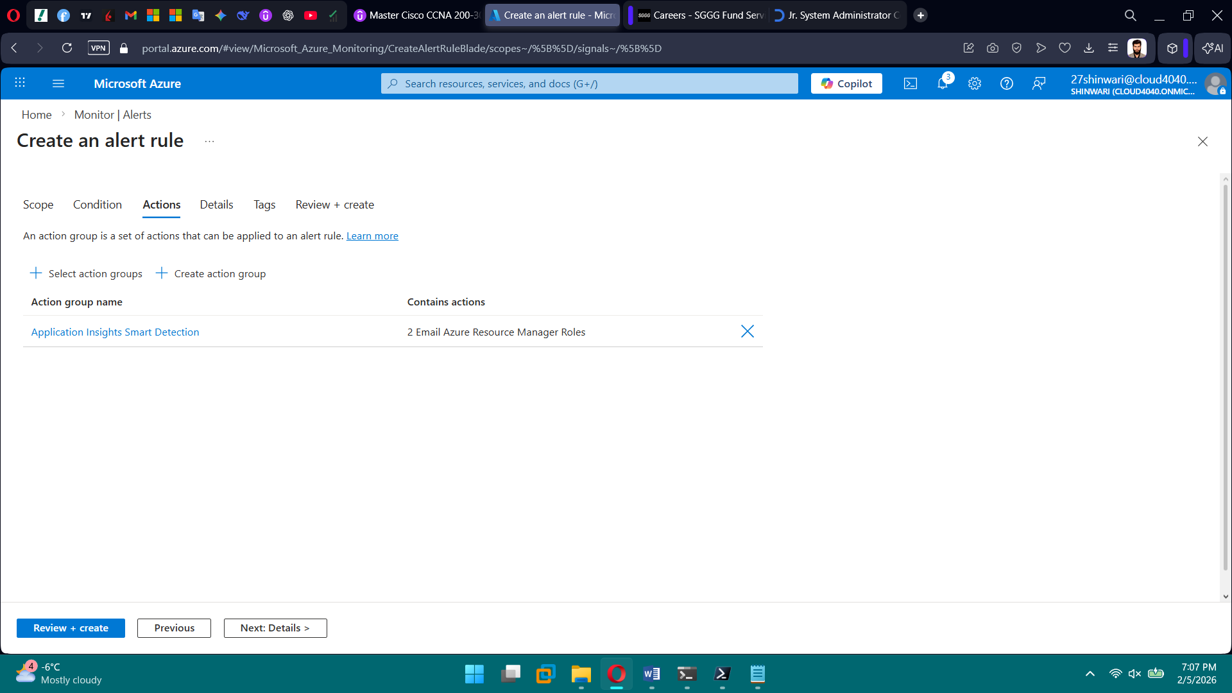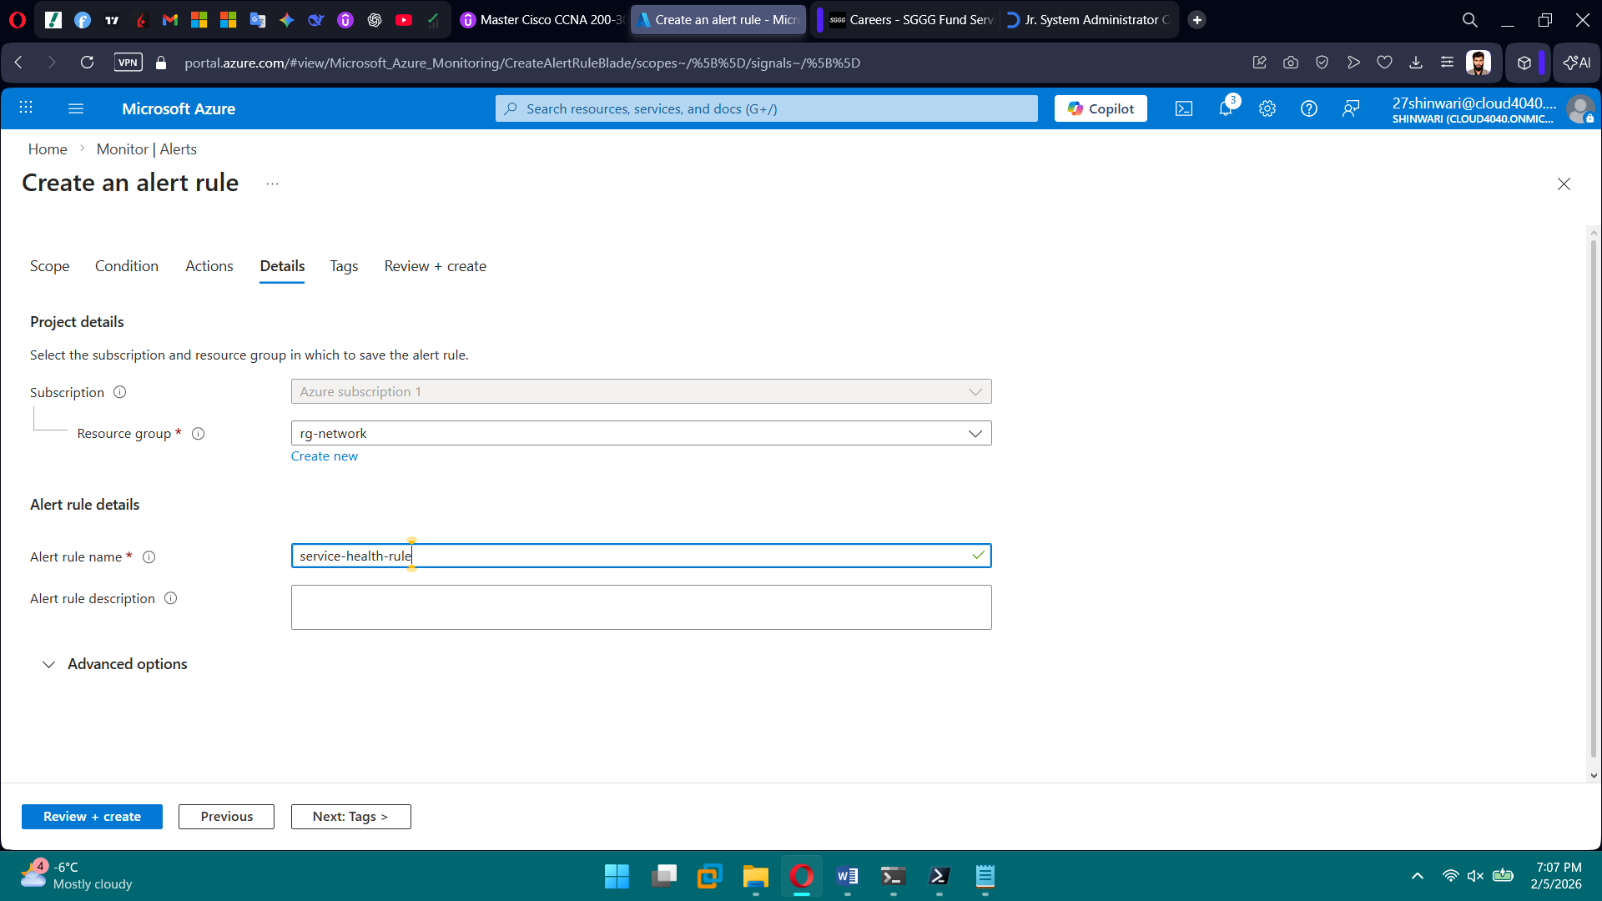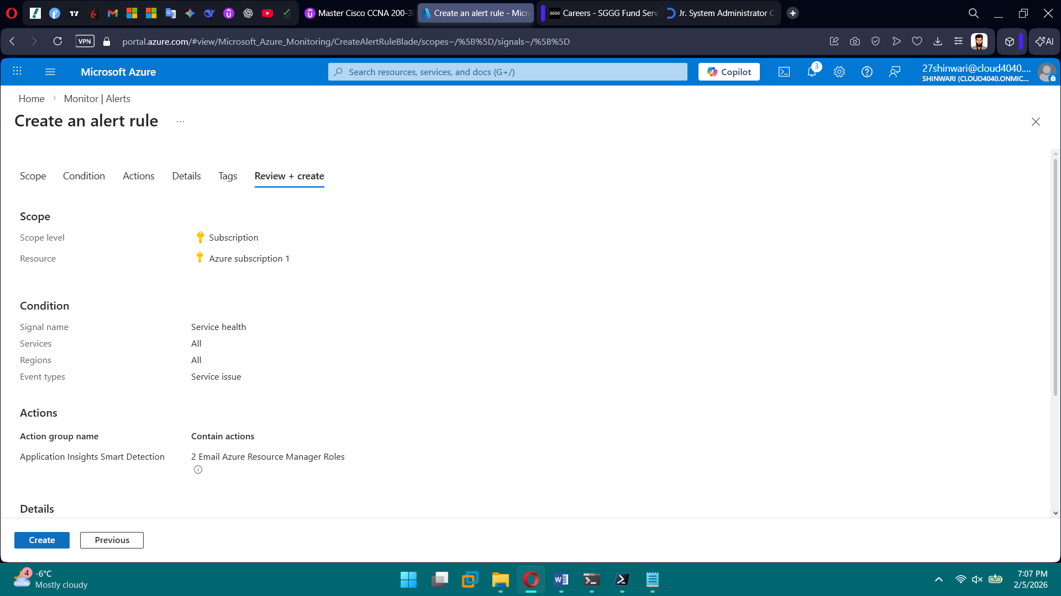

**PHASE 11 — Backup & Disaster Recovery**

**Tasks**

1. Create Recovery Services Vault
2. Configure VM backups
3. Define backup policies
4. Site Recovery

**Brief Explanation:** In this phase, we set up a Recovery Services Vault to centrally manage backups and disaster recovery. We configured automated backups for all virtual machines to protect data against accidental loss or failures. We defined backup policies to control backup schedules and retention periods. We enabled Azure Site Recovery to replicate VMs to a secondary region. Overall, this ensured business continuity and disaster recovery readiness.

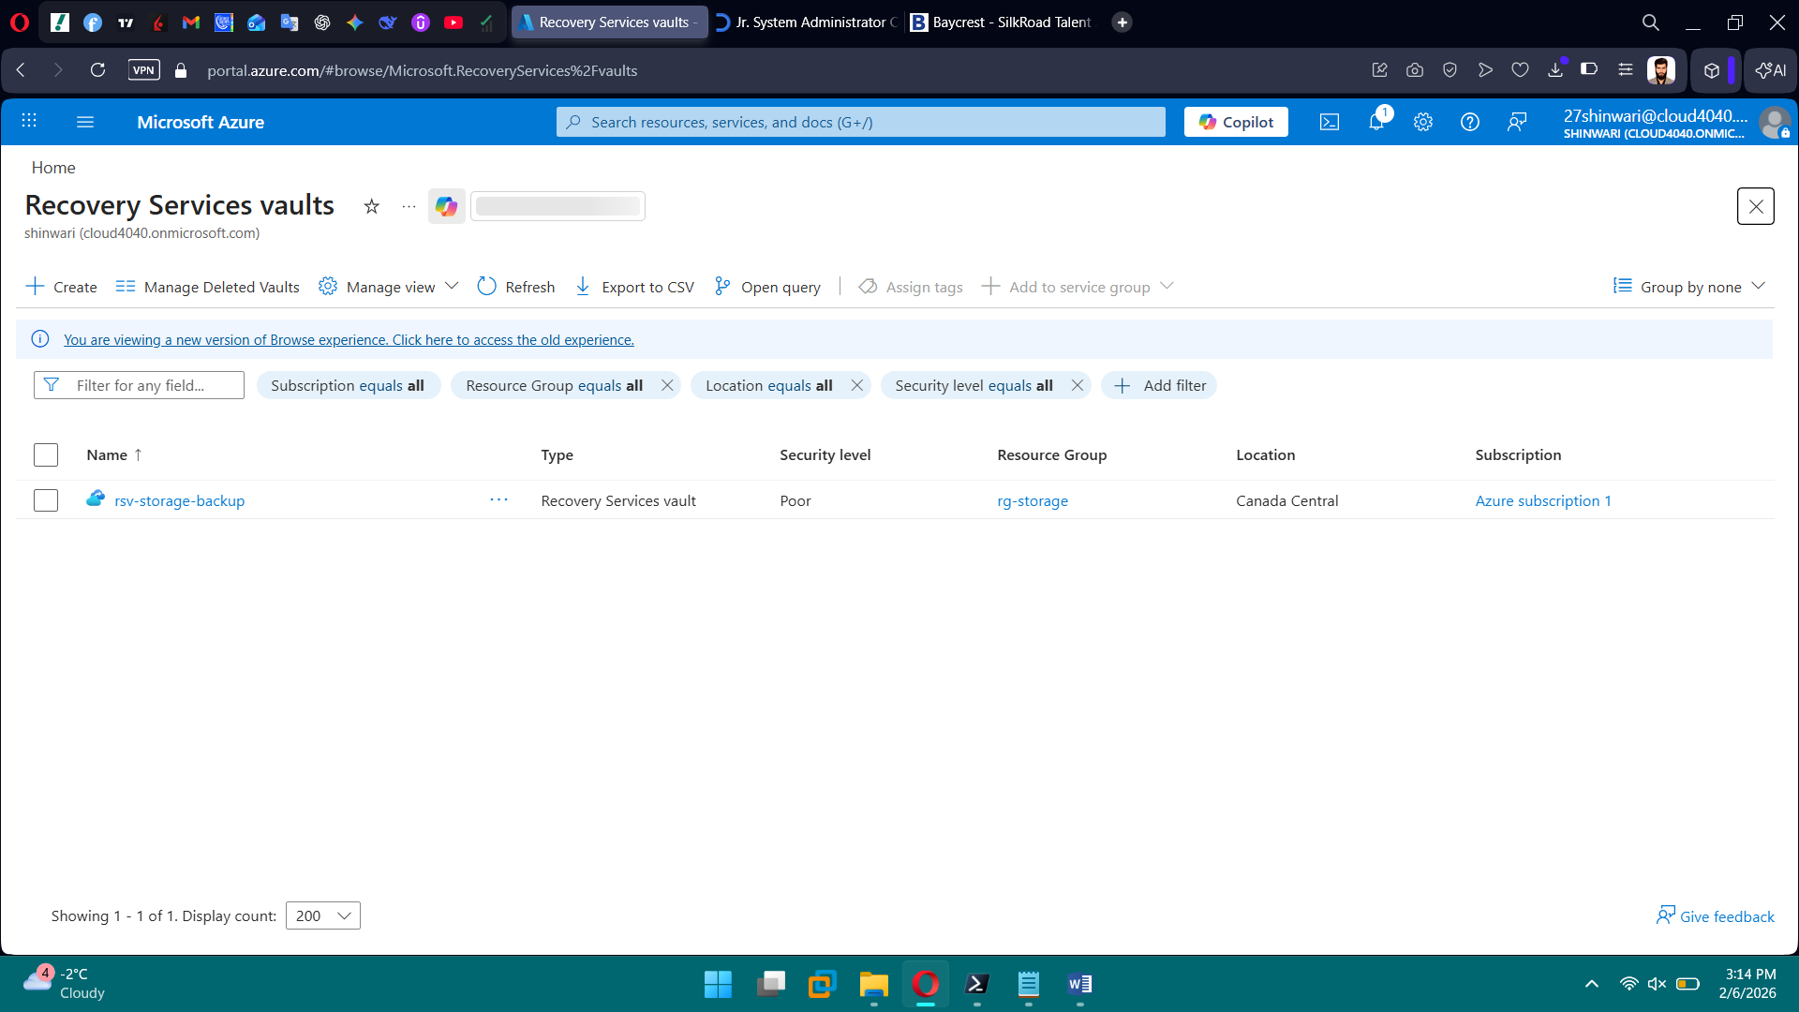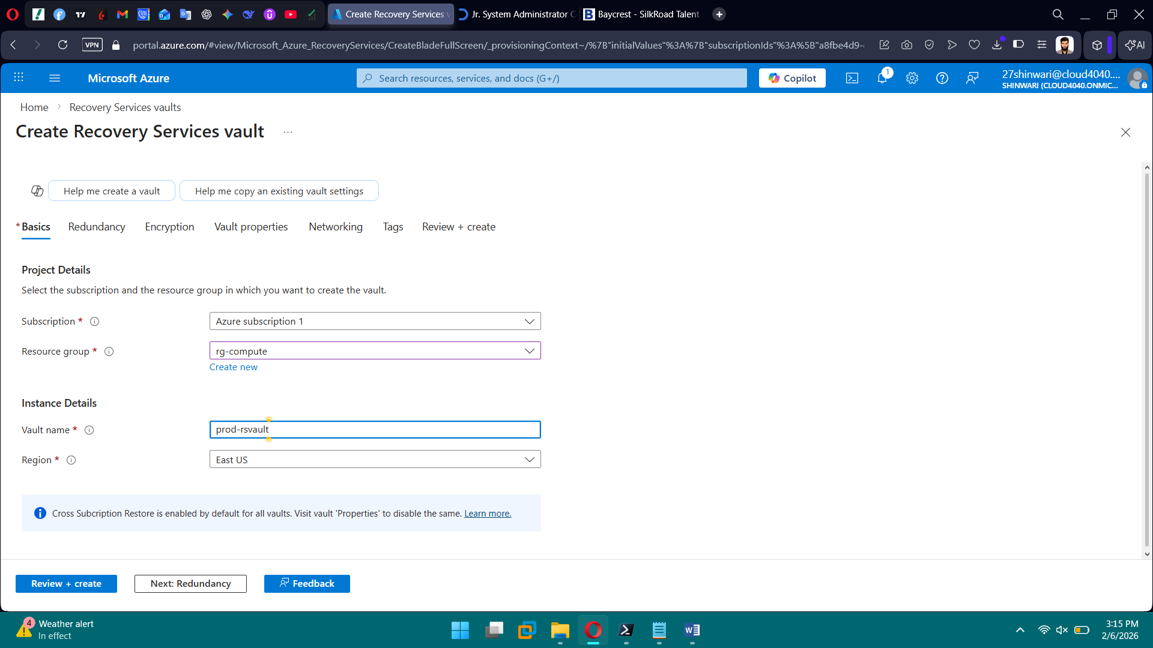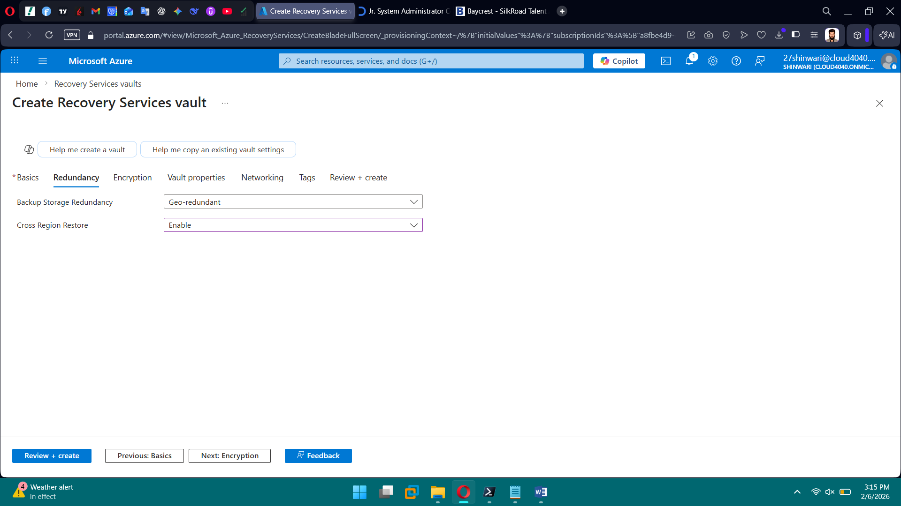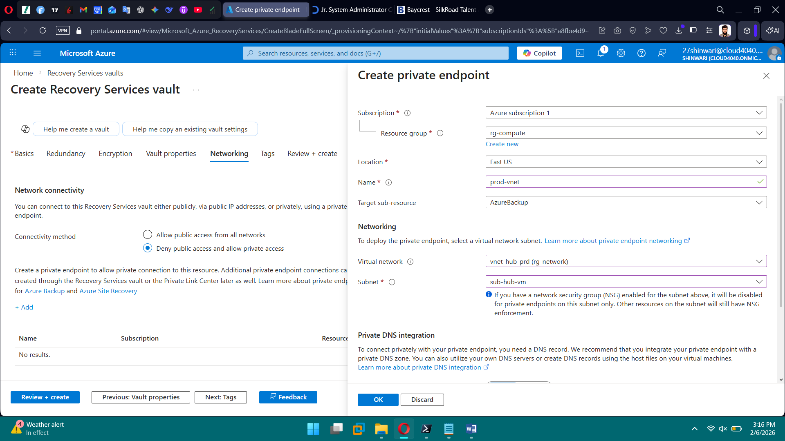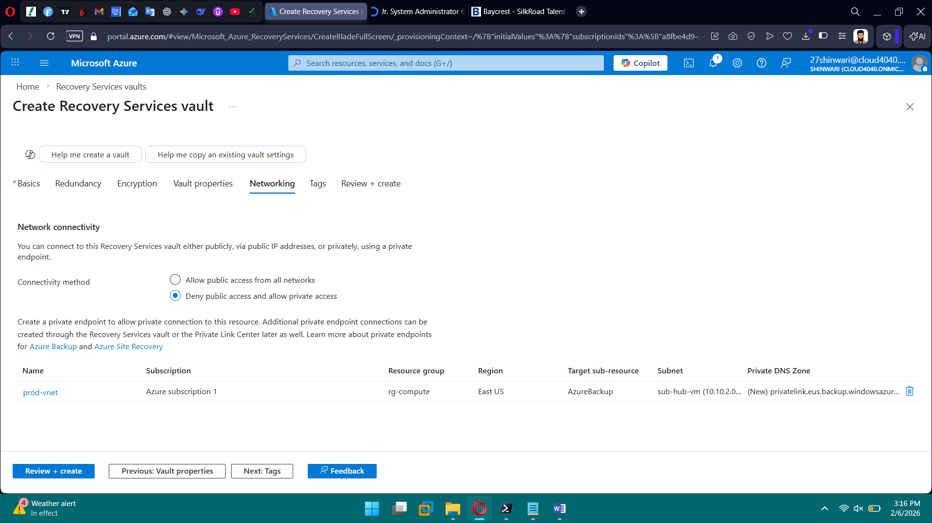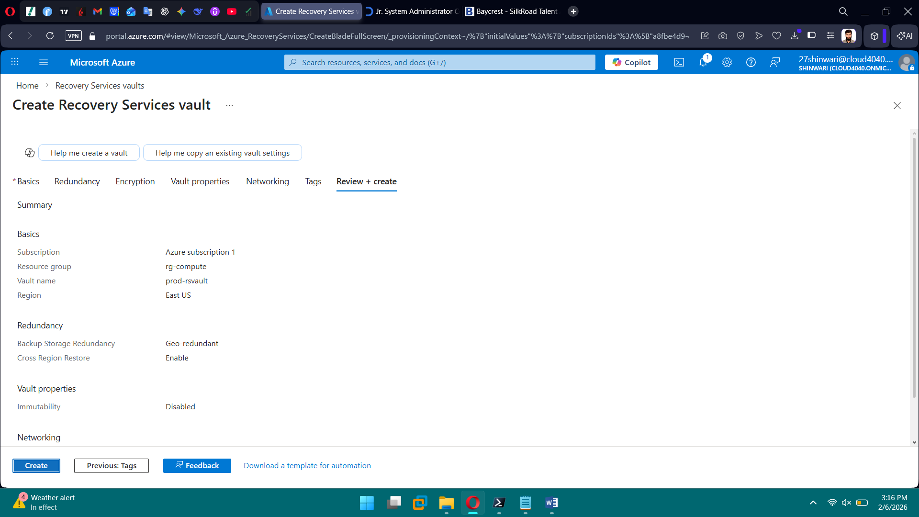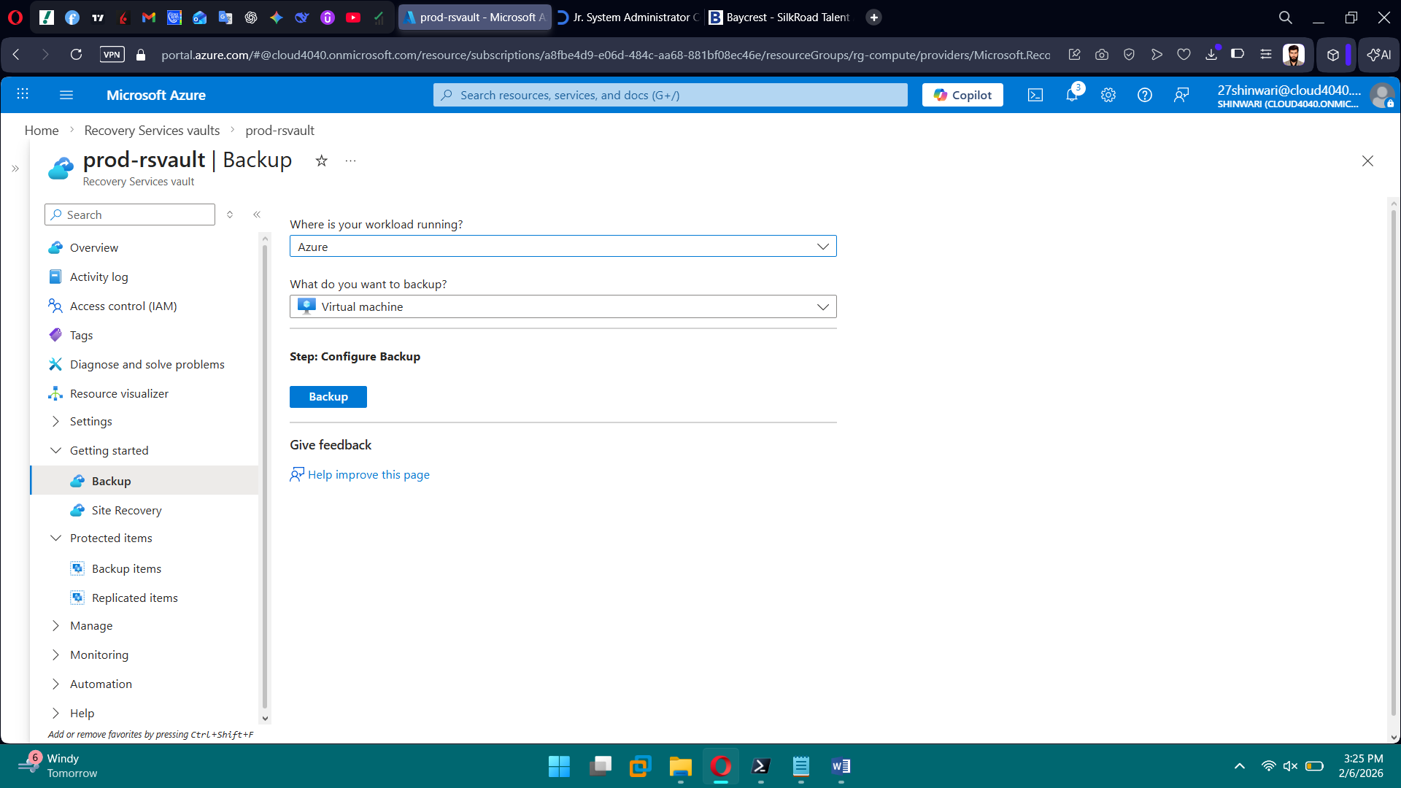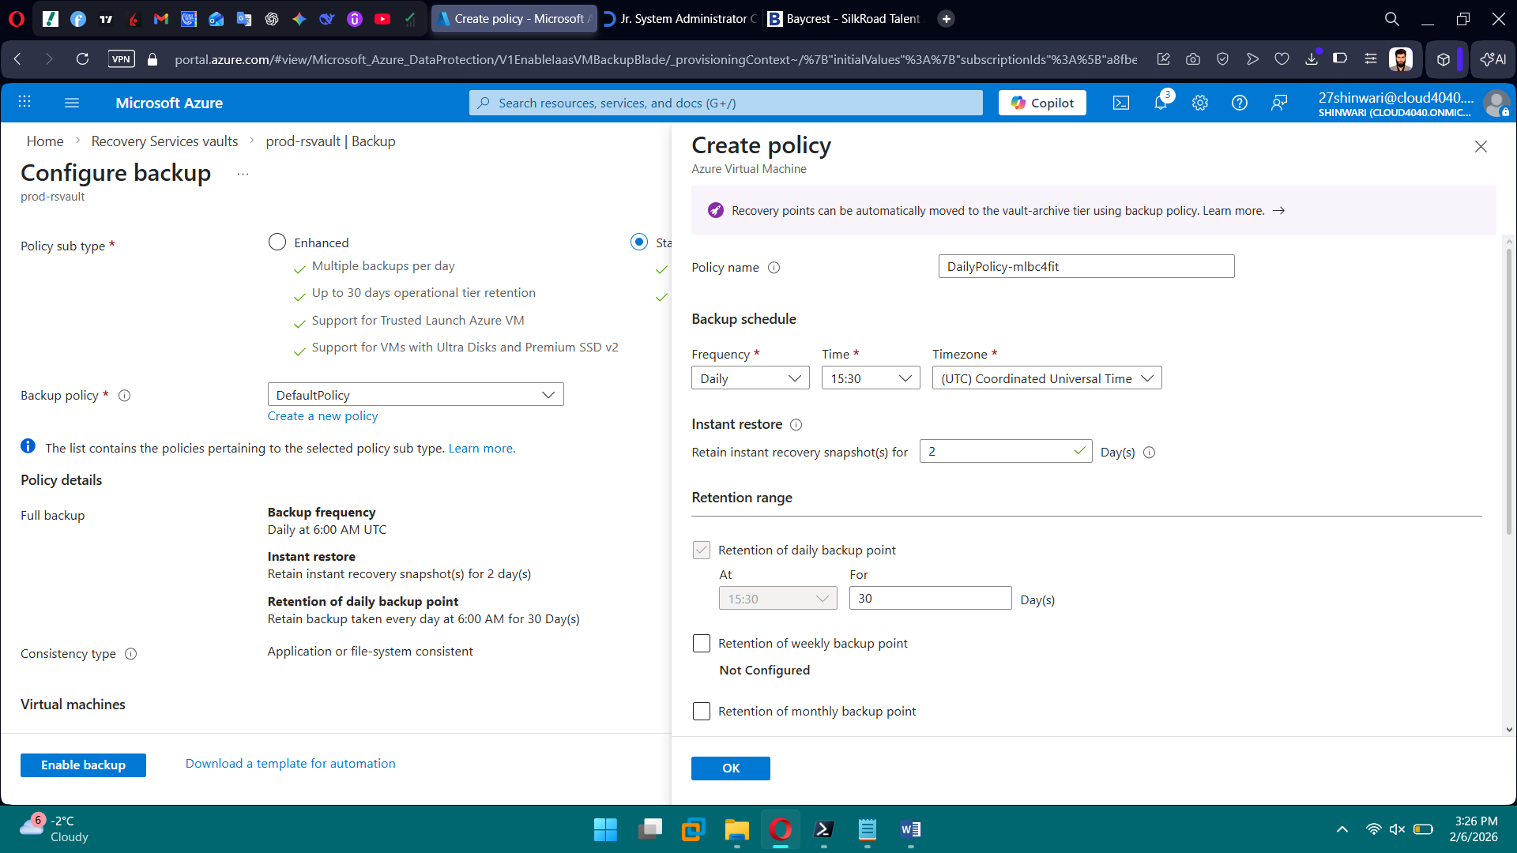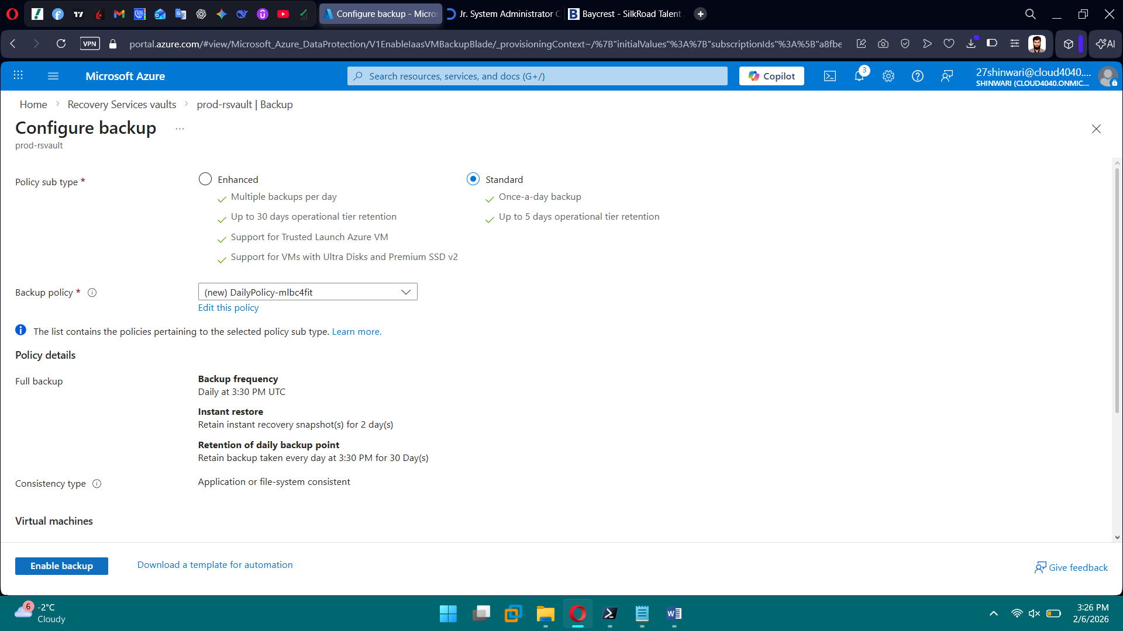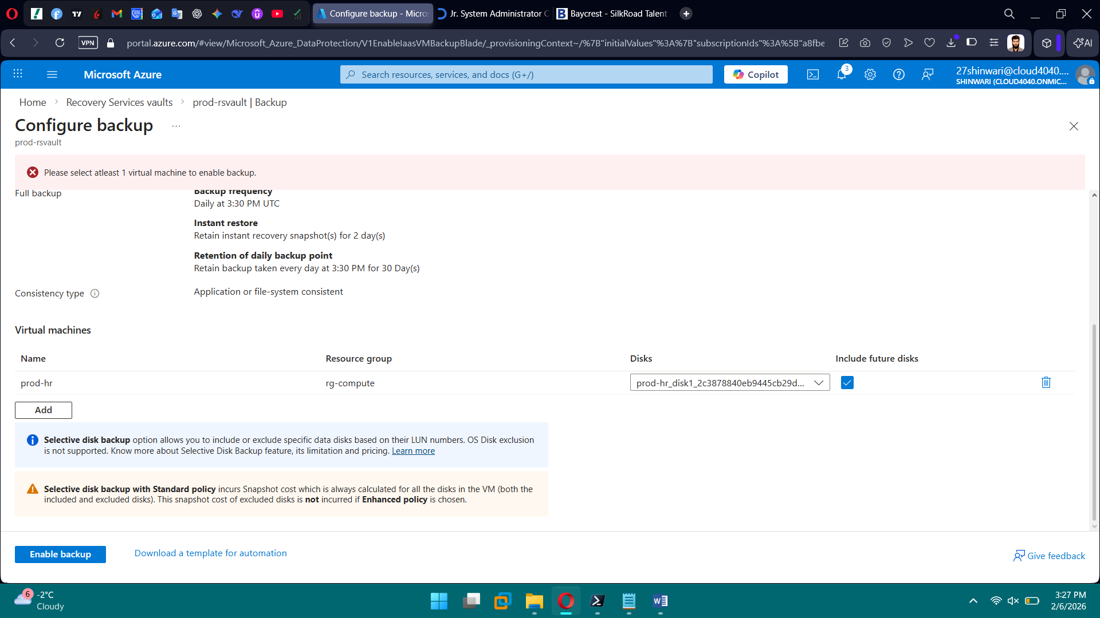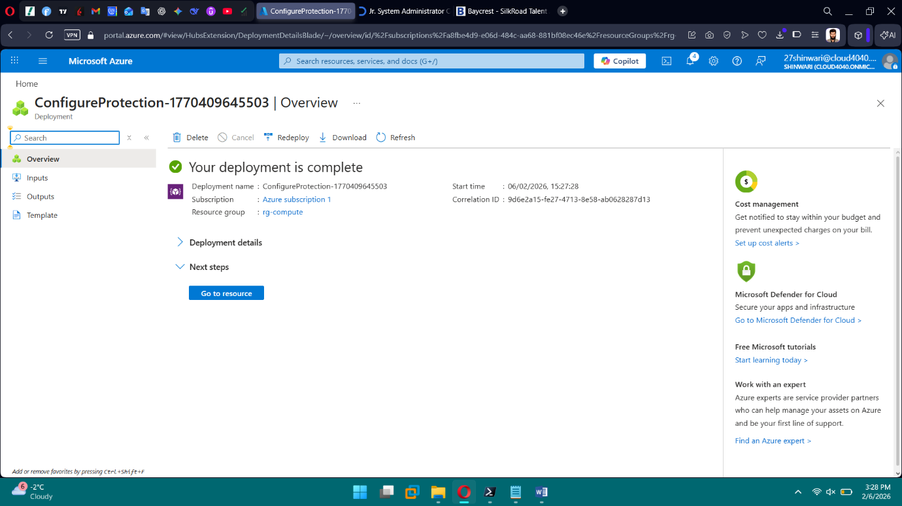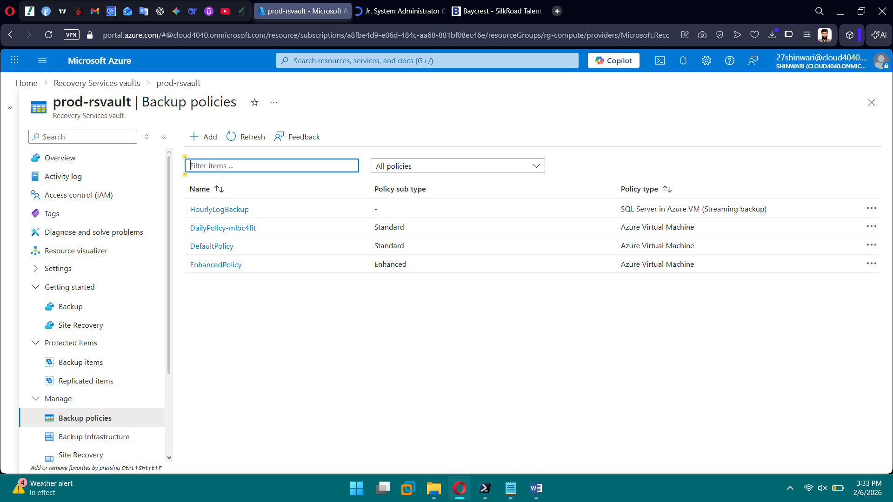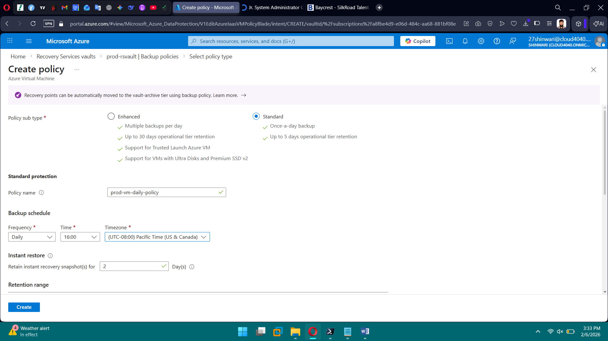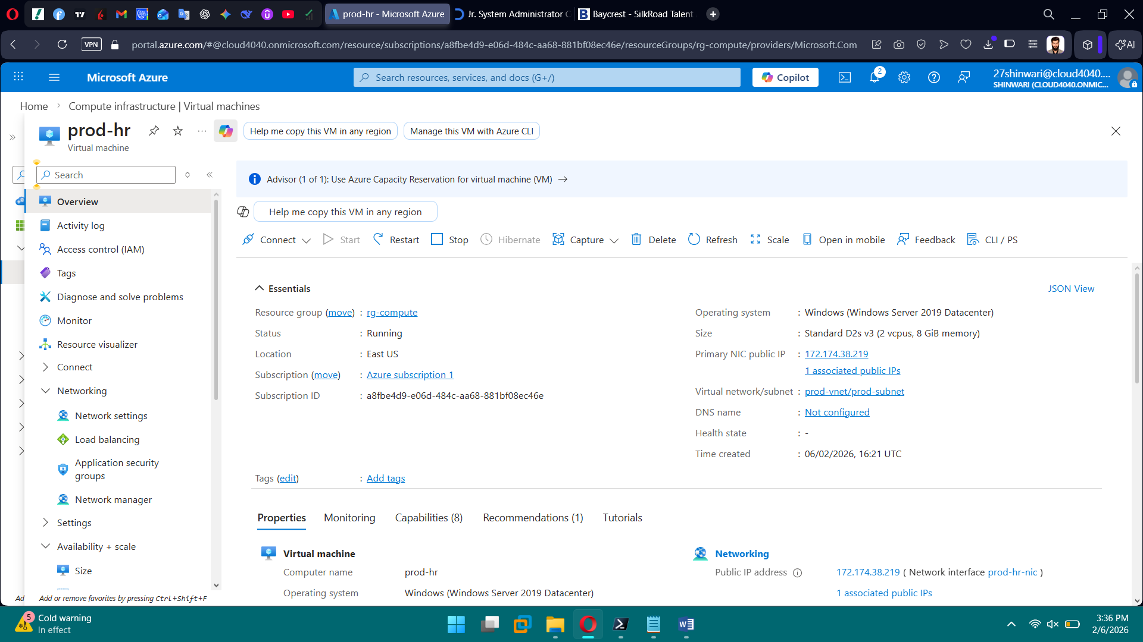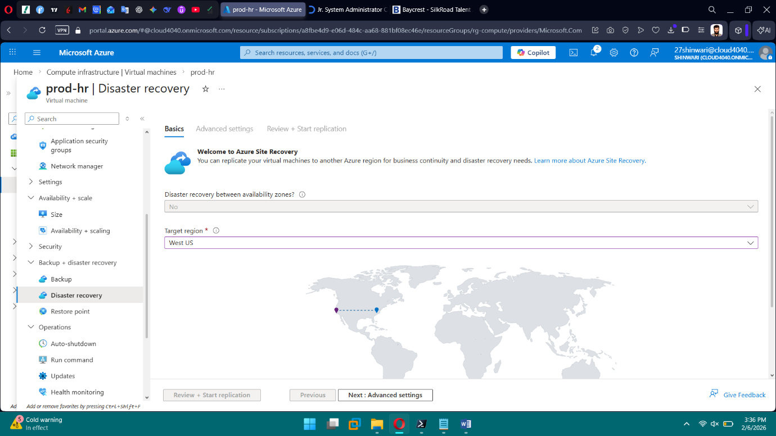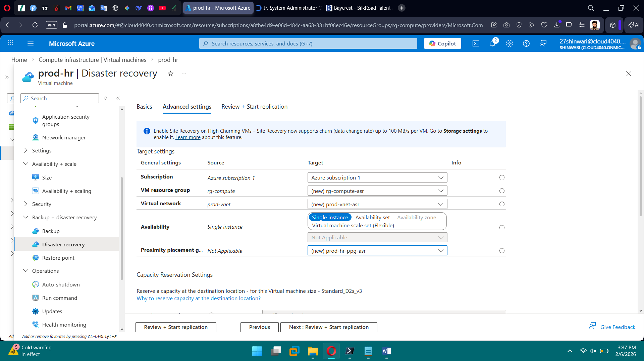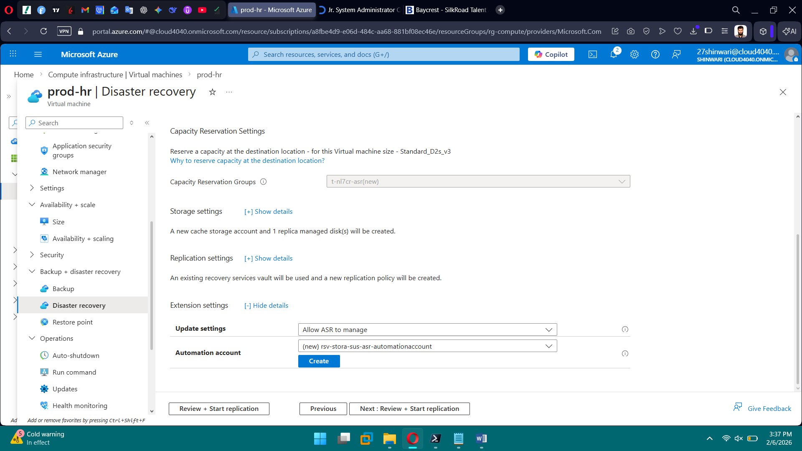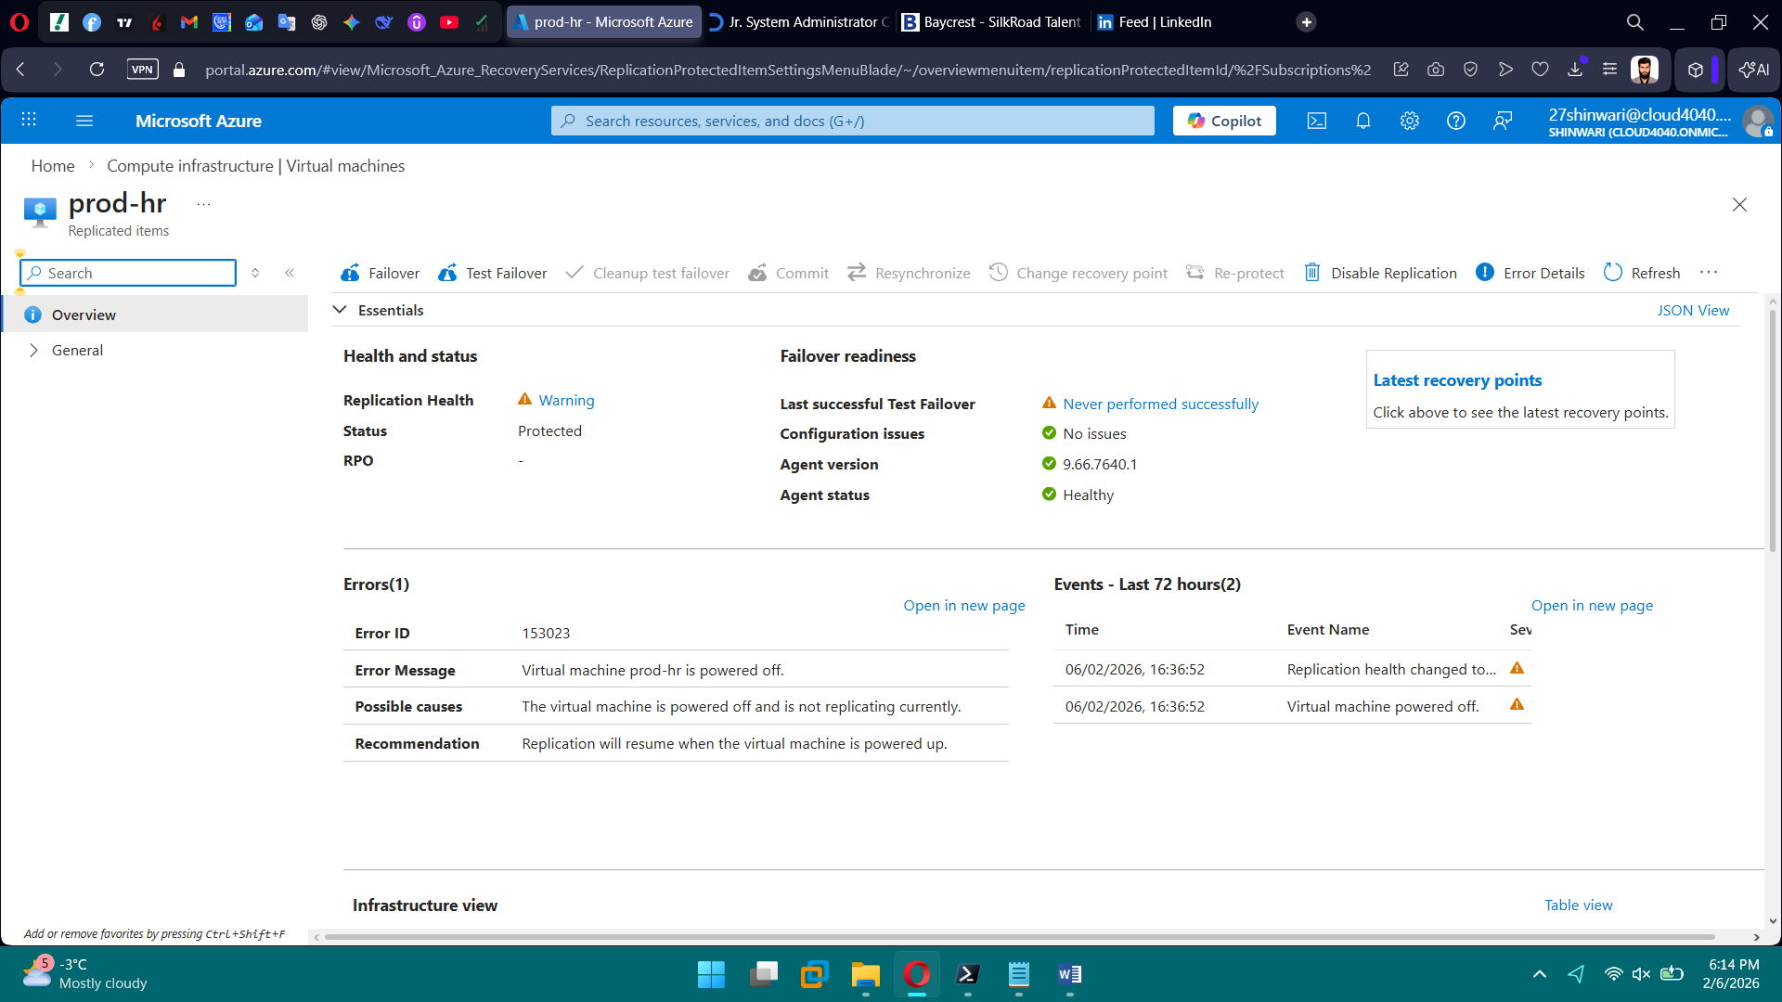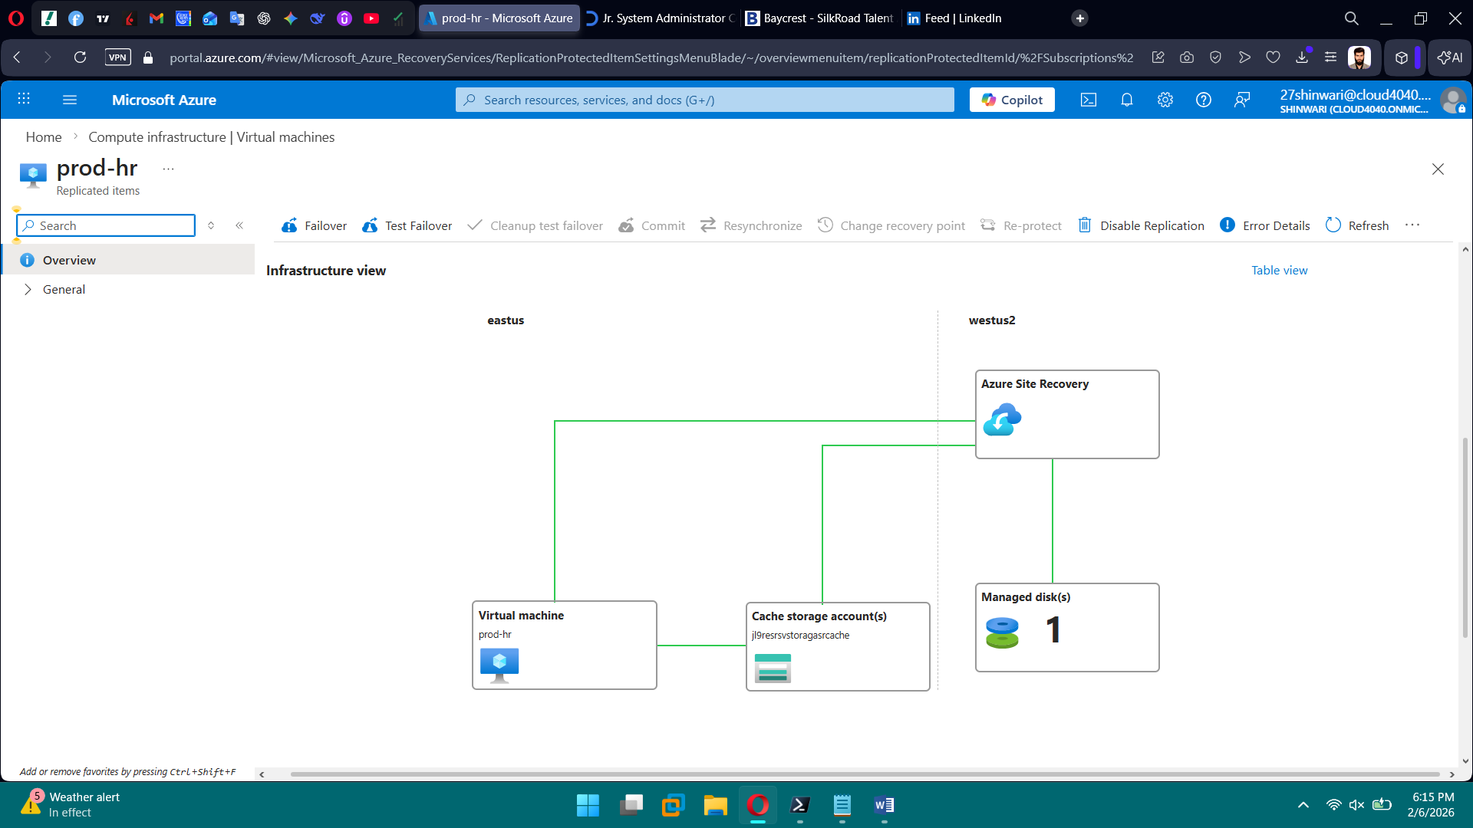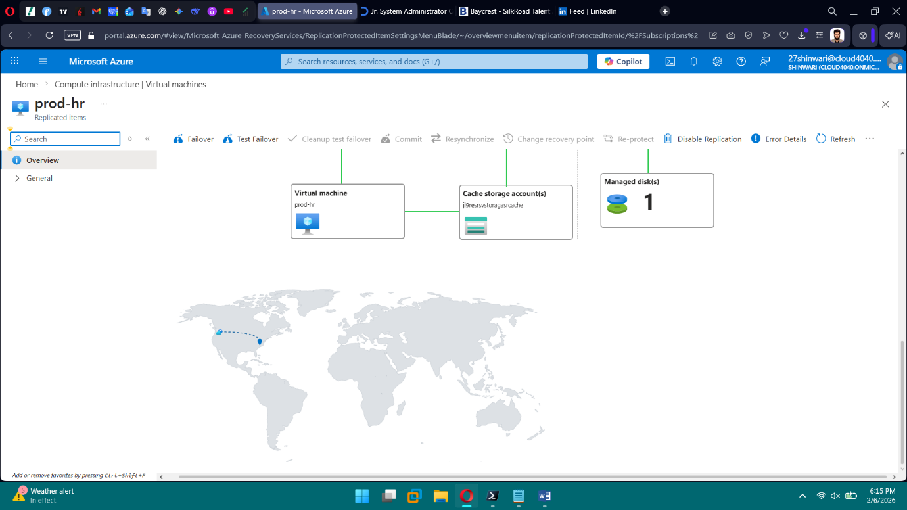

**PHASE 12 — Automation & Optimization**

**Tasks**

1. Write PowerShell automation
2. Create Bicep modules
3. Parameterize deployments
4. Configure auto-shutdown
5. Create cleanup scripts

**Brief Explanation of phase 12:** In Phase 12, we automated and optimized our Azure environment to reduce manual effort and costs. We wrote PowerShell scripts to start, stop, and monitor VMs, and created cleanup scripts to remove unused resources. We modularized deployments using Bicep modules and parameterized them for flexibility across environments. Auto-shutdown was configured to save costs, and tagging and monitoring tasks were automated for better resource management. Overall, this phase ensured efficient, consistent, and cost-effective operations.

